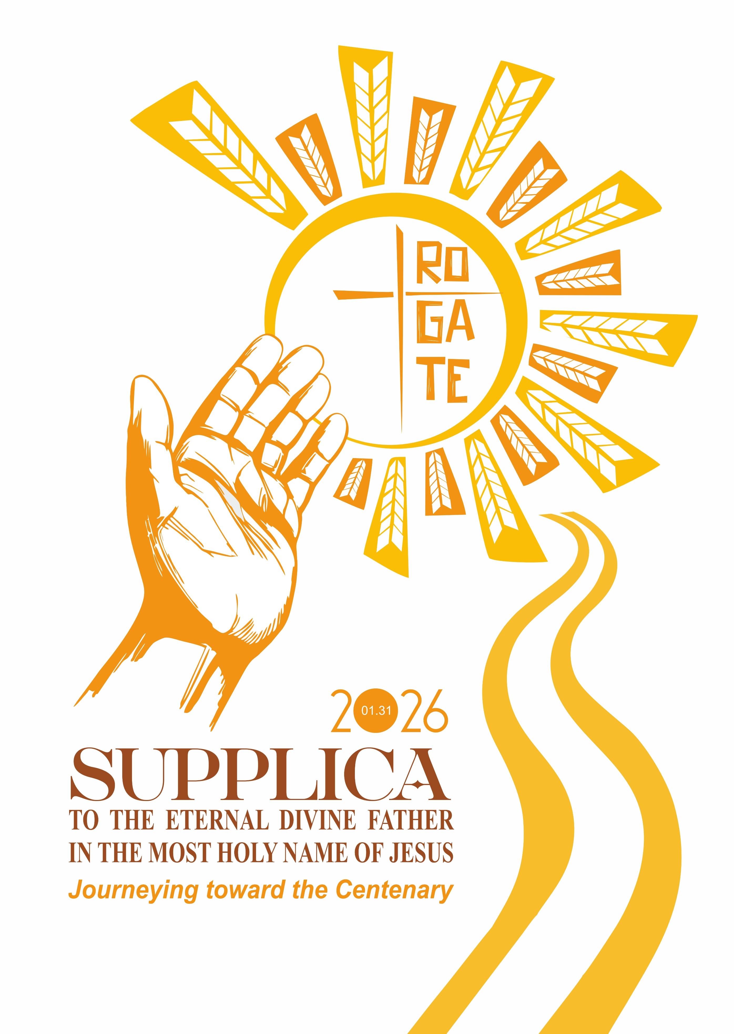

Congregation of the Rogationists of the Heart of Jesus

SUPPLICA
TO THE ETERNAL DIVINE FATHER
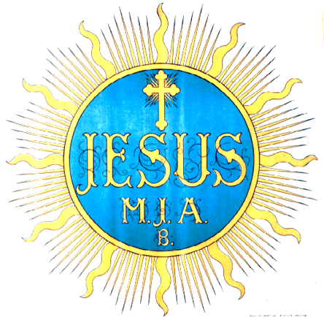
IN THE MOST HOLY NAME OF JESUS

“By prayer and petition, with thanksgiving,
make your requests known to God.”
Phil 4:6

January 31, 2026
Journeying toward the Centenary

OUTLINE OF THE CELEBRATION

Presentation

Introductory Rites:
1. Exposition of the Blessed Sacrament
2. Listening to the Word of God

Supplica: The Congregation remembers the benefits received from God.
- Praise and Petition for the Gift of Life and Faith
- Praise and Petition for the Gift of Vocation
- Praise and Petition for the Gift of Mission
- Praise and Petition of the Circumscription and the Community

CONCLUDING RITES:
- Concluding Prayer
- Eucharistic Benediction

INDICATIONS FOR THE CELEBRATION OF THE SUPPLICA

- The Supplica, which marks the Rogationist Feast of the Most Holy Name of Jesus, should be celebrated with due decorum and solemnity in every community.
- The roles of Guide and Lectors are to be assigned beforehand. The prayers may be read by all those present or be proclaimed by some Lectors.
- It may be wise to prepare the final petitions in advance:
  - the second to the last, by each Circumscription
  - the last one, by each community.
- If necessary, prepare the hymns of praise and thanksgiving or Psalms to be read at the end of each part of the Supplica. Otherwise, simply recite them.

PRESENTATION

From the Writings of Saint Hannibal Mary Di Francia
(cf. Scritti, Vol. VI p. 345)
"Since January 1888, a great importance has always been given to the petition (supplica) of January 31, consecrated in our Houses as the Solemn Feast of the Most Holy Name of Jesus. On that day, a very special petition must be presented to the Eternal Divine Father in all [our] Houses, as has been the custom in our communities until now.
“All the value of this petition is based on the divine promises made by Our Lord Jesus Christ and recorded in the Holy Gospels: 'Truly, truly, I say to you: if you ask anything of the Father in my name, He will give it to you. Until now you have asked nothing in my name. Ask and you will receive, so that your joy may be full (Jn. 16:23-24).”

Song for the Exposition of the Blessed Sacrament

INTRODUCTORY RITES

Commentator: The Supplica is one of the most significant moments in the prayer of the Family of the Rogate. Year after year, the journey of the "little caravan" that started from the Avignone Quarters continues.
United by the spirit passed down to us by our Father Founder, we welcome the Lord Jesus with faith. He continues to deem it worthy to come and dwell among us in the Eucharist.

Exposition Song

1. EXPOSITION OF THE BLESSED SACRAMENT

Celebrant: Praise and thanks every moment
All: To the Most Holy and Most Divine Sacrament who has deigned to come and dwell among us.

Brief personal adoration

2. LISTENING TO THE WORD
Commentator: As we contemplate and adore the mystery of the presence of Jesus in the Eucharist, let us listen to His Word which prepares our hearts to praise Him and pray to Him as He deserves (cf. Rm 8:26-27).

From the letter of St. Paul to the Colossians (3:15-17)
And let the peace of Christ control your hearts, the peace into which you were also called in one body. And be thankful.
Let the word of Christ dwell in you richly, as in all wisdom you teach and admonish one another, singing psalms, hymns, and spiritual songs with gratitude in your hearts to God. And whatever you do, in word or in deed, do everything in the name of the Lord Jesus, giving thanks to God the Father through him.

The Word of the Lord.

All: Thanks be to God.

Responsorial Psalm (Ps. 117 or similar)

All: Alleluia, Alleluia
O Praise the Lord, all you nations;
Acclaim him, all you peoples! (Response)

Strong is his love for us,
He is faithful forever! (Response)

From the Gospel according to Matthew (18:19-20)
Again, amen, I say to you, if two of you agree on earth about anything for which they are to pray, it shall be granted to them by my heavenly Father. For where two or three are gathered together in my name, there am I in the midst of them.
The Gospel of the Lord.

All: Praise to you, Lord Jesus Christ.

Song or moment of reflection

SUPPLICA
THE CONGREGATION REMEMBERS

THE BENEFITS RECEIVED FROM GOD

Commentator: With the same faith as the Father Founder, and filled with the Spirit, let us thank God the Father for everything in the Name of our Lord Jesus Christ (Cf. Eph. 5:18-20).
In this past year, we bring the painful separation from Pope Francis and the consolation of the gift of Pope Leo XIV to Jesus in the Blessed Sacrament, recognizing in the successor of Peter his loving and paternal guidance.
It has been a year of spiritual consolation for millions of brothers and sisters worldwide who crossed through the Holy Door during the Jubilee and encountered the merciful embrace of the Father.
At the same time, we carry in our hearts the wounds of countless brothers and sisters who live with daily anguish and the terror of fratricidal wars in many parts of the world.
As Family of the Rogate, the daughters and sons of Father Hannibal, we wish to renew our commitment as children of our Holy founder. We will walk together as brothers and sisters toward the 100th anniversary of his passing on June 1, 2027.

1. PRAISE AND PETITION
FOR THE GIFT OF LIFE AND OF FAITH

1. The Gift of Life and of Faith
We thank you, O Father, because in the plan of your goodness, you have created us in your image and made us sharers in your blessed life. We thank you because in this past year you have preserved us in life and above all in faith.
We ask you, in particular, to grant our leaders, lawmakers, and health workers respect for the sacredness of life, to strengthen the faith of the doubtful, and to restore faith to the lost.

All: Blessed are you Lord, our Father.

2. The Gift of the Church
We praise you, O Father, through your Son in the Spirit for calling us to become your adopted children. In baptism, you inserted us into the communion of your family, the Church.
We pray that you strengthen and vindicate those in the Church who are persecuted for their faith.
May our charismatic presence in the Church become a blessing proclaimed and lived out by each one of us.

All: Blessed are you Lord, our Father.

3. The Pope and the Bishops
We thank you, O Father, for the gift of Pope Francis, whom you called to experience your merciful love, a testament he left to us. We praise and bless you for the gift of Pope Leo XIV, who, in his first message, calls us to be witnesses to his love for the poor.
We thank you for all the Bishops of the Local Churches in which we are present, and we thank you in a particular way for our bishops: Mons. Ottavio Vitale, Bishop of Lezhë, Albania; Mons. Angelo Ademir Mezzari, Archbishop of Vitória, Brazil; Mons. Juarez Albino Destro, Auxiliary Bishop of Porto Alegre, Brazil; Mons. René Ramirez, Auxiliary Bishop of Melbourne, Australia; and Mons. Herman Guinto Abcede, Bishop of the Diocese of Daet (Philippines),

All: Blessed are you Lord, our Father.

4. The Eucharist Makes Us Grow as the Mystical Body
We thank You, Father, in the Name of Jesus for welcoming us into His Mystical Body, nourishing us with His eucharistic body and calling us to a spirituality that stems from the zeal of the Rogate.
Following the example of St. Hannibal, grant that we may grow in love for Jesus Christ, especially through the adoration of the Eucharist. In the spirit of the First of July, may we accept Pope Leo's invitation to convert our hearts, forgive wrongs, and transform sorrow into consolation. May we also promote perpetual or prolonged adoration in our churches whenever possible.

All: Blessed are you Lord, our Father.

5. Nourished by the Word of God

We give you thanks, O Father, for instilling in our Holy Founder a great love for your word, "a lamp for his steps and a light for his path" (Psalm 119).

Pour into each of our hearts the same love and spiritual joy of having your Word as a traveling companion and a source of discernment and renewal in our community meetings.

All: Blessed are you Lord, our Father.

Silent pause. Each person reflects on the most significant blessings received and thanks the Lord for his fidelity to his vocation.

Song of praise

2. PRAISE AND PETITION
FOR THE GIFT OF VOCATION

6. The Gift of the Rogate
Blessed are you, God our Father, who has blessed us in Christ with the gift of the Rogate, uniting us to the compassion of your Son. Make us good laborers of the harvest, imitating him.
We ask you to instill in each of us the zeal that inflamed St. Hannibal's heart for this holy mission of living out and spreading the command of Jesus your Son, a special secret for the salvation of souls.

All: We glorify you, Father, in the Name of your Son.

7. The Holy Founder

We thank you, Father, source of all holiness, for enriching the Church with a new way of holiness according to the Gospel through your servant, Saint Hannibal Mary Di Francia, the Apostle of the Rogate and Father of the Orphans and the Poor.

Grant that we may be his devout children, help us make him known, and help us spread his devotion in the Church so that he may be invoked and imitated universally.

May the hearts and lives of those who come to venerate him be filled with your gifts, and may they be inspired by his example.

All: We glorify you, Father, in the Name of your Son.

8. Rogationist Religious Consecration
Blessed are you, Father, source of all holiness, for calling us to consecrate ourselves according to the spirituality of the Rogate: to unceasing prayer for good laborers, spreading this prayer, and serving the least of these, following the example of our Holy Founder.
Guide us, following the example of your Son, Jesus, and according to the teaching of Pope Leo, to make a preferential option for the poor.
Make our communities houses of prayer that are faithful and committed to the mission you have entrusted to us.

All: We glorify you, Father, in the Name of your Son.

9. The First Collaborators of Father Founder
We thank you, O Holy Father, for the fidelity of the Founder's first collaborators, especially Mother M. Nazarena Majone, Fr. Francis Vitale, and Fr. Pantaleone Palma. Like many other confreres and sisters, they accepted his entire spiritual inheritance and realized it wonderfully in their lives. They transmitted it to us. Grant that we may imitate their example and make their radiant witness known.
We offer special thanks for the decree in which the Dicastery for the Causes of Saints recognized the heroic virtues of the Venerable Servant of God, Fr. Giuseppe Marrazzo. Help and console those who turn to him through your intercession.
If it is in accordance with Your will, grant a favorable outcome to the causes of beatification of Venerable Mother Nazarena Majone and Servants of God Fr. Giuseppe Aveni and Fr. Pantaleone Palma.

All: We glorify you, Father, in the Name of your Son.

10. The Daughters of Divine Zeal
We praise you, O Father, for the many graces you have given to the Daughters of Divine Zeal this year for their witness of consecration, their mission in the Church, and the gift of new vocations with which you have blessed them.
We bless you for granting us Rogationists the gift of collaborating with them in moments of spiritual growth, especially during this final stretch of our journey and during the celebration of the Centenary Year of our Father Founder's blessed passing. We ask that all of this continue to flourish for the sake of spreading the charism and for the good of our institutes and the Church.
All: We glorify you, Father, in the Name of your Son.
11. The Union of Prayer for Vocations and the Priestly Alliance
We thank you, O Good Father, for inspiring Saint Hannibal to establish the Rogationist Priestly Alliance and the Union of Prayer for Vocations.
Grant us renewed zeal to promote and support those enrolled in these organizations and to spread prayer for holy gospel laborers in collaboration with the entire Family of the Rogate.

All: We glorify you, Father, in the Name of your Son.

12. The Laity
We thank you, Father, for the Rogationist charism, which has been shared with lay men and women since the beginning. We bless you for the journey of the Missionaries of the Rogate and ask you to accompany their upcoming General Assembly in February. Sustain their growth in the charismatic dimension and sense of belonging to the Family of the Rogate. Guide the various associations that comprise the Union of Rogationist Associations (UAR): the Family of the Rogate, the Rogationist Lay Vocation Animators (LAVR), the European Rogationist Association (ERA), and the Alumni. We thank you as well for lay people who do not belong to any of our associations but accompany us in our apostolate in various ways.
Master of the Harvest, open us to greater enthusiasm for sharing the charism with the laity. Teach us to share experiences and projects in complementarity of gifts.
Guide us during our six-year term, as directed by the General Chapter, as we prepare for and carry out the International Laity Symposium. The theme of this symposium is "The Laity of the Charismatic Family, Prophets of the Rogate and of Charity on the Occasion of the First Centenary of the Death of St. Hannibal Mary Di Francia." Local symposia and congresses will precede the symposium.

All: We glorify you, Father, in the Name of your Son.

13. The Divine Superiors and Special Patrons
Father, in the name of your Son, Jesus, we thank you for inspiring our founder to dedicate our institutes to the Most Sacred Heart of Jesus and the Immaculate Virgin as our effective and immediate superiors.
We also thank you for the intercession of St. Michael the Archangel, St. Joseph, the Holy Apostles, and St. Anthony of Padua, our special patrons. May their presence and intercession always guide and sustain us.

All: We glorify you, Father, in the Name of your Son.

14. The Heavenly Rogationists and Daughters of Divine Zeal
We praise and thank you, O God of Goodness, for the saints you have given to your Church. We recognize in them the reflection of Your holiness. We thank you for inspiring our Founder to proclaim some of them as our heavenly confreres and sisters, as we feel they are partners in our Rogationist spirituality.
Grant that we may be open to their example, so that we may follow your Son, the Christ of the Rogate.

All: Blessed are you, O Father, with the Son and the Holy Spirit.

15. Our Communities
We thank you, Holy Father, in the name of Jesus, for the gift of our communities. May they live their lives by listening to the Word, celebrating the Eucharist, practicing fraternity and sharing, and serving their neighbors.
We thank you for the new houses that have been opened as missionary stations or initial presences in the various Circumscriptions: Port Moresby (Papua New Guinea); Victoriaville (Canada); San Isidro Labrador and San Vicente on the island of Palawan (Philippines); and Munich (Germany). We pray that you accompany their growth.
Help us, we pray, to build fraternal life in communion and sharing of charism and mission in our communities, as the Circular Letter, Our fraternal communion of life with Christ and with the Poor, exhorts us.
All: Blessed are you, O Father, with the Son and the Holy Spirit.

16. The Superiors
We thank you, Holy Father, in the name of Jesus present in the Eucharist, for guiding us through the superiors you give to our communities as your representatives.
Patient and merciful Father, grant wisdom, serenity, strength, and prudence to those who lead us in promoting holiness and fostering fraternity in our communities for Your greater glory.
We thank you for the experience we shared with the Governments of Circumscription during last year's conference in São Paulo from October 12 to 22. This coincided with the 75th anniversary of the Congregation's presence in Brazil and included the participation of the respective Councilors for Missions and Treasurers. Help us put what we shared into practice.
In particular, we thank you for the Superior General's visit to the circumscriptions and pray that it bears the desired fruit. We ask you to enlighten and sustain the Father General as he begins the second visit of his six-year term.

All: Blessed are you, O Father, with the Son and the Holy Spirit.
17. The Governments of Circumscriptions
We bless you, O God our Father, for supporting us in renewing the governments of the Quasi-Provinces of St. Thomas and St. Joseph. May these two Circumscriptions implement the programs identified for their growth.
We also thank you for the successful unification chapter of the two Italian Circumscriptions that merged to form the St. Hannibal-St. Anthony Province. May the new province, through the intercession of the two saints whose names it bears, be revived in spiritual vitality and in the apostolate.
We thank you for the assemblies of Circumscriptions that we celebrated this past year.
Support the Governments of Circumscriptions in their demanding roles of providing guidance and assistance, and protect them with your paternal care.

All: Blessed are you, O Father, with the Son and the Holy Spirit.
18. Preparation for the 14th General Chapter of the Congregation
O God, our Father, who willed to be the Divine Superior of our religious family, you know the difficulties of our journey. You enlighten us during important stages of the General Chapters so that we may proceed on a path in accordance with your will.
Guide us in preparing for the upcoming 14th General Chapter and lead us along a path of proper discernment of critical issues and objectives for the greater good of our Congregation.

All: Blessed are you, O Father, with the Son and the Holy Spirit.

19. The Brothers
Praise, blessing, and thanksgiving are yours, All-powerful and Eternal Father, in the name of Jesus. You have given our Congregation many Brothers over the years.
Reward, O Father, the precious work of the Brothers and confirm them in their consecration to You. Enlighten us to promote the vocation of the Brothers and continue to bless our Institute with generous and holy Brothers.

All: Blessed are you, O Father, with the Son and the Holy Spirit.

20. The Sick and Elderly Confreres
O Father, your Son Jesus manifested your love for us and brought us salvation through suffering and the cross. We thank you and adore your unfathomable plan of love, hidden in the suffering of our sick and elderly Confreres and Sisters, and in their solidarity with suffering humanity.
Good Father, grant them the strength and peace to accept your will, and if it pleases you, grant them the joy of recovery. Help us serve them with affection in our religious communities so they may better experience the preciousness of their suffering as participation in the common Rogationist mission. We ask you to enlighten us so that we may make appropriate choices in carrying out this important service.

All: Blessed are you, O Father, with the Son and the Holy Spirit.

21. Youth Ministry
We thank you, O Father, in the name of Jesus because the vocation to consecrated life and to the priesthood is your gift, which we implore through prayer. We thank you for the activities of Youth Ministry that we carry out in all the circumscriptions, especially for the success of the Year of Rogate Youth (2025), including the Jubilee of Youth on July 28th.
Lord of the Harvest, grant that, within a fully ministerial Church, we may labor particularly in parish ministry and in socio-educational apostolates. Help us promote in teenagers and young people the awareness of being called by God to become living stones for building His Kingdom.

All: Blessed are you, O Father, with the Son and the Holy Spirit.

22. Vocation Animation and Formation
Holy Father, in the name of Jesus, who is chaste, poor, and humble, we thank you for blessing the houses of formation for postulants, novices, juniorates and studentates of our institutes with the gift of vocations. Come to the aid of circumscriptions experiencing a scarcity of vocations.
We thank you for the formation experience for formators that took place in Italy last year, and we ask you to accompany this years’ experience.
Bless the International Student Residence in Rome so that it may grow in sharing, solidarity, and missionary availability.
Renew our personal and communal commitment to promoting vocations to the consecrated life, focusing on vocational promotion through the witness of our lives.

All: Blessed are you, O Father, with the Son and the Holy Spirit.

23. Priestly Ordinations and Religious Professions
Holy Father, source of every order and consecration, we praise and glorify you because you have once again called many young confreres and sisters in different circumscriptions to receive the orders of priesthood and diaconate or profess religious vows.
Father, in the name of Christ the Eternal Priest, we thank you with joy, together with the confreres and sisters who have celebrated the jubilee of their religious profession and priestly ordination.

All: Blessed are you, O Father, with the Son and the Holy Spirit.

24. The Gift of Perseverance
We thank you, Holy Father, in the name of Jesus, who is present in the Eucharist. We thank you for your faithful love and for giving us the grace to persevere in our Institute. We thank you for the daily support of our confreres, for the journey of ongoing formation, and for the joy of apostolic service.
We thank you for the ongoing formation initiatives organized by the General Government and the Circumscriptions, including webinars.
Sustain, O Father, with the strength of your Spirit, the confreres who are experiencing difficulty. Grant us fidelity in our radical commitment to Rogationist holiness for your greater glory and the good of the Church.

All: Blessed are you, O Father, with the Son and the Holy Spirit.

25. Our Departed
Father, source of life, in the name of your Son, Jesus the Risen One, we offer you our thanks for your love, which extends beyond the limits of our earthly existence into the fullness of life in your house.
Praise be to you because in this past year, the mystery of your love was fulfilled in our confreres: Father Giacomo Alberto Rossini, Father Sergio Maria Bini, Brother Jaime A. Moncada, Father Osni Mariano Zanatta, and some of our relatives, friends, and benefactors.
O merciful Father, forgive their sins and welcome them into the peace of the heavenly Jerusalem. May their good example be an incentive for us to remain faithful to our mission.

All: Blessed are you, O Father, with the Son and the Holy Spirit.

26. Our Relatives
All-powerful and Eternal Father, we glorify and thank you for sending your only Son to sanctify family affection and for giving us the grace to experience your love in our loved ones.
O good Father, bless our parents, who gave us to you. Help our relatives in their times of need, and grant that one day, we may all be together in the joy of your house.

All: Blessed are you, O Father, with the Son and the Holy Spirit.

27. Friends and Former Confreres
We bless you, O Lord, for the gift of friendship, which has enabled us to build constructive relationships of mutual edification with many brothers.
We remember those who shared a part of their journey with us and then made different life choices. May the Rogate spirit live on in them in new and different ways, through which we can enrich ourselves through dialogue and fraternity.

All: Blessed are you, O Father, with the Son and the Holy Spirit.

Silent pause. Each person reflects on the blessings received from the Family of the Rogate through sharing the charism and gives thanks to the Lord for them.

Song of praise

3. PRAISE AND PETITION
FOR THE GIFT OF THE MISSION

28. The Diffusion of the Rogate
We thank you, O Father, for all that our religious family has accomplished over the years with your help in zealously carrying out the charism of the Rogate.
We bless you for the magazine Rogate Ergo, which was the first to give voice to our charism; for the Rogate Publishing House (Editrice Rogate); for the journal Studi Rogazionisti; and for the Rogate Institute of Theology and Psychopedagogy. Help us promote their progress and widespread outreach.
May such centers be established where they do not yet exist and may they actively spread your divine command, even through media, possibly in collaboration with the Daughters of Divine Zeal and the Rogationist Associations.

All: May all the earth praise your Name, O Most High.

29. Apostolate of Social-Education and Schools
We praise you, O Father, in the name of Jesus, the Friend of the little ones and the poor, for calling us—following the example of our Founder—to care for the integral education of the most disadvantaged children and youth. We thank you for enabling us to perform good works in many parts of the world on behalf of at-risk children and in defense of life. We adapt to the new demands of this mission, particularly in Italy, by welcoming unaccompanied migrant minors.
We thank you for completing the school in Aluva, India; starting construction on a new school in Kigali, Rwanda; building a new dormitory for university students in Vietnam; and planning the construction of a new building for the Saint Hannibal Multi-Level School Foundation in Parañaque, Philippines. May the Multipurpose Center for the Deaf in Butembo, Democratic Republic of the Congo, be equipped with the necessary furnishings to become fully operational.
Good Father, grant us the strength of your love to become intelligent educators attentive to the needs of our time. Help us guide and form youth in the school of Christ so that they may recognize their lives as vocations at the service of charity.

All: May all the earth praise your Name, O Most High.

30. Apostolate among the Poor and for the Care of Life
We bless you, O Father, from the depths of our being because you gave Saint Hannibal Mary the gift of seeing your Son's face in the faces of the poorest in the Avignone Quarter. We also thank you for enabling him to hear your divine words in his heart: "Whatever you did for these little ones, you did it for me."
We praise you, Lord, for the many works and initiatives of solidarity and human promotion for the poor that you have allowed us to carry out in our congregation. We thank you for establishing the "St. Hannibal Mary Di Francia" Solidarity Clinic in Oria.
Enlighten us and grant us the obedience to accept the XII General Chapter's invitation to rediscover service to the poor as acceptance, closeness, and sharing in order to achieve true evangelization. May we be guided by Pope Leo's Apostolic Exhortation Dilexi Te and the circular letter Our Fraternal Communion of Life with Christ and with the Poor.

All: May all the earth praise your Name, O Most High.

31. Apostolate of Missions
Almighty and Eternal Father, we thank you in the name of Jesus for the gift of the missio ad gentes, which we, the sons and daughters of Saint Hannibal, have also vowed to proclaim to the ends of the earth.
Sustain our confreres and sisters who work in the missions and express their zeal for the Rogate far from their homeland. Make us feel the duty to support them with our prayers and concrete acts of affection and solidarity. Grant special help to those missions experiencing difficulties or hardships in their initial stages.
We thank You for the 25th anniversary of the Congregation's presence in Cameroon.
Bless the annual missionary projects, as well as the distant and missionary adoptions, which are instruments of providence for many children, their families, and our seminarians in our missions.
Bless the missionary journey of our congregation and grant that the seeds sown will bear much fruit.

All: May all the earth praise your Name, O Most High

32. Parish Apostolate
We thank you, Holy Father, in the blessed name of Jesus, for enabling us to serve the people of God in various parishes, shrines, and places of worship.
Father, grant new energies to the confreres entrusted with this ministry, so their parishes may bear fruits of evangelization through charitable, vocational, and missionary works.
All: May all the earth praise your Name, O Most High.

33. Apostolate of the Anthonian Propaganda
We praise you, O Most High, for your fatherly love that embraces our entire lives. This love is manifested through the constant and generous support of many benefactors, through the intercession of St. Anthony of Padua.
Father, help us direct our Anthonian Propaganda for the good of souls. May you reward the generosity of our benefactors.
Bless us with the secret of charity and guide us so that we may faithfully and soberly administer the goods you entrust to us to serve the poor.
All: May all the earth praise your Name, O Most High.

34. The New Means of Social Communications
We thank you, Father of Life, for giving us the opportunity to spread the message of the Rogate through modern social media. In particular, we thank you for our collaboration with television and radio stations, including Radio Vaticana and the Communication Office of the Italian Bishops' Conference (CEI). We also thank you for enabling us to communicate through the internet, where we, the children of Saint Hannibal, proclaim the Gospel.
Guide us to make good and profitable use of these possibilities offered to us in life so that we may "walk together in unity, sharing and coordination" to promote our formation and the apostolate to which we are called.
All: May all the earth praise your Name, O Most High

Silent pause. Each person remembers the benefits received through the pastoral activities in which they have been involved and gives thanks to the Lord for them.

Song of praise

4. PRAISE AND PETITION
OF THE CIRCUMSCRIPTION
AND OF THE COMMUNITY

35. Our Circumscription

All: Praise the Lord and proclaim his wonderful works to all peoples.

36. Our Local Community

All: Praise the Lord and proclaim his wonderful works to all peoples.

CONCLUDING RITES

Commentator: With joy, we remembered the blessings the Lord has given our religious family. We presented our petitions with humility. Now, let us conclude this celebration by expressing our willingness to belong to the Lord and to remain faithful to the charism given to us by Father Hannibal.

CLOSING PRAYER
Lord, Holy Father, in the name of Jesus, who is present here in the Sacrament of the Altar, we thank you for giving the Church, St. Hannibal Mary Di Francia. Through the charism of the Rogate, you called him to be an apostle of prayer for vocations, a father to orphans and the poor, a model of holiness, and an inspiration for new apostolic dynamism in evangelizing the world. Holy Father, enable us to walk in the footsteps of our Founder, who gave his life for the coming of the Kingdom of your Son.
To you, God, Father Almighty, in the most holy name of Jesus Christ, your Son, the model of evangelical laborers, and in the Holy Spirit, the author of every gift, we present this solemn petition to your praise and glory forever and ever. Amen.

2. EUCHARISTIC BENEDICTION
Tantum Ergo or another Eucharistic Song
Benediction
Final Song

“For in Him our hearts rejoice;
in His holy name we trust.”
Ps. 33:21

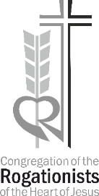

General Curia
Rogationists of the Heart of Jesus

