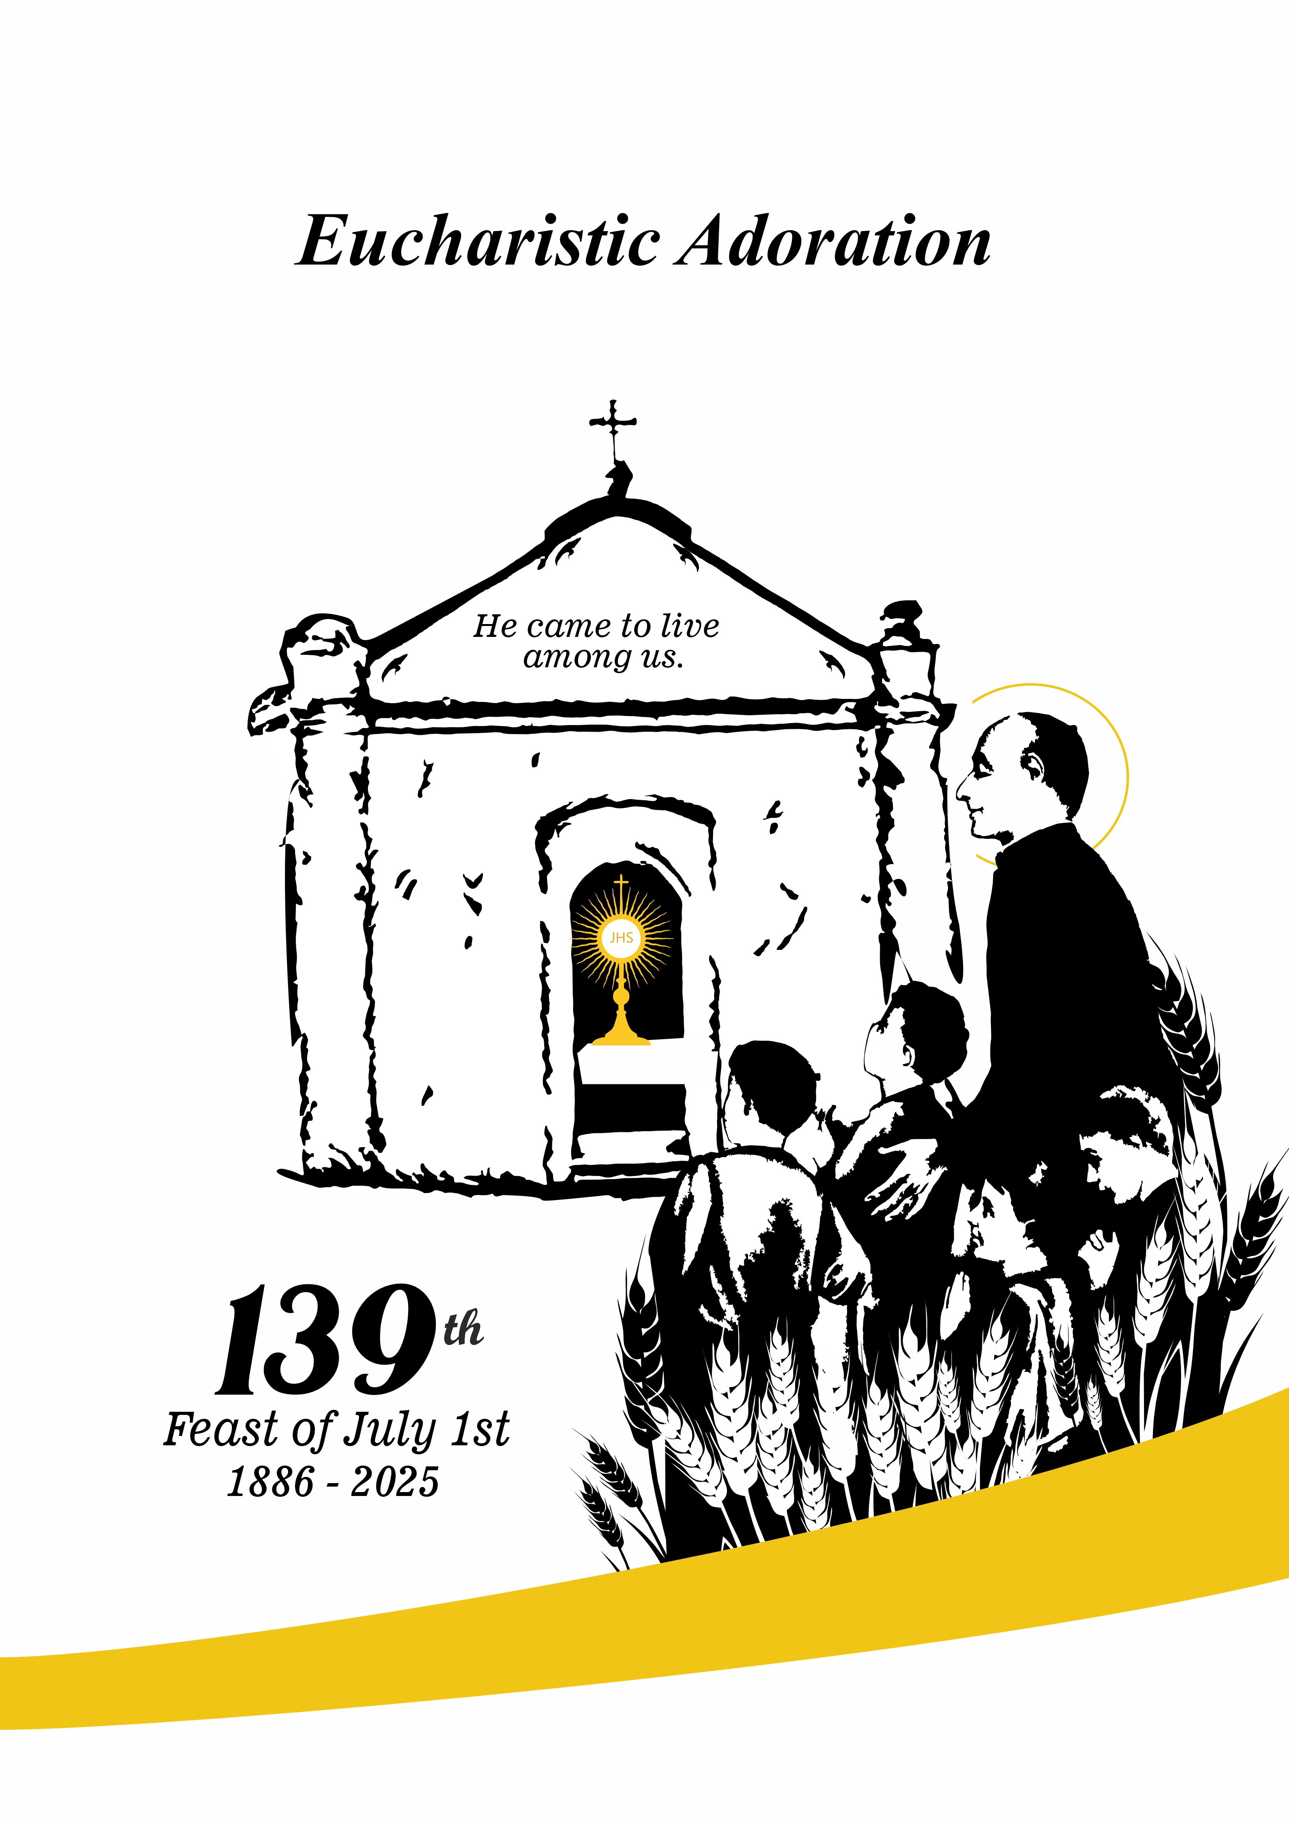

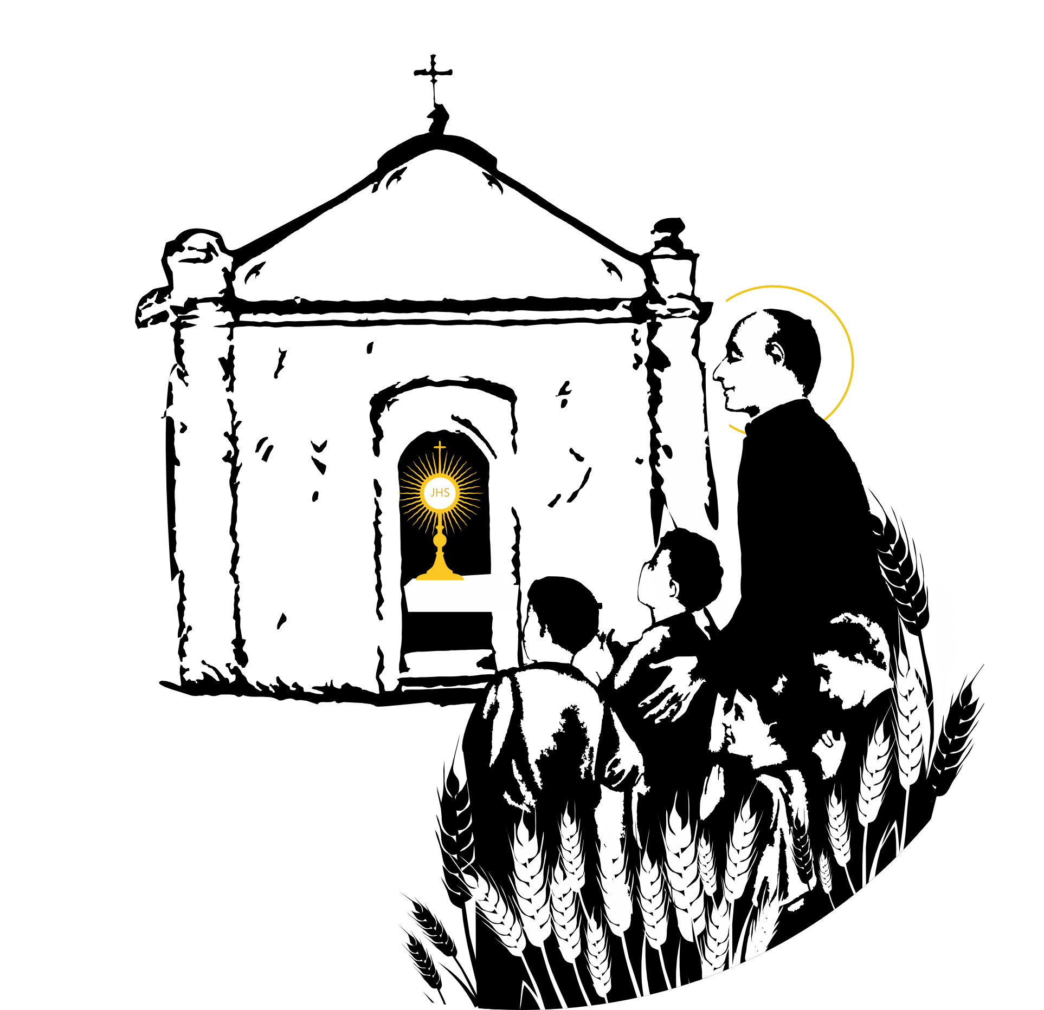
IN MEMORY OF HIS COMING.

Guide: In communion with the entire Family of the Rogate, which is present on five continents, we remember the coming of Jesus in the Blessed Sacrament to the Avignone District on July 1, 1886.
The Holy Founder, Hannibal Mary Di Francia, reminds us why it is important to commemorate this grace-filled event in his work.
"It is written," says Fr. Hannibal, "Opus tuum, Domine, in medio annorum vivificabis illud" (Ab 3:2, Vulg.). O Lord, thy work, in the midst of the years bring it to life.” And it is precisely on July 1, in the middle of each year, that this little work is, as I would say, brought to life! Ah, yes! This feast of July 1st enlivens our faith, lifts us up from all our discouragement, refreshes our courage, reopens our hearts to hope, strengthens us, and gives us new, vigorous life" (Di Francia, A., Writings, vol. 54, p. 59).

Song of Adoration (from "Heavens of Heaven, Open")

The beloved has come
The desired good.
The Most High has come!
Lord, King of kings,
to console our sorrows,
and comfort us in Himself.

O miserable earth!
You are not among your peers,
since you welcome a guest
who has descended from heaven.
The enemy host learns
to respect the Lamb.
Come adore him!
within that white veil.
Come and consume yourselves
in the most fervent love.
He descended from heaven
to inflame our hearts.

Most Beloved Love,
Jesus, divine lover,
Behold, languishing and fervent,
are the children of your heart.
Here we are before you,
Sacramental love.

Silent adoration.

Guide: After each invocation, repeat:
Refrain: We praise you and adore you.

- Eternal Priest
- Way, Truth, and Life.
- Great Master of the Mystical Harvest!
- Divine Founder!
- Prince of Peace.
- Good Shepherd
- Beloved of Hearts
- Tender and merciful friend of sinners
- Father and Comforter of Orphans and the Poor
- Jesus in the Blessed Sacrament
- Our Center of Love

JESUS IN THE BLESSED SACRAMENT,
OUR CENTER OF LOVE.

Guide: All graces, help, enlightenment, and divine providence have poured forth from His divine heart in the Blessed Sacrament. Father Hannibal experienced this firsthand. As a young man, he learned to have a profound encounter with Jesus through Eucharistic adoration. "In those early years, before he was ordained, he had his first inspiration to consecrate himself to prayer for priests during one of his intimate conversations with Jesus in the Blessed Sacrament in the Church of St. John of Malta. At the time, he was unaware of Jesus's Gospel command, 'Rogate,' to whose spread he would consecrate his life" (Tusino, La Messina del Padre n. 92 in Bollettino 1968, p. 405).

Reader: From the writings of St. Hannibal

"The whole loving, fruitful, dutiful, and continuous center of this Pious Work of the Heart of Jesus must be Jesus in the Eucharist. It must be known and believed now and forever that Jesus in the Blessed Sacrament is the true, effective, and immediate founder of this Pious Work. It seems that of this Pious Work, one can say: Novum fecit Dominus: God has done a new thing. In His works, God usually places a founder rich in His graces and gifts. But in this Pious Work, which raised the divine command of the zeal of His Heart to an institution after it had been forgotten for so many centuries, it can be said that Our Lord Himself, without an intermediation of a founder, showed Himself to be the true founder from the Holy Tabernacle. All graces, help, enlightenment, and divine providence poured forth from His divine Heart in the Blessed Sacrament. When this Pious Work began, it started in a miserable place among the poor. A few years after a priest set foot there, one of the small houses was rented, transformed into a church, and a small wooden altar was placed inside. Holy Mass was celebrated there for the first time. Thus, Jesus, the Supreme Good in the Blessed Sacrament, began to take possession of those places. In that poor field, he planted the seed of this new plant" (A.R., pp. 729–730).

Brief pause for silence.

Let us pray:

- We thank you, O most loving Jesus, for coming and dwelling among us.
- We praise you for loving us with a special love and calling us to follow you on the path of the Rogate.
- Increase our faith in your Eucharistic presence and make us true witnesses of your Gospel.
- Give us a constant hunger and thirst for you so that our desires may be directed toward what is true, noble, just, and good for the good of all.
- Make us like Mary, Eucharistic people capable of leading others to God and bringing God to others.
- Raise up men and women in the Church who are in love with you and who can transmit to new generations the centrality of the Eucharist in their lives.

Song:

JESUS IN THE BLESSED SACRAMENT
IS THE TRUE VINE THAT NOURISHES
THE BRANCHES.

Guide: "If you remain in me, and my words remain in you, ask whatever you wish, and it will be done for you" (Jn 15:7). This teaching presents us with the mystery of Jesus's mutual indwelling with his disciples and the disciples' indwelling with the Master. This presence of Jesus is made possible by the Eucharist.
Father Hannibal designated July 1st as a day of grace to commemorate the profound communion between us and Jesus. He writes, "On that day, the entire Pious Work was renewed in faith and love for Jesus in the Blessed Sacrament. It was completely restored in fervor and the liveliest spirit of devotion and piety." Jesus, exposed on the altars and surrounded by all the members of the Houses, seemed to say, ‘Behold, I am with you; Ecce vobiscum sum (Mt 28:20). You are mine, and I am yours. I am the vine; you are the branches. Ego sum vitis, vos palmites (Jn 15:5)." (Di Francia, A., Writings, vol. 54, p. 96).

Song: Alleluia!

Reader: From the Gospel of John (15:1-11):

I am the true vine, and my Father is the vine-grower. Every branch that does not bear fruit he cuts away; every branch that does bear fruit he prunes to make it bear more. You are already clean because of the word I have spoken to you. Remain in me, and I will remain in you. Just as a branch cannot bear fruit unless it remains on the vine, neither can you unless you remain in me. I am the vine; you are the branches. Anyone who remains in me, and I in them, bears much fruit because you can do nothing without me. Anyone who does not remain in me is like a branch that is thrown away and withers. Such branches are gathered up, thrown into the fire, and burned. If you remain in me, and my words remain in you, you may ask for anything, and it will be granted. This is how my Father is glorified—by your bearing much fruit and becoming my disciples.
As the Father has loved me, so have I loved you. Remain in my love. If you keep my commandments, you will remain in my love, just as I have kept my Father's commandments and remain in his love. I have told you these things so that you may have my joy and that your joy may be complete.

Song: Alleluia!

Pause for adoration.

Let us pray (Psalm 84).
Refrain: Show us your face, O God.

You once favored, Lord, your land,
restored the captives of Jacob.
You forgave the guilt of your people,
pardoned all their sins. (Refrain)

I will listen for what God, the Lord, has to say;
surely he will speak of peace
To his people and to his faithful.
May they not turn to foolishness! (Refrain)

Yes, the Lord will grant his bounty;
our land will yield its produce.
Justice will march before him,
and make a way for his footsteps. (Refrain)

JESUS IN THE SACRAMENT
OFFERS HIMSELF AS A FRIEND.

Guide: "You did not choose me, but I chose you and appointed you to go and bear fruit—fruit that will last" (Jn 15:16). What fruit must the disciples bear? Jesus is the fruit that remains forever (Jn 12:34). We can bear this fruit because we belong to him; we are part of his family. This is why Father Hannibal says, "He came as a most loving father among his children to form a small family that would live on his flesh and blood. This family would be made capable by his real presence in the Blessed Sacrament. They would receive the divine command of his heart's zeal from his divine lips: Rogate ergo Dominum messis, ut mittat operarios in messem suam (Mt 9:38). (Tusino, Memorie Biografiche, vol. 1, p. 570).

Song: Alleluia!

Reader: From the Gospel of John (15:12-17):

This is my commandment: love one another as I love you. No one has greater love than this, to lay down one’s life for one’s friends. You are my friends if you do what I command you. I no longer call you slaves, because a slave does not know what his master is doing. I have called you friends, because I have told you everything I have heard from my Father. It was not you who chose me, but I who chose you and appointed you to go and bear fruit that will remain, so that whatever you ask the Father in my name he may give you. This I command you: love one another.

Silent Adoration

Guide: Let us pray, repeating after each invocation:
Refrain: Keep us in your love, Lord Jesus.

- We believe that you are the Bread of Life. Refrain.

- You are the food given by the Father to satisfy our hunger. Refrain.

- You have been the food and the guide for the journey of your "little caravan" that set out from the Avignone district. Refrain.

- Continue to nourish us with your Word and your Body. So that we may proclaim and bear witness to your love in the world. Refrain.

- May your constant Eucharistic presence among us guide us on the path to holiness. Refrain.

- May the love we receive in the form of food transform us into bread broken for our brothers and sisters. Refrain.

IN THE EUCHARIST,
WE FIND THE HEART OF JESUS.

Guide: "In the Holy Eucharist, the Heart of Jesus is found." This idea comes from Father Hannibal's faith in the real presence of Jesus in the mystery of his body and blood. In the Eucharist, we contemplate the Heart of Jesus, who reveals himself to us through his word. Before the harvest is lost, he commands us to pray the Rogate.

Reader: From the writings of Saint Hannibal

It is comforting and tender to reflect that in the Holy Eucharist, we find the Heart of Jesus. The Heart of Jesus is here with all the affections of which it is capable, with all the eternal charity with which it burns, and with all the divine sentiments that inflame it.
The humble and meek Heart formed by the blood of the Immaculate Virgin Mary, the Heart that felt such pity for sinners, the Heart from which came the words of eternal life and the loving sayings that made such a deep impression on Mary Magdalene and the Samaritan woman. That noble, pious, beautiful, generous Heart, which bore no grudges, loved everyone, had compassion on everyone, and forgave everyone, was pierced on Calvary by a lance. It is found whole, true, and real in the Most Holy Eucharist."(January 1888).

Homily

Silence

Celebrant: Let us lift up our prayers to the Father, who desires to gather all of humanity at the Eucharistic banquet and form them into the people of the new covenant in Christ.

Let us say together: Stay with us, Lord.

• For the Church of God, that it may draw from the Eucharist the strength to follow its Master in the total gift of self.
• For priests, who are called to break the bread of the Word and the Eucharist, so that they may faithfully witness to God's love among people.
• For those called to a life of consecration, that they may be strengthened by the Eucharistic bread and follow Jesus on the path of holiness.
• For children, young people, orphans, and the poor, so that they may find educators and models among adults who can love them and accompany them in their human and Christian growth.
• For the family of the Rogate, that they may multiply exemplary witnesses such as the Venerable Mother M. Nazarena Majone, the Venerable Father Giuseppe Marrazzo, the Servants of God Father Pantaleone Palma and Father Joseph Aveni and the many others who transmitted their love for the Eucharist and the spiritual heritage received from Saint Hannibal.
• For Christian families, that they may proclaim the sacredness of unborn life, be environments in which vocations to the priesthood and consecrated life may flourish and be schools of education in the gift of self.

Celebrant: We thank you, O Father, for the constant presence of your Son among us in the Eucharist, the memorial of his death and resurrection. We accept this holy sign as a gift of your mercy that transforms us and gives us a new heart, the grace of reconciliation and communion. Through Christ our Lord.

Our Father

Eucharistic Blessing

Final Hymn

