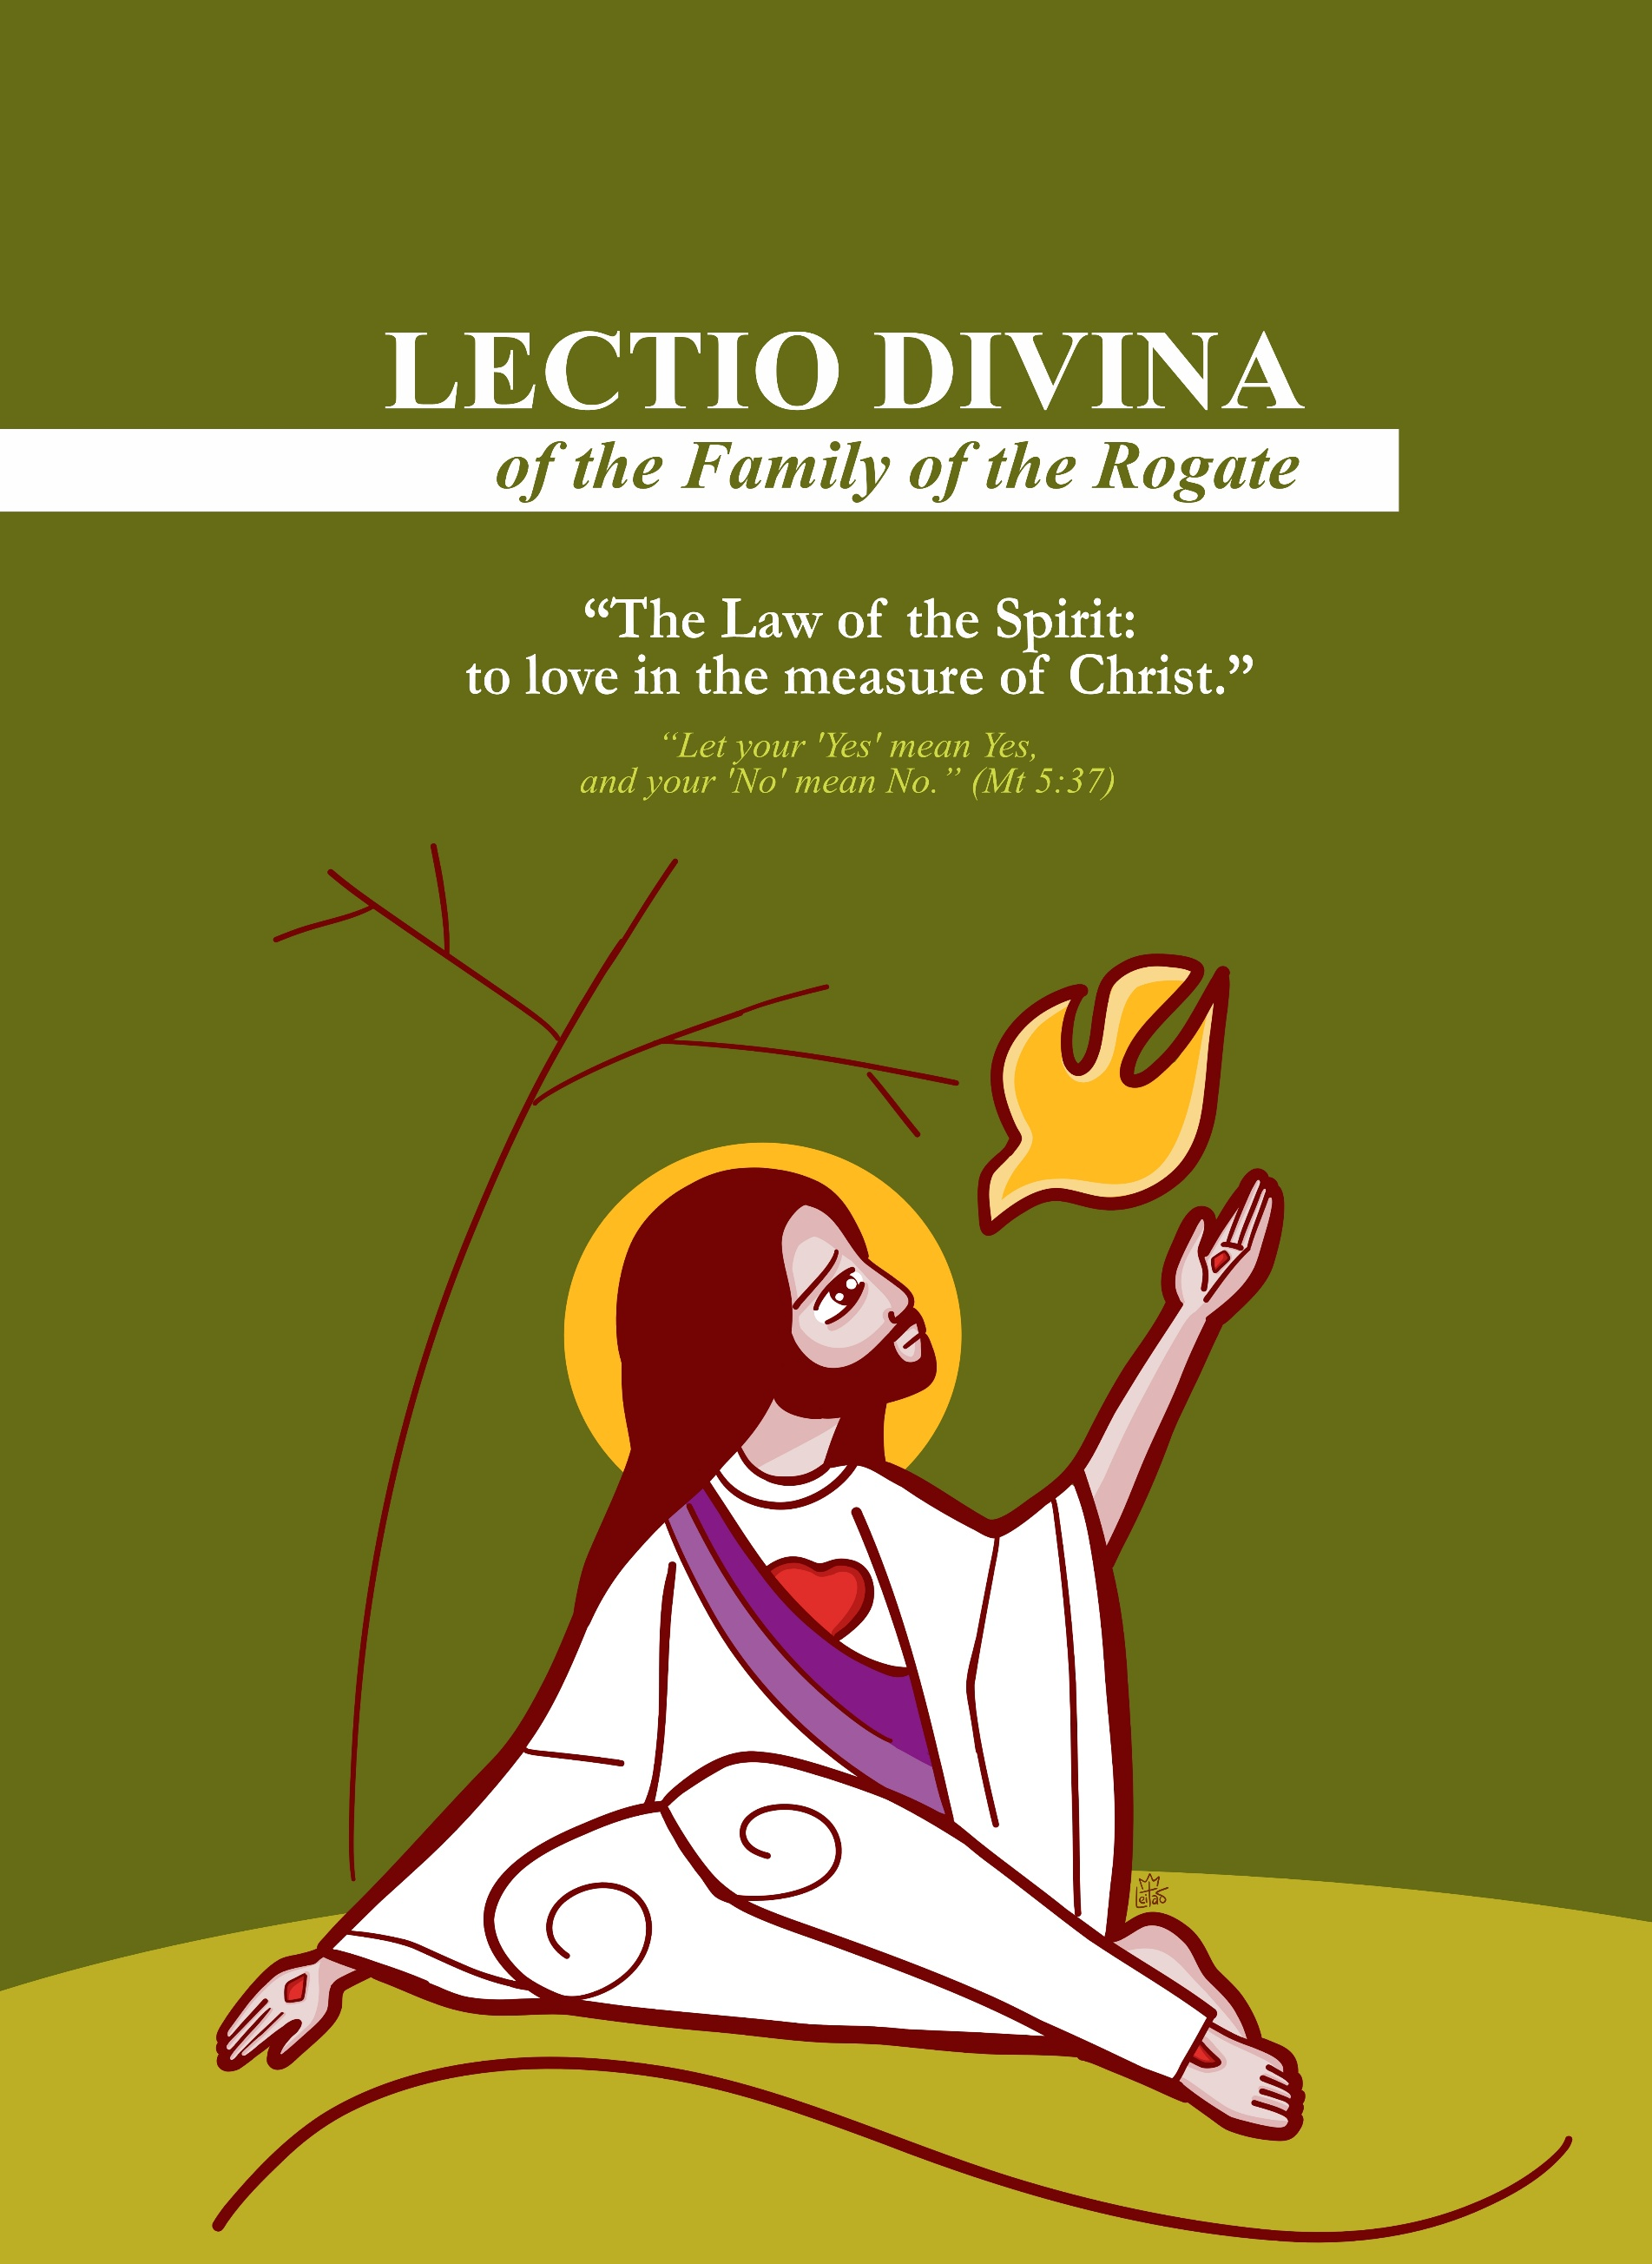

- HYMN (Invocation of the Holy Spirit)
- Reading: Mt 5:17–35 (preferably from one’s personal Bible)
  - Welcome the Word in silence
  - Re-read it personally
  - Share a word or phrase that strikes you
  - Connect this passage with other biblical texts
  - Prayerful refrain (of your choice)
- Understanding the meaning of the text

LEADER:
Dearest brothers and sisters, on this Sixth Sunday of the Ordinary Time, the Word invites us to enter into the very heart of Christian life: the Law of God fulfilled in Christ and impressed within us by the Holy Spirit. Jesus did not come to abolish the Law, but to bring it to its full completion, leading it to its deepest truth. This fulfilment is not a stricter legalism, but an interior transformation: the Law of Love, the Law of the Spirit. This liturgy places before us a decisive choice: life or death, good or evil. And it asks of us a concrete, total, and coherent response.
This is also a profoundly Rogationist Word: one cannot live the Rogate without living the Law of the Spirit, because asking for holy laborers means desiring and building a Church of true, reconciled, chaste, upright, and faithful hearts. This is the demanding and loving path of holiness embraced by Saint Hannibal Mary Di Francia: holiness as obedience to the Spirit and as total offering for the salvation of souls.

LEADER:
Today’s liturgy places before us a strong and radiant affirmation of Jesus: “I have not come to abolish the Law, but to fulfill it” (Mt 5:17). We understand, then, that we are called to obedience and to the accomplishment of the Lord’s Will. Jesus fulfills and surpasses the Law because He Himself is the fullness of what the Law foretold. The ancient Law is not despised: it is brought to completion, transfigured, and led to its Truth.

L1:
In the First Reading (Sir 15:16–21), the Lord places responsible freedom before the human person: “Before you are life and death, good and evil; whichever you choose shall be given you.” God does not command anyone to act wickedly, nor does He give permission to sin.
Here we are called to recognize that holiness is not a matter of fate, but of choice; not an accident, but a response.

L2:
Psalm 118(119) is the song of the soul that loves the will of God: “Blessed are those whose way is blameless…” and it prays: “Open my eyes that I may behold the wonders of your law.” Here the Law is path, light, orientation. The Word becomes nourishment, and the heart learns to desire what God desires.

L3:
In the Second Reading (1 Cor 2:6–10), Saint Paul speaks to us of a hidden wisdom: the wisdom of the Cross, which the world does not understand. The great saints—including our Father Founder—remind us that this wisdom is not accessible through the logic of power: it is revealed by the Spirit, who “scrutinizes the depths of God.” Without the Spirit, the human person does not understand Christ; with the Spirit, the new Law is born within us: the Law of love… the love expressed in the Word that brings Mercy to the world: ROGATE.

L4:
In the Gospel (Mt 5:17–37), Jesus teaches that Christian righteousness must surpass that of the Pharisees: it is not enough to avoid evil in outward actions; the heart must be purified.
For this reason He deepens three fundamental areas of human life:
- anger, which can kill already within the heart;
- impure desire, which makes one an adulterer interiorly;
- duplicity, which corrupts the truth of one’s “yes.”
In this way Jesus forms disciples with an undivided heart, capable of authentic and boundless love.

LEADER:
On this Sunday the Word converges toward a decisive center: the Law of Christ is the Spirit of Love, who does not allow us to live by appearances, but by truth. It is the Law that transforms the heart so that we may love as He has loved.

MEDITATIO – WHAT DOES THE WORD SAY TO US?

Exegetical, Pastoral, and Rogationist Foundation
LEADER: Jesus does not offer merely a series of commandments; He reveals a new life, a new way of existing before God. In Mt 5:17 He declares: “I have not come to abolish but to fulfill / bring to fullness.”
This means that Christ does not “reduce” the Law nor repeat it mechanically; He accomplishes it from within, as its fullness of meaning. In Christ, the Law becomes a path of the heart.
For this reason, the disciple’s righteousness must overflow (Mt 5:20). It is not a matter of multiplying rules, but of embracing the measure of the Gospel: a righteousness that exceeds because it is moved by the Spirit and configured to the Heart of Jesus.

L1:
When Jesus descends into the depths of the human person, He begins at the root: “Whoever is angry…” (Mt 5:22). Anger is not merely an impulse: it is a seed of death, a rupture of communion, a silent negation of the brother. This is why the Lord is so concrete: if you are presenting your offering at the altar and remember that your brother has something against you, go first and be reconciled (Mt 5:24). This imperative is a living Gospel: without reconciliation, worship loses its truth.
Here the Rogationist spirituality finds a profound foundation: how can we implore holy laborers without first welcoming the grace of becoming a reconciled people?
The harvest requires laborers with a pacified heart, for one cannot serve the Lord with divided hands and a wounded soul.

L2:
Next, the Lord touches the mystery of purity: “Whoever looks with desire…” (Mt 5:28). The Gospel goes beyond external action and reveals the battle of the heart. This is not the good and holy desire that God has placed in the creature, but the desire corrupted into interior possession, appropriation, domination. Christ asks for the purification of the gaze and interior freedom.
This directly illuminates the Rogate: the Lord calls laborers who belong to Him entirely.
Vocation is an undivided self-gift; this is why Saint Hannibal insisted so strongly on concrete holiness: the harvest needs hearts that are clear, free, and ready for total offering.

L3:
Finally, Jesus concludes this section with a decisive point: truth. The disciple must have a transparent word: “Let your ‘Yes’ mean Yes and your ‘No’ mean No” (Mt 5:37). This is not merely a moral norm: it is the demand for a unified life, without duplicity. The holy laborer is the one whose “yes” is not rhetorical but embodied; whose fidelity is not apparent but real.
Here lies the heart of vocational ministry: vocations are born where witness is true.
When the Church lives the Gospel with simplicity, clarity, and coherence, God’s call finds fertile soil. Thus, through the Law of the Spirit, the Rogate is fulfilled: we ask for holy laborers and, at the same time, allow ourselves to be formed into a Church that generates holiness — as Saint Hannibal Mary Di Francia dreamed and lived.

LEADER:
The Word is not only to be understood; it is to be welcomed to the very roots. Christ fulfills the Law by engraving it in the heart. He calls us to a righteousness that exceeds, to authentic reconciliation, to interior purity, and to a “yes” without shadows. From this lived Gospel holy laborers are born. For this reason, with Saint Hannibal, we renew the supplication: Pray the Lord of the harvest! May the Spirit form in us the holiness we ask for the whole Church.

The following questions may help guide a path of listening, discernment, and conversion:
“Before you are life and death” (Sir 15:17–18) – Freedom and calling
In which concrete choices do I perceive today that God places before me life and death, good and evil? What does it mean for me to live the Rogate as a life choice, as an option for the Kingdom?
“Open my eyes…” (Ps 118/119) – The Law as light and path
Do I love the Word as a guide for life, or do I still see it as a limitation? Which practices (prayer, interior discipline, daily fidelity) help me remain within the Law of the Lord?
“God has revealed them to us through the Spirit” (1 Cor 2:10) – Wisdom that transforms
Which wisdom guides my decisions: that of the world (appearance, prestige, advantage) or that of the Spirit (truth, service, love)? What resistances must I surrender so that the Spirit may engrave within me the Law of Love?
“Go first and be reconciled” (Mt 5:24) – Reconciliation and authentic worship
Is there someone with whom I must take a step toward reconciliation? In what way does the Rogate ask of me a reconciled heart so that my prayer and my mission may be fruitful?
“Let your ‘Yes’ mean Yes” (Mt 5:37) – Integrity and fidelity
Where does my life need to become more transparent, simple, and true? Does my witness inspire vocations or generate confusion? What conversion is the Lord asking of me so that I may be a clear sign of the Gospel?

SHARING THE WORD
LEADER: Let us share, with simplicity and truth, what the Spirit has helped us to understand.

ORATIO – WHAT DO WE SAY TO GOD?

Responding to the Word that Has visited us
LEADER: Let us pray together, as a people gathered under the Law of the Spirit, asking for the grace to love in the measure of Christ:
Lord Jesus Christ, fullness of the Law and fulfillment of the promises, engrave within us your Law of Love. Purify our hearts from anger that wounds, from desire that divides, from words that deceive, and make us men and women of a true “yes.” Pour out upon your Church the Holy Spirit, wisdom unknown to the world, strength that conquers sin, light that leads to holiness. And awaken within us the ardor of the Rogate: send, O Lord, holy apostles to your Church! Laborers filled with your Spirit—reconciled, pure, humble, and strong—so that your salvation may reach the ends of the earth. Amen.

CONTEMPLATIO – WHAT DOES THE WORD DO WITHIN US?

Silent adoration: welcoming the mystery
LEADER: Close your eyes and remain before the Lord. Not before a law written on stone, but immersed in the living Spirit who speaks to the heart. Contemplate Jesus on the mountain. He does not shout, He does not humiliate, He does not condemn: He enlightens. He reveals the interior. He calls to truth. Remain in silence. Let the Word descend.
Anger, desire, duplicity… everything comes before Him. And the Lord does not wish to crush you: He desires to free you through Mercy.
To contemplate the Law of the Spirit is to recognize that:
• God desires the whole heart;
• God desires simple truth;
• God desires charity without appearance;
• God desires a holiness born of love.
Allow the Spirit to engrave within you the new Law: to love as Christ has loved. And listen, in the silence, to the desire of the Heart of Jesus: “Pray… Pray… Pray…”

ACTIO – HOW DOES THE WORD MOVE US INTO LIFE?

The Word becomes action; the Gospel becomes choice
LEADER: The Word we have heard does not ask to remain only meditated, but to become life. Whatever the Spirit has caused to be born in our hearts today—a desire, a calling, a consolation, or even restlessness—is a gift to welcome and guard in daily life.
Let us leave this Lectio with a concrete commitment: to allow the Word to orient our choices, illuminate our relationships, and transform the simple gestures of each day. Great works are not required, but a willing heart, capable of listening, trusting, and loving.
Let us entrust to the Lord what we have received and ask for the grace to be credible witnesses of the Gospel.

CONCLUSION OF THE LECTIO DIVINA
LEADER: Today the Lord has shown us that the Christian Law is the Spirit of Love. We do not live by appearances, but by truth; not by mere norms, but by a transformed heart. May Saint Hannibal accompany us this week: he understood that only the saints will save the world, and that the Rogate is the way for the Church to receive laborers according to the Heart of Christ.

FINAL PRAYER
LEADER: Lord our God, we bless you because in Jesus Christ you have brought the Law and the Prophets to fulfillment and have given us the Holy Spirit, the living Law of Love.
1st CHOIR: We thank you, Father, because you have not left us prisoners of appearance, but have called us to the truth of the heart. Make us upright, reconciled, and pure, so that our righteousness may be greater—born of love.
2nd CHOIR: We thank you for the gift of Saint Hannibal Mary Di Francia, who welcomed the Law of the Spirit and made of his life an offering for the salvation of souls. Grant us his zeal, his compassion, and his fidelity, that we may live the Gospel without measure.
ALL: And, moved by the Holy Spirit, we raise to you the cry of the Rogate: “Send, O Lord, holy apostles to your Church!” Stir up holy and generous vocations, sanctify those who have already responded, and make us living witnesses of the Gospel. May the Church be light for the nations and a sign of reconciliation and peace in the world. Through Christ our Lord. Amen.

----------------------------------------------------------------------------------------
Production: Rogate Sector - RCJ | FDZ
Text: Province of Our Lady of Rogate – FDZ, Brazil
Center for Studies, Spirituality, and Communication — February 2026
Design and layout: Fr. Reinaldo de Sousa Leitão, rcj
Translation and revision: Fr. Kristian Irvin Taok, rcj

