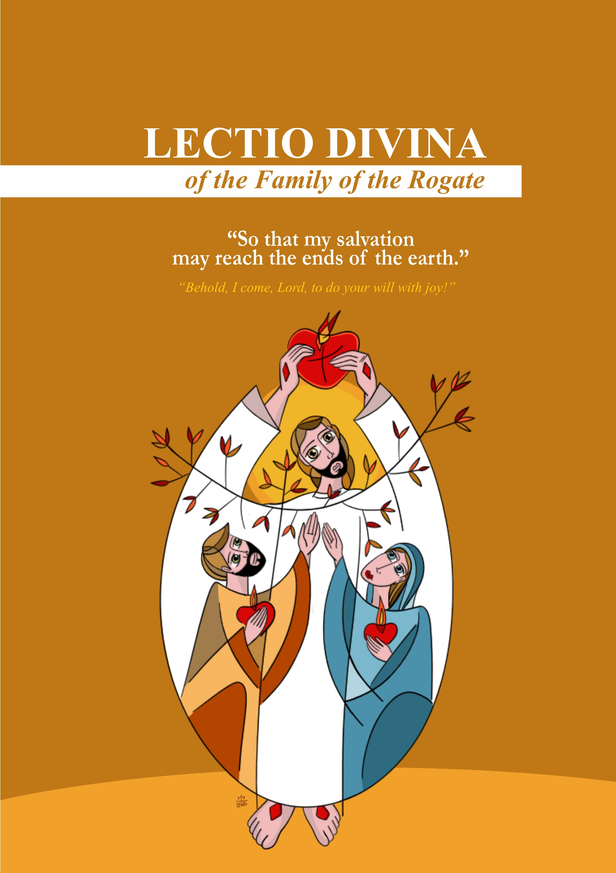

(The biblical text and meditation may be read individually in advance.)

I. LECTIO – WHAT DOES THE TEXT SAY?
(Listening to the Word in its literal and historical-salvific sense.)
Leader: The liturgy of this Sunday leads us toward a decisive step in the revelation of Jesus: He who was born in Bethlehem and manifested at the Jordan is now revealed as the Lamb who takes away the sin of the world. Through Him, the Word of God unveils a great design: God desires to save all peoples and reunite a scattered humanity.
Reader 1: In this Lectio Divina, let us be guided by the Word to recognize Jesus as the Servant-Lamb. Let us welcome the Spirit that remains upon Him and renew our commitment to pray, live, and work so that holy apostles may never be lacking in the Church.
- Hymn (Invocation to the Holy Spirit)
- Reading: John 1, 29-34 (Preferably from the Bible)
  - a. Welcome the Word in silence;
  - b. Personal re-reading;
  - c. Share a word or phrase that strikes you;
  - d. Link this text to other passages in the Bible;
  - e. Chanted Refrain (optional).
Understanding the Meaning of the Text
Leader: Today’s liturgy is profoundly missionary. The Father reveals that His project is not limited to Israel: "I will make you a light to the nations." The heart of God is universal. This touches the very core of the Rogate: if salvation is to reach the ends of the earth, it is because God desires laborers to carry this light, to point to the Lamb, and to announce the Kingdom.
Reader 2: In the first Reading (Is 49:3, 5-6), the Servant of the Lord appears as one chosen from the womb for a mission that transcends all borders. Restoring Israel is not enough; God wants His light to reach the nations and His salvation to reach the ends of the earth.
Reader 3: The Responsorial Psalm teaches us that this mission becomes fruitful only when we place ourselves totally under the Lord's guidance. To live according to His will—setting aside our interests to embrace the designs of the Heart of Christ—is the sure way for the Kingdom of God to manifest among us. When we invoke the Spirit, we are shaped into the image of the Master, becoming laborers whose lives are offered for the glory of God and the salvation of humanity.
Reader 4: In the second Reading (1 Cor 1:1-3), St. Paul addresses the community of Corinth as a people "sanctified in Christ Jesus and called to be holy." The Christian community exists because it has been summoned by God. In this light, we understand our Rogationist vocation: we are called to witness to a holiness that arises from Baptism and is expressed as a gift to the Kingdom. This call requires laborers who can say "yes" and inspire others to follow the Lord.
Reader 5: In the Gospel (Jn 1:29-34), John the Baptist identifies Jesus as the Lamb of God and testifies that the Spirit descended and remained upon Him. Jesus is revealed as the Son of God and the one who baptizes in the Holy Spirit.

II. MEDITATIO – WHAT DOES THE WORD SAY TO US?
(Exegetical, pastoral, and Rogationist foundation.)
Leader: On this second Sunday of Ordinary Time, the Church remains on the banks of the Jordan. The Word reminds us that Jesus’ Baptism was the revelation of His path: the path of the Servant of Isaiah—humble, silent, and obedient. The Messiah does not impose Himself through force but through mercy that does not give up and love that becomes service.
Reader 1: When John proclaims, "Behold the Lamb of God," he reveals that this Servant carries the weight of the world's sin. Jesus is the Passover Lamb whose blood seals the Covenant. He does not flee from pain but transforms it into redemption.
Reader 2: This Lamb is also the Servant destined to be a light for all. In His offered and glorified Body, God creates a new people: the Church. This community, anointed by the Spirit, is called to witness to reconciliation. Thus, the Servant-Lamb continues His work today through those He calls, sends, and consecrates to the mission.
Reader 3: John the Baptist recognizes that Jesus is the Son of God upon whom the Spirit remains. To follow the Servant-Lamb means entering a path of total self-giving and trustful obedience until all humanity is led to the light of the Father.

SHARING THE WORD
Leader: Let us share with humility the insights given to us:
- "I will make you a light to the nations" – Does the charism of the Rogate broaden my horizons of prayer and service, or am I still preoccupied only with my own needs?
- "Called to be holy" – How does the Rogate help me see that my personal holiness is linked to the mission of the Church and prayer for vocations?
- "Behold the Lamb of God" – How am I called to purify my images of power and success in my service to the Church?
- "The Spirit remained upon Him" – Do I act on my own strength, or do I let myself be guided by the Holy Spirit?

III. ORATIO – WHAT DO WE SAY TO GOD?
(Responding to the Word.)
Side A: Lord Jesus Christ, Lamb of God and faithful Servant of the Father, we adore You as the Light of the nations and Savior of the world.
Side B: You, upon whom the Spirit descended and remained, draw our hearts to the path of obedience, so that we may say with our whole lives: "Behold, I come, Lord, to do your will with joy."
Side A: Deliver us from self-seeking and make us docile instruments of Your Kingdom. May Your Spirit lead us to live as a sanctified people, committed to the mission of salvation.
Side B: Awaken in Your Church the fervor of the Rogate: raise up priests after Your own Heart, consecrated men and women totally given to You, and laity committed to the Gospel, so that laborers for Your harvest may never be lacking.
ALL: To You, the sacrificed and glorified Lamb, be honor, praise, and love now and for all eternity. Amen.

IV. CONTEMPLATIO – WHAT DOES THE WORD DO IN US?
(Silent adoration; welcoming the mystery.)
Leader: Let us contemplate Jesus, the gentle Lamb and beloved Son. In His silence, we recognize the obedience of the Servant and the eternal love of the Father. Let the Spirit form us into disciples. In silence, welcome the call to be sent as laborers into the harvest.

V. ACTIO – HOW DOES THE WORD MOVE US TO ACTION?
(The Word becomes action.)
- Live under the guidance of the Spirit: Pray daily to the Holy Spirit and seek His light before making decisions.
- Feed the fervor of the Rogate: Pray daily for vocations and support priests and consecrated persons through the offering of your life.
- Be a sign of the Lamb in the world: Practice gentleness, service, and reconciliation. Support those who are discouraged.
- Awaken vocations through witness: Listen attentively to those seeking their path and speak of the beauty of serving God.

CONCLUSION
Leader: The Lamb continues to pass among His people. Blessed are those who recognize Him, follow Him, and become laborers of the harvest.

FINAL PRAYER
All: Holy Father, we bless You for Jesus, the faithful Servant and the Lamb who takes away the sin of the world. Moved by the Spirit, we raise the cry of the Rogate: Lord, send holy apostles to Your Church. Make us living witnesses of the Lamb, so that Your salvation may reach the ends of the earth. Amen.

Production: Rogate Sector - RCJ | FDZ
Text: Province of Our Lady of Rogate – FDZ, Brazil
Center for Studies, Spirituality, and Communication — January 2026
Design and layout: Fr. Reinaldo de Sousa Leitão, rcj
Translation and revision: Fr. José Maria Ezpeleta, rcj
