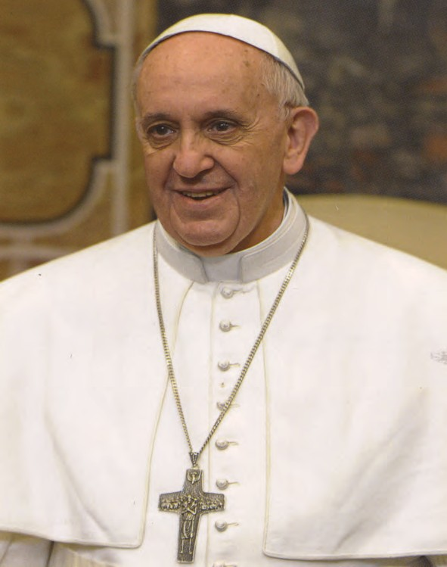

PHOTO CHRONICLE
OF THE 13th GENERAL CHAPTER
July 2022
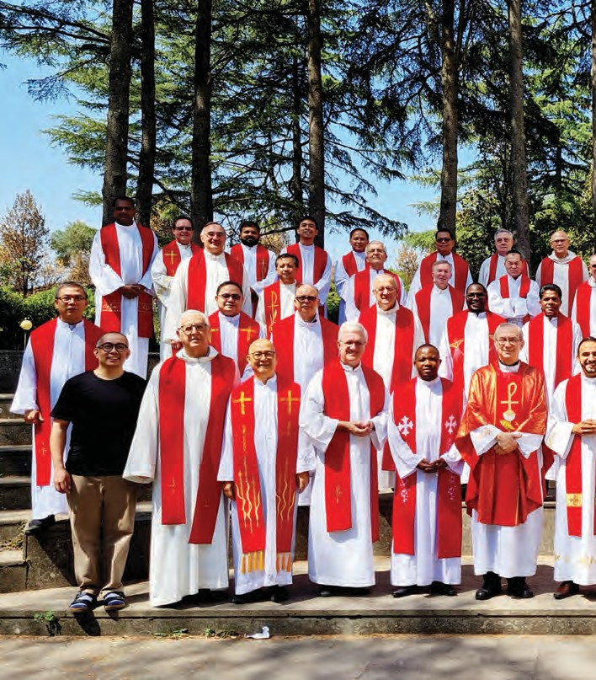

Group photo of the members of the Chapter
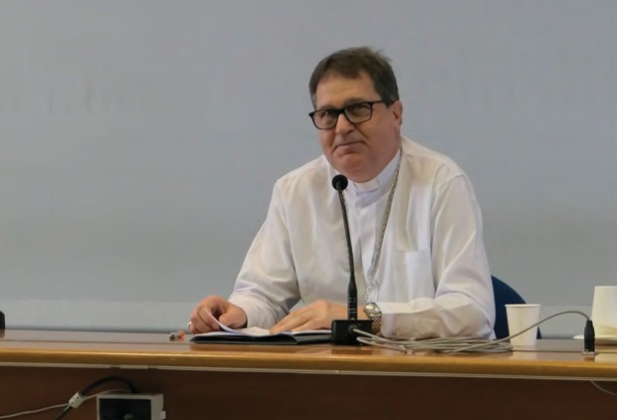
Keynote Address by Msgr. Angelo A. Mezzari RCJ, Auxiliary Bishop of Sao Paulo (Brazil)

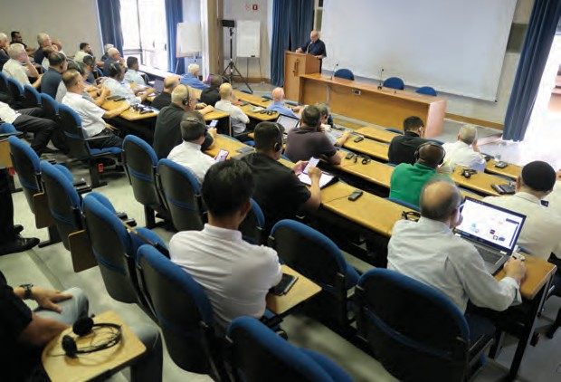
Chapter Assembly

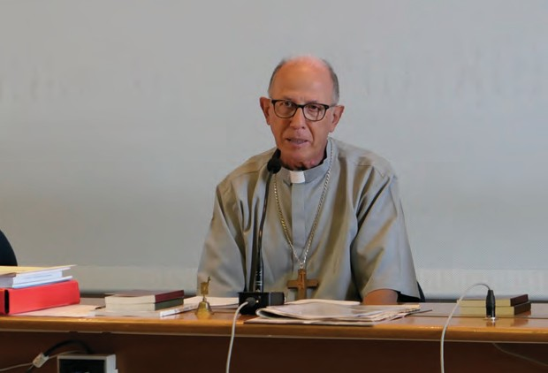
Address by Msgr. Ottavio Vitale RCJ, Bishop of Lezhë (Albania)

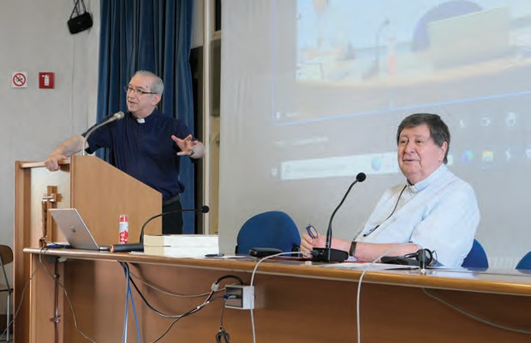
Address by Card. João Braz De Aviz, Prefect of the Congregation for Institutes of Consecrated Life and Societies of Apostolic Life

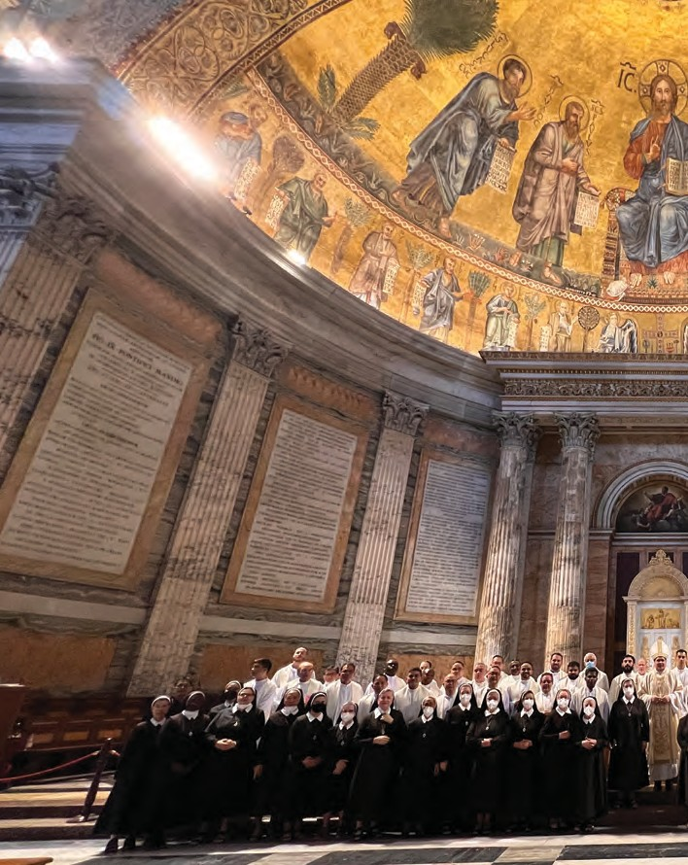
Holy Mass with the Daughters of Divine Zeal presided over by Bishop Angelo A. Mezzari, in the Basilica of St. Paul Outside the Walls

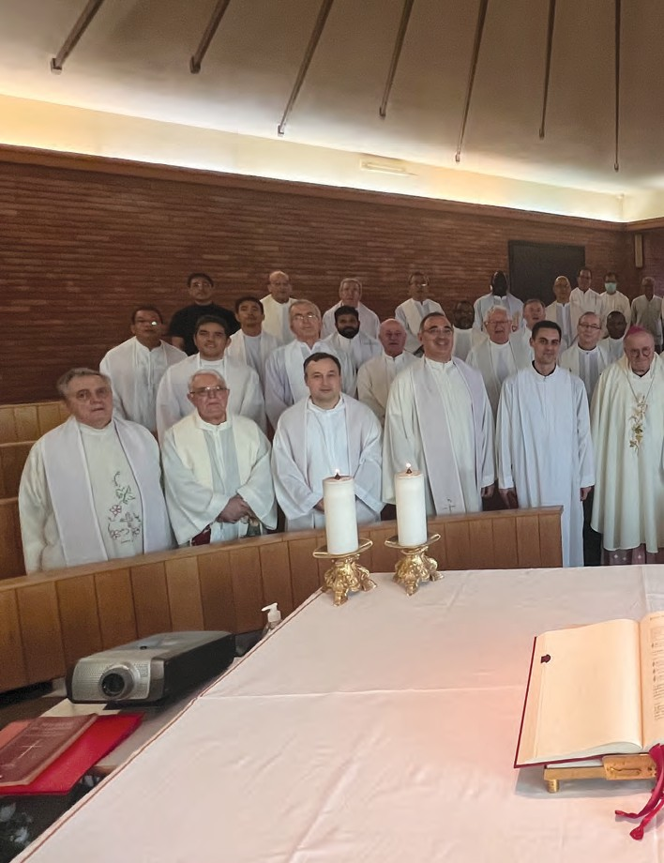
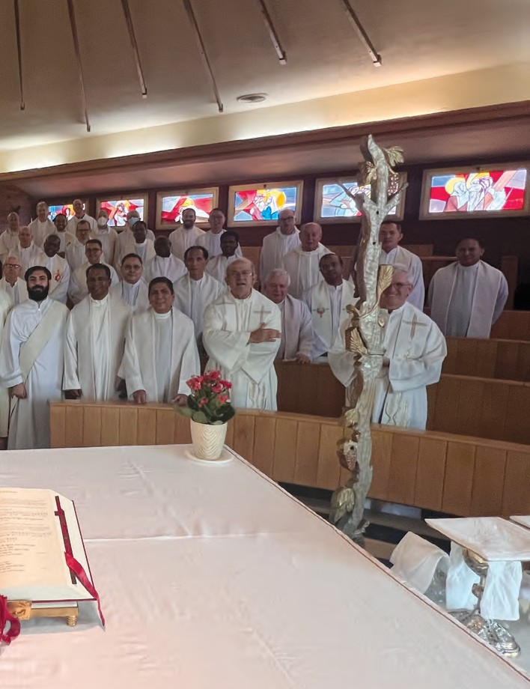
Holy Mass with Msgr. Romano Rossi, Bishop of Civita Castellana
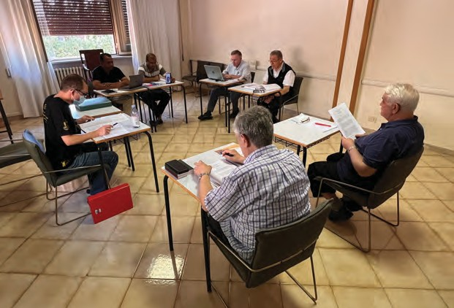
First Commission - The first three parts of the Instrumental laboris

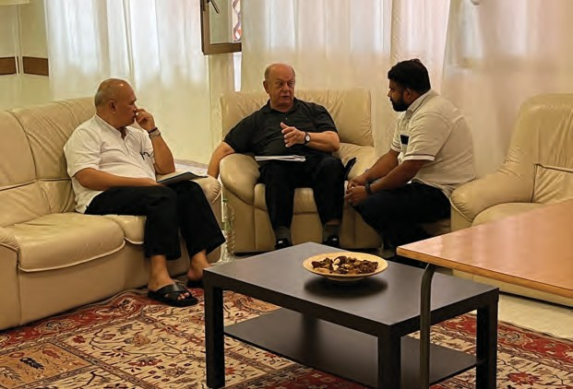
Second Commission - Religious Life, Formation, and Vocation Ministry

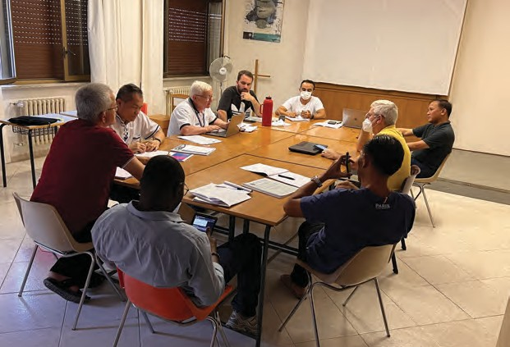
Third Commission - Rogate, Parish, Laity, and Youth Ministry; Charity and Mission

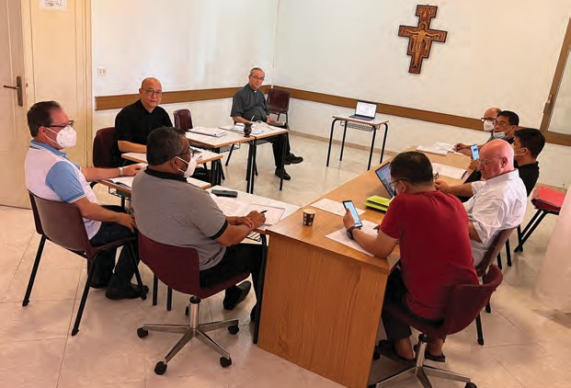
Fourth Commission - Administration of Goods and Part four of the Instrumentum laboris

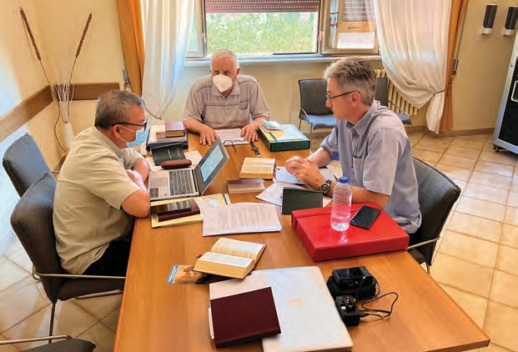
Fifth Commission - Updating of the Norms

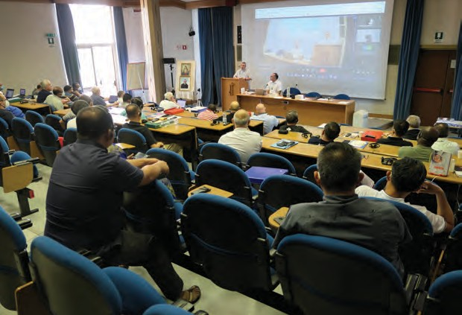
Meeting with Fr. Savino Castiglione of the Little Mission of the Deaf-Mutes.

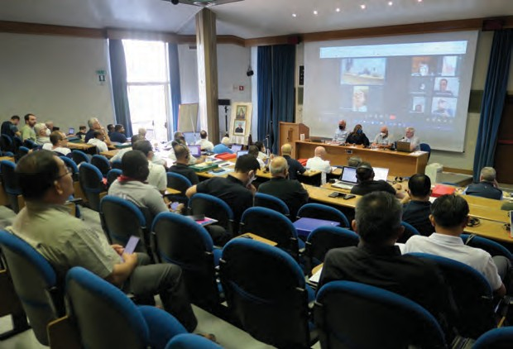
Meeting with representatives of the Laity of the Union of Rogationist Associations (UAR)

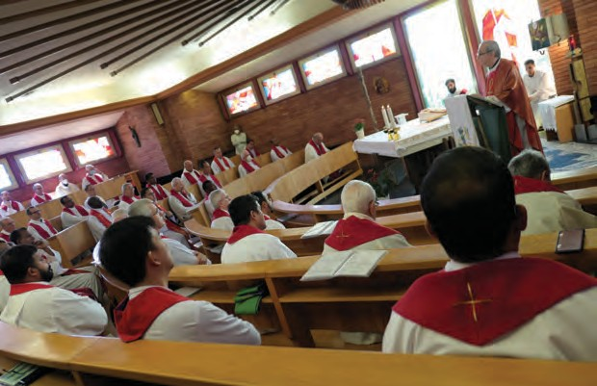
Concluding Holy Mass of the 13th General Chapter, presided over by the Superior General, Fr. Bruno Rampazzo RCJ

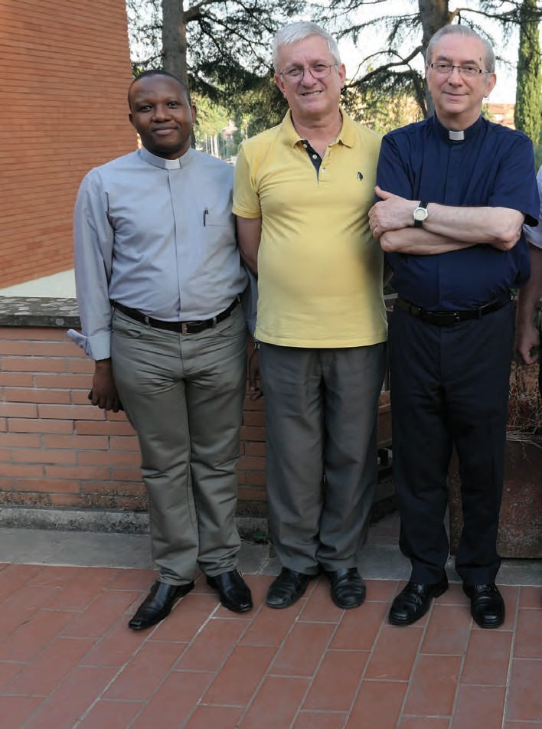
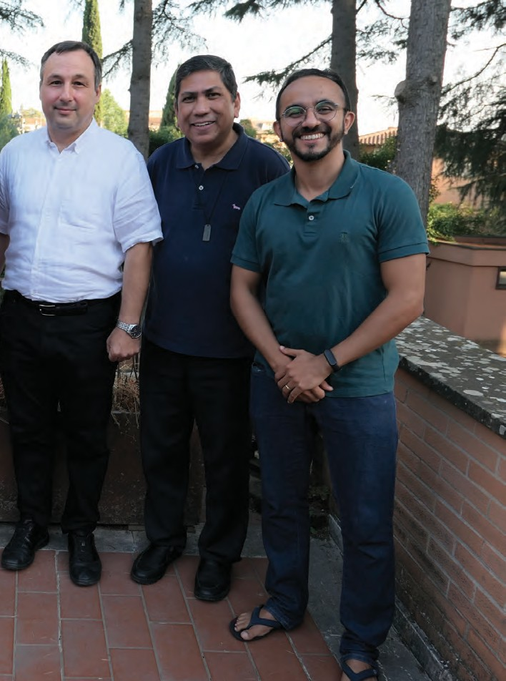
The new General Government

