ROGATIONISTS OF THE HEART OF JESUS
St. Matthew Province
24 Calcutta St., Merville Park
1709 Parañaque City
Philippines
Telephone #: +63 (2) 776 03 92 / 824 91 95

Parañaque City, October 6, 2018

Prot. n.: 141/18
Re: Request for Prayers for the Success of the
2nd St. Matthew Provincial Chapter

To: FR. BRUNO RAMPAZZO, RCJ
Superior General
Curia Generalizia dei Rogazionisti
Via Tuscolana 167
00182 – Roma
Italia

CC: ALL ROGATIONIST CIRCUMSCRIPTIONS,
COMMUNITIES and CONFRERES

Dearest,
Greetings of Peace!

The Rogationists of the Heart of Jesus of the St. Matthew Province – comprising the Philippines, Papua New Guinea, Australia, Indonesia, South Korea and Vietnam, is set to hold its 2nd St. Matthew Province, on October 15-20, 2018 at the Oasis of Prayer in Lalaan II, Silang, Cavite.

This occasion shall be highlighted by the election of our new Provincial Superior and his Council, and shall be concluded by the Priestly Ordination of seven (7) Deacons.

I am, therefore, humbly requesting for your prayers for the success of this event, and that the Rogationists be of authentic witness in the Church of the specific mission the Lord of the Harvest has entrusted them to accomplish.

God bless us all!

Sincerely yours,
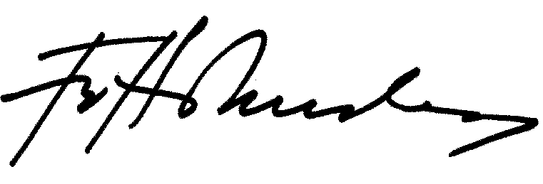

Fr. Herman Abcede, RCJ
Provincial Superior
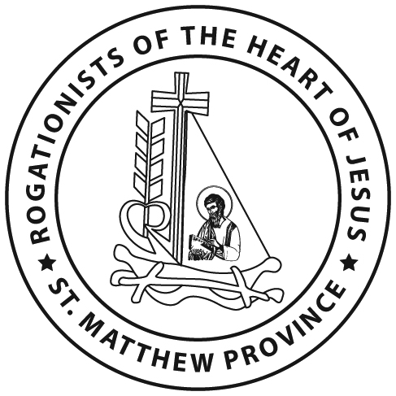

Bro. Christian Allan R. De Sagun, RCJ
Provincial Secretary

