ROGATIONISTS OF THE HEART OF JESUS
St. Matthew Province
24 Calcutta St., Merville Park
1709 Parañaque City
Philippines
Telephone #: +63 (2) 766 03 92 / 824 91 95

Parañaque City, October 6, 2018

Prot. n.: 142/18
Re: Request for Prayers for the Success of the
2nd St. Matthew Provincial Chapter

To: PROVINCIAL CAPITULARS and
ALL CONFRERES OF THE ST. MATTHEW PROVINCE

THEIR HOUSES

Dearest,

Greetings of Peace!

Nine (9) days before the celebration of the 2nd St. Matthew Province at the Oasis of Prayer in Lalaan II, Silang, Cavite, on October 15-20, 2018, I would like to humbly invite every community and each one to intensify your prayer that the will of the Lord of the Harvest be done in this historic affair, and that we, the Rogationists of the St. Matthew Province, be of authentic witnesses in the Church of the specific mission He has entrusted us to accomplish.

God bless us all!

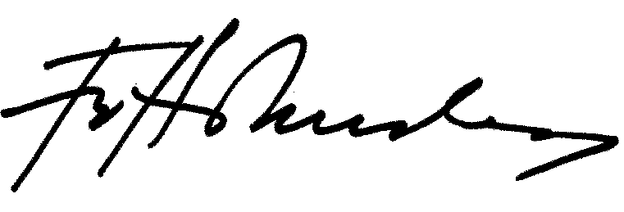
Sincerely yours,

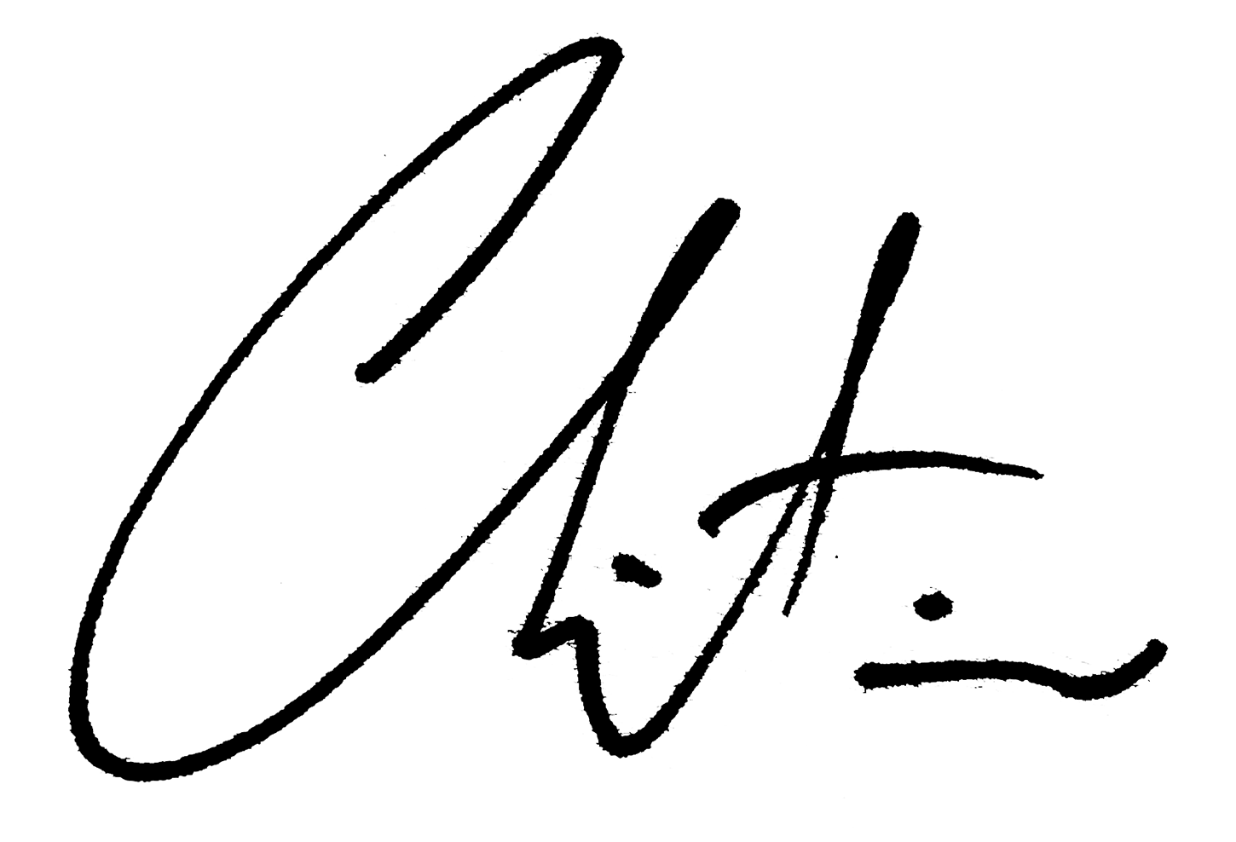
Fr. Herman Abcede, RCJ
Provincial Superior
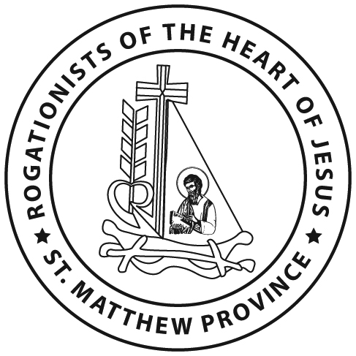

Bro. Christian Allan R. De Sagun, RCJ
Provincial Secretary

Prayer for the 2nd St. Matthew Provincial Chapter

O loving Father,
who care for your people with gentleness
and rule them in love,
endow us,
members of the St. Matthew Province,
with the Spirit of wisdom,
so that through the Rogate,
your people may be led to know the truth more fully
and grow in holiness by becoming good laborers in your harvest.
May our 2nd Provincial Chapter
become a symbol of unity among us
in realizing our vocation and mission
in serving the Rogate.
AMEN

