Fr. Bruno Rampazzo RCJ

The Inspiration of the Rogate
in Its 150th Anniversary

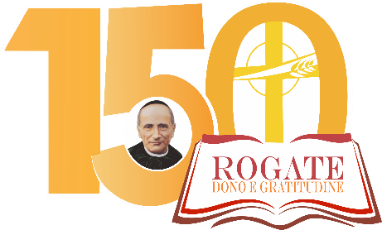

Circular Letter to the Family of the Rogate

Rome 2020

Original Title: L’ispirazione del Rogate nel suo 150º anniversario. Lettera Circolare alla
Famiglia del Rogate, Roma, 2020.
Translation: Fr. Jose Maria Ezpeleta RCJ

Authorization to Print:
Fr. Bruno Rampazzo RCJ,
Superior General of the Rogationists of the Heart of Jesus

© Rogationists of the Heart of Jesus
Commission for Translations, Rome, June 1, 2020.

Jesus went about all the cities and villages,
teaching in their synagogues,
preaching the gospel of the Kingdom,
and healing every disease and every infirmity.
When he saw the crowds, he had compassion for them,
because they were harassed and helpless,
like sheep without a shepherd.
Then he said to his disciples,
“The harvest is plentiful, but the laborers are few;
pray, therefore, to the Lord of the harvest
to send out laborers into his harvest!”
(Mt. 9: 35-38, RSV)

To the Family of the Rogate: Rogationists, Daughters of Divine Zeal, Missionaries of the Rogate, Lay Associates, collaborators and benefactors, devotees of Saint Hannibal Mary Di Francia.

Introduction

1. In his well-known self-eulogy, Father Hannibal could not help but confess that the Rogate was the passion of his life: “For the Rogate, we say nothing: he dedicated himself to it, either out of zeal or by fixation, or both.”
He discovered the Rogate as a teenager and, over the years, he progressively confirmed that his existence was marked by this resource idea.
When he became aware of having received the mission to be the Apostle of the Rogate, he handed the Rogate to his spiritual daughters and sons as the charism that the Spirit gave to the Church through the Institutions that he gave rise to.
After the year in which we commemorated the 150th anniversary of the Inspiration of the Rogate, we still feel the need to examine together our charism, the precious pearl that, in our poverty, has been handed to us, in order to find more light and strength to understand and welcome it.

2. We have a vast literature on Rogate and if we continue to talk about it, we do so both in an attempt to discover new aspects and, simply, to meditate again on this precious heritage that has been handed on to us and wish to keep alive, in its potentials, to respond to the signs of the times.
Initially, we will look at the blossoming of the Rogate in the mind and heart of the adolescent or young Hannibal; we will remember how the Rogate was sown and found lifeblood to grow in the soil of poverty; we will reflect on the charism of the Rogate in the various aspects of its identity: the prayer for good workers, its dissemination, and living as good workers; we will then see how the Rogate was transmitted to the episcopate, the clergy, and the people of God; then, we will dwell on the handing on of the Rogate to the Daughters of Divine Zeal and to us Rogationists with the canonical approval of our Constitutions.
At this point, we will try to grasp the vision that Father Hannibal had of the Rogate, as an extraordinary means for salvation.
We will then move on to retrace the main paths taken in living and spreading the Rogate and we will ask ourselves about our fidelity to this mission that was given to us by Father Hannibal.
Finally, we will reflect on how the charism of the Rogate, a gift of the Spirit in our times, demands of us today to live and spread it more and more in the Church for the salvation of the world, as a new way of holiness.

1. THE INSPIRATION

1.1. Becoming an Apostle and Propagator of the Rogate
3. Hannibal's infancy and childhood were marked by suffering which, nonetheless, favored in him the development of remarkable sensitivity. The faith that prevailed in his family became a valid support to face the test brought about by the death of his father. The experience at the San Nicolò boarding school, while on the one hand was another cause of suffering for Hannibal, on the other hand, it allowed him to grow in a protected environment and in a religious context.
Following the Italian Parliament’s Law of the Suppression Religious Orders of July 7, 1866, even the San Nicolò boarding school of the Cistercians was closed, and Hannibal, fifteen years of age, and his younger brother Francesco, returned to the family.
We learn from Father Vitale and Father Tusino that the teenager Hannibal continued his studies under the supervision of well-qualified private teachers. Among other things, he cultivated poetry, guided by the poet Felice Bisazza. He demonstrated a thirst for knowledge and loved reading, especially on spiritual matters and the lives of the Saints. He usually visited the Churches of Messina, where the Blessed Sacrament was exposed for the Quarantore devotion. In particular, he gladly went to the convent of the Most Holy Mary Fathers in Porto Salvo, where he could find peace and engage in spiritual conversations that he needed.

4. The Inspiration of the Rogate took place sometime between 1866 and 1869.
The Positio places it in 1868. In the Chronology we read:
“1868 - At the age of 17, he obtains permission from his confessor to receive the Eucharist daily. In the same period, while praying before the Most Blessed Sacrament exposed in the form of Quarantore in the Church of San Giovanni di Malta in Messina, he intuits the need to pray for vocations. He has what can be called the “understanding [= intelligenza]* of the Rogate”. Sometime later, he discovers in the Gospel the command of Jesus: “Rogate ergo Dominum messis ut mittat operarios in messem Suam (Mt 9:38 and Lk 10:2).”

5. The statement of the Positio rests on the testimony of Father Vitale,
“In the fervor of his prayers, and perhaps even before wearing the habit, staying at the foot of Jesus in the Blessed Sacrament, he was reflecting (certainly not without divine inspiration) that one of the most important graces he could ask continuously from the Lord for the salvation of souls is undoubtedly that of sending Holy Priests into His Church. He sought in the books of devotion such a prayer but could not find any that expressed his sentiments. From then on, he always carried in his thoughts the need for such prayer. When he later saw it in the Holy Gospel commanded by Our Lord with those words: ‘Rogate ergo Dominum messis ut mittat Operarios in messem suam,’ he felt it as an inner voice addressed to him, to make of him its apostle and propagator.”

6. In turn, Father Vitale relies on the direct testimony of Father Hannibal who, in the Preface to the Precious Adhesions, explains to the Sacred Allies the beginnings of his mission for the Rogate. Speaking of himself in the third person, Father Hannibal reports of having paid attention to the divine command of Jesus to pray for good workers, long before he made the choice for the priesthood. There are two different Prefaces to the publication of the Precious Adhesions and both contained the said statement:
“And behold, a beautiful idea, which we would call resource-idea, suddenly flashed in the mind of the Priest-starter. This idea was herself the daughter of a great Word of the Gospel, a child of an even greater, more sublime idea, which the Spirit, who blows wherever he wishes, seems to have inspired him from the very beginning of a spiritual youth, many years before the Pious Work began.”
“There was, therefore, a man who paid attention to this divine command, even before he had read it in the Gospel; and he began his career in life with this attention.”

7. Father Tusino distances himself somewhat from Father Vitale's testimony regarding the Inspiration of the Rogate, both as to the manner (due to the fact that Father Vitale speaks of two distinct moments, before and after the discovery of the Gospel pericope) and as to the time. He reveals that he learned confidentially from Father Hannibal that his priestly vocation was “sudden, irresistible and very sure” and concludes that the young Hannibal made the choice of the priestly vocation a few months before December 1869 and had the Inspiration of the Rogate before that but in the same year.

8. We can consider Father Vitale's testimony valid and reliable, based also on Father Hannibal's statements. It is understandable that the young Hannibal, who loved to stop by for adoration before the Blessed Sacrament, had known some priestly figures who had played an almost paternal role toward him. Thus, he understood the importance of priests and felt the need to ask them from the Lord. It is comprehensible that when he read in the Gospel that Jesus commanded to pray for the workers of the Kingdom, moved by the Spirit, he felt that he was called to become this prayer’s apostle and propagator.

9. We must take note of a text written by the Deacon Hannibal, which refers to his choice regarding the priestly vocation and places it a year before 1868. In fact, on December 16, 1877, he addresses a touching letter to the Archbishop, Mons. Giuseppe Guarino, reminding him that in September of that year, he [= the Archbishop] had promised him [= Hannibal] that he would ordain him a priest in December but then he had moved the date of ordination to March 1878, as it indeed happened. Deacon Hannibal entrusts himself to the will of the prelate, but he begs him not to have further changes, bringing up his precarious health and family situation as motivations. Among other things, he confesses that his “desire (to become a priest) has been nourished in him for ten years and in the midst of many vicissitudes.” Father Hannibal is usually very careful when referring to dates, but in this case, regarding the calling to the Priesthood, we find that in the self-eulogy, he places it at the age of seventeen and not sixteen, as could be deduced from the above-mentioned letter.

10. We can assume that at the beginning, as Hannibal's bond with Jesus in the Blessed Sacrament gradually grew, he senses also a corresponding growth in his interest in the Rogate, which according to his vision, should be the prayer of the whole Church because it constitutes the answer to the wider problems of the Church itself and the secret of the salvation of all souls. This dual vocation will gradually become clearer when he enters the Avignone Quarter, the field of his mission.

2. WITH THE POOR

2.1. The Rogate and the Poor
11. To understand the zeal of Rogate in Father Hannibal, we must consider another fundamental aspect of his life and spirituality: the compassion and love for the poor. If we explore all the moments of his life and writings, we constantly come across with his second passion, his second fixed idea: “the Poor”. We see him as a boy in the San Nicolò boarding school of the Cistercians, collecting a basket of food and hurries to take it to a beggar who has been driven out badly by his companions. We see that when he is about to leave this world yet his thoughts go to his poor.

12. “During the worsening of the disease, he very often confessed and asked for advice of conscience, like a naive boy, from some of his priests. ‘See to it’, he said one evening to Father Vitale, ‘that after my death, I want these people to continue to be helped, - mentioning them one by one, - and in these proportions.’ Charity dominated him to his last breath.”
The Poor of Father Hannibal each had a name, a story, and a face; the face was that of Jesus, as experienced on the day when - as a witness reports - “he welcomed a poor filthy fellow into the house; he washed and fed him, put him in bed, kissed his feet, and immediately had the vision of Jesus Crucified in that poor person. I have witnessed several times to the scene of the poor who, repulsive for the foulness, enters the Father's room and comes out neat and dressed in new clothes. It was he [=the Father] who personally had taken care of such transformation because next to his bedroom was a bathtub which he also used; he also gave spiritual food to the poor: the Christian doctrine.”

13. We still report some testimonies concerning the particular connection that Father Hannibal has toward the poor because they help us discover the deep bond between the Rogate and the Poor, in whom Jesus is present.
In the Positio, two Theologian Consultors wrote about it: “We must truly admit it: there were many heroes of Christian charity, but only a few with this characteristic of our Servant of God - to give without any human calculations, certain that God would have given even more; it was no longer just “quod superest (to the needs of others who are equally poor) date pauperibus” (=give to the poor what is in excess), that is, after providing for the needs of those you attend to, give also to others who are suffering. For our Servant of God, giving to the first one who asked was a duty. (...) A boundless and limitless faith pushed him to this. It is obvious that for someone who did not share the same quality of faith, that way of acting seemed imprudent, without the order of charity, dictated more by megalomania than by true charity and magnanimity. But this was the charism distinct to our Servant of God, that which distinguishes him from many others who are also great heroes of charity.”
“One would not understand,” writes another Theologian, “the way of acting of the Servant of God and the spring that pushed him to such a heroic life if he does not understand what the poor represented for him [= Father Hannibal]. We all know that Jesus said that whatever is done for the poor is done for him, but very few have explored and lived out this unsettling truth the way our Servant of God did; not only is there in him great philanthropy or human compassion which is expressed in tears at the sight of miseries and he strives to help soothe them but a true supernatural faith pushed to heroism to the point of seeing in the poor how much larger there is on earth as absolute values; to the point of seeing Jesus in them.”

14. We must pay due attention to the above considerations. It is said that Father Hannibal had a “true supernatural faith” in the words of Jesus who identified himself with the poor; such faith is “pushed to heroism to the point of seeing in the poor how much larger there is on earth as absolute values; to the point of seeing Jesus in them.” In other words, we are told that this was Hannibal's “distinct charism” that “distinguishes him from many other great heroes of charity.”

15. We know that Father Hannibal loved to establish relationships with the apostles of the charity of his time, like Don Bosco, Father Cusmano, Don Guanella, Father Ludovico da Casoria, and others. Mutual esteem and veneration were born.
We learn from Father Vitale that Father Ludovico, “in one of their first meetings, at hearing our Father speak of the Works he started, he [= Father Ludovico] said in both serious and witty tone to Father Bonaventura [= Father Vitale], his companion and then successor, who was present: “What should we do? Should we keep him with us? He is very inclined to the poor.”

16. We want to dwell still on some other testimonies of Confreres and Sisters who admired Father Hannibal for his dedication to the poor.
Sr. Gabriella Ruvolo reports: “One day, a poor old man, whose face and clothing were horrible to look at, knocked on the door; he said that Father Francia had invited him for lunch. I told him [= Father Hannibal] about it (...) The Servant of God realized that I had reluctantly served, and then he reproached me gently, but seriously: “If Jesus your husband had come in a clean and elegant suit, you would have had a feast; instead, he came in the form of a poor man, and what a poor man, and you frowned. When will you understand that the poor is Jesus himself?”
Let us also listen to the words of Father Carmelo Drago, a Confrere who learned in a very special way the lesson of Father Hannibal on charity toward the little ones and the poor:
“When I entered the Institute in Messina in 1908, my first impression of how the Servant of God treated the poor is indescribable. It was a moving sight. When he returned from outside and came back to the House, he was always surrounded by poor people. As if they were important people, he led them to the table and gave them as much as he could find, often depriving himself of what had been prepared for him.”

17. Father Hannibal’s vision of faith, without any doubt, saw the person of Jesus in the poor. This certainty gave him the strength to give himself at their service, pushed him to love them with the same way he had for his Lord. If then, with a human vision, we ask ourselves who were these poor people, then the answer is as varied as the conditions of poverty that we see next to us on a daily basis.
Father Hannibal’s great faith moved him first of all to compassion for those who had lost and risked losing their faith. He was deeply aware that the greatest wealth is the gift of God’s grace and the worst poverty is the deprivation of God. When for the first time he went to the Avignone Quarter to meet the poor Francesco Zancone, he did so to bring him the “things of God”, to talk to him about the love of God, in an urban context where degradation, selfishness, and oppression reigned.

18. Father Hannibal may have wondered how God could be present in his poor brothers and sisters in whose faces it was difficult to see the human face. He would have dismissed this doubt by repeating to himself that the love of God that seeks to be revealed was present in each of them. Enlightened by the wisdom of the Gospel, he would have repeated to himself that those poor were the “beloved” of God, the Merciful Father.
Only on the basis of these convictions can we understand how the young priest, Hannibal Di Francia, was able to overcome the shock experienced in the impact of the disturbing vision of the Avignone Quarter, find the strength to return there and, finally, go to live among the little ones and the poor.

19. When we reflect on charity toward our neighbor, our attention leads us in particular toward the little ones and the orphans. We learned about it from Father Hannibal, who was concerned to establish the first orphanages for them. He did it because those boys and girls were the poorest of the poor, those most exposed to the dangers of exploitation and corruption, and to the loss of the meaning of life even from the first the bud.

2.2. The Rogate in the midst the Poor
20. We have a beautiful page written by Father Tusino entitled “The Rogate among the poor”, wherein he describes very well how the Rogate pervaded among the poor of the Avignone Quarter in the beginning.
“We have repeatedly pointed out that the desolate spectacle of the mass of poor people of Avignone evoked in the Father's mind the tired and dejected evangelical crowds, which provoked the compassion of the Heart of Jesus and his categorical command: Rogate ergo Dominum messis ut mittat operarios in messem suam.
“Therefore, starting his work of evangelization, he put ‘the most perfect and dutiful obedience to that divine command of the divine zeal of the Heart of Jesus as the main program of the pious undertaking. He made it a rule of common prayer in the midst of that crowd of poor and children of poor people in the greatest abandonment, who truly formed a flock without a shepherd.’
“And we saw the Father displayed the divine command on the facade of the humble chapel of Avignone, and wrote to Father Cusmano: ‘This spirit of prayer, for this supreme interest of the Heart of Jesus, that is, the grace of having good workers for the Holy Church, I make the effort to make it become spirit and life of this Work.’
“And with heartfelt nostalgia, the Father returns with his thoughts to those early years: ‘It was very beautiful that the Evangelical Rogation to obtain good workers for the Holy Church now resounds in the tender voices of the children of the poor, and from that miserable place it rose up to the Heaven, to the throne of the One who humilia respicit in caelo et in terra [= looked down on the low things in heaven and on earth. Psalm 112, 6; Vulgate, Duoay-Rheims] et exaudit Desiderium pauperum [= and has heard the desire of the poor. Psalm 9,38; Vulgate, Duoay-Rheims].*
“That common people were catechized, the two sections of boys and girls were trained and instructed in the arts and crafts, and above all, religious education abounded, and the constant unceasing prayer to obtain from the adorable Hearts of Jesus and Mary all that they ever wanted.
“The teaching that was given was this: Children, we have gathered you here to rescue you but see how many difficulties hinder the formation and stability of these Institutes. However, let us trust and serve God, let us love Jesus, let us rely on prayer. Everything is obtained with humble, confident, and persevering prayer. And in fact, prayer was the continuous breath of the newborn Work. Even at night, we sometimes prayed with special vigils. The understanding of the Holy Mass was enhanced as much as possible. He made it clear that with the offering of the Holy Mass, every grace is obtained; that the Holy Mass is everything; that when the divine Victim is sacrificed, the heavens open and the graces rain down (...). Needless to say, the daily Holy Mass was applied for these intentions, thus no offerings were received, not wanting to divide the daily intentions of the special fruit of the great Sacrifice” (Preziose Adesioni, n. 5).

21. We have a clear answer to our question on the bond between the Rogate and the Poor. It is clearly legible in the same pericope of the Rogate, which quote:
Jesus went about all the cities and villages, teaching in their synagogues and preaching the gospel of the kingdom, and healing every disease and every infirmity. When he saw the crowds, he had compassion for them, because they were harassed and helpless, like sheep without a shepherd. Then he said to his disciples, “The harvest is plentiful, but the laborers are few; pray therefore the Lord of the harvest to send out laborers into his harvest. (Mt 9:35-38, RSV)
Jesus is moved by compassion for the sick, tired, and exhausted crowds. He dedicates himself to them to help them; he highlights the need for good workers and indicates the remedy to obtain them: ask for them from Lord of the harvest. The Rogate has its locus theologicus in tired and exhausted crowds.

22. On March 19, 1881, Father Hannibal celebrates, for the first time, the Holy Mass among the poor of the Avignone Quarter in the chapel dedicated to the Heart of Jesus. On the feast of St. Joseph, he also organized a lunch for the poor to introduce the Pious Work to the citizens of Messina. St. Joseph is chosen as the custodian and administrator of the Pious Work, but at the center of the small oratory, there was the image of the Heart of Jesus, who has compassion for his poor and reminds them of the Rogate.

2.3. The Poor of the Rogate
23. In 1924, the aspiration of the Congregation to have its headquarters in Rome was realized but the anticipated event put a strain to, and even seriously jeopardized, the health of Father Hannibal. He felt the effect of the hardships he faced in the final period. In November, for the intense cold that occurred in Rome, he was struck by the flu that soon turned into severe widespread bronchitis with high fever, which forced him to bed for forty of days, until mid-December 1924. “It was the illness,” comments Father Santoro, “that, with ups and downs, after about two years, would bring him to the grave.” Father Hannibal, meanwhile, as soon as he regained health to travel, returned on December 15 to Messina, where he recovered, but very slowly and with worrying periods of crisis.” On the night of January 19, 1925, Father Santoro said, “he had such a crisis of discouragement and languor, that in the morning he said, ‘If this goes on for another two or three days, I will ask for the last Sacraments!”

24. Father Vitale, writing about this last period of Father Hannibal's life, underlines the bond he had with the professionals and the educated class of the city, people who in many cases were far from the faith, yet nonetheless, nourished great esteem and sometimes affection for him. For his part, Father Hannibal cared for this bond, both to solicit charity for his Institutes and to seek their conversion.
“Even those who were far from God appreciated his exquisite sensibility for the salvation of souls; and every class of intellectuals, magistrates, professors, heads of organizations, professionals, and the like, one might say, sought his friendship. There was no shortage of those, even among the high ranks of Freemasonry, whom he attracted so much that they kissed him privately before taking their leave. And how much he suffered in his soul, considering that many of them could have been damned!
“Ah! also for them, his charity could not fail, and in the last years of his life, he thought of expressing his deep yearning, and printed a booklet, a kind of theological-moral-pastoral treatise, addressed to his Friends and Gentlemen, in which by breaking down the principal truths of the Faith and their reasonableness, it illuminates the errors of unbelief and indifferentism, and warmly exhorts the readers (who even then were far from God) to think of saving their soul, the only final purpose of life. This eagerness of his zeal is a sign of the warm tears he shed for the miserable state of guilt in which they lay, and the deprivation of strength to rise again. The booklet bears this title: Letter from Can. H. M. Di Francia to his friends and gentlemen whom he loves as himself and whose well-being and happiness he desires and yearns as himself.”
The publication, dated 1925, is accompanied by a printed sheet in which Father Hannibal presents the booklet, motivated by an extraordinary confession:
“I feel that I have a bond of holy friendship with everyone on Earth, whether they are of my religion or of another, whether they are rich or poor, Gentlemen or Workers, humble and miserable people or high aristocracy. I saw my brother, my Lord in each one, and what I desired best for myself in this life and in the next, I desired it equally for everyone.”

25. It must make us reflect the fact that Father Hannibal, in the last years of his life, tried by many efforts and illness, troubled by the concerns to guide so many works in their initial phase, was concerned with writing a treatise on catechesis, about a hundred pages, for his Friends and Gentlemen far from the faith. But there is a reason. He gave himself to the poor and these Friends are poor “of faith”, poor in knowledge and relationship with the Lord.
If those who entered the Avignone Quarter were greatly impressed by the human and social degradation of those people, their moral poverty and their need for evangelization brought greater suffering in Father Hannibal, a man of God who lived by faith. He promised Zancone that he would go see him, precisely to teach him the things of God.
In emphasizing the importance of the Rogate, the fixation of the Rogate in Father Hannibal, it must be borne in mind that the “poor” for whom we must feel compassion and beg the good workers are first of all the poor who need the presence of the Lord, his closeness, his knowledge, his salvation.
At the basis of the mission of Father Hannibal who is taken by the love of God, there is above all the Glory of God and the salvation of souls.

3. THE EUCHARISTIC HEART OF JESUS

3.1. Generating the Rogate
26. The first presence of Jesus in the Blessed Sacrament in the Avignone Quarter, accompanied by the awareness-raising of its inhabitants, gave new energy to Father Hannibal to overcome the many difficulties that he was encountering and that risked to discourage him.
The Pious Work gradually grew with the purchase of new houses; orphanages and arts and crafts workshops were built; in particular, the training of some teenagers who manifested the first seeds of a religious vocation was fostered.
With these new realities, the good multiplied but the problems increased, for which there was the attempt to relinquish the Pious Work to an already established Institution. With this in mind, on May 11, 1885, Father Giacomo Cusmano, the founder of the Opera del Boccone del Povero visited from Palermo. Noting that the chapel was not sacramental, he exclaimed: “How can one stay here without the presence of Jesus Christ?” Father Hannibal, more than any other, desired the stable presence of the Blessed Sacrament and, to become particularly significant, he had started for a year to prepare his community of little ones and the poor.

27. Let us listen to what he says:

“The wish for the Oratory to become sacramental arose spontaneously in everyone. This thought prevailed over the mind the Starter of this Pious Institution. In reality, it would have required very little to put the Blessed Sacrament there; the permission according to ecclesiastical laws would have been enough, but the Priest who had begun the Work judged that the coming of Jesus in the Blessed Sacrament to that Oratory in the midst of that crowd of poor people of every kind and the little children was to be preceded by a sufficiently long and suitable preparation to deeply touch their souls. He deemed that the coming of the Blessed Sacrament in that place marked an event, an era of the Work because Our Lord Jesus Christ would be housed there in the midst of the poor people, he himself becoming poor in those shanties, for the love of his forsaken children.
“Thus, with every pious industry, holy expectation in the soul of the sheltered children and all the crowds began to kindle. This effort lasted two years. At this time, there were continuous instructions on the importance of this great event that was to take place; hearts were aroused to faith, love, and the desire for Jesus. Some stanzas were written and set to music, beginning with these verses: Heavens of Heavens, open!/ Let the Beloved descend to us (...). It was a very loving invitation with which so many innocent and humble souls beseeched the Supreme Good to be in their midst. A similar prayer was added, inlaid with the beautiful expressions with which the Bride of the Canticles (of Canticles) calls out her Beloved, and was recited every day. Meanwhile, the Oratory was enlarged, adding to it a choir for the orphans, and the entire miniature Temple and the sacred Altar were adorned and embellished more and more.
“Without any preconceptions, but perhaps by divine disposition, July 1, 1886 was chosen as the date to carry out the happy event. The preparations and the expectation grew with great fervor. A hymn was composed that was to be sung as soon as the Blessed Sacrament was placed in the Tabernacle. So came the July the First of that year. THAT DAY WILL ALWAYS BE UNFORGETTABLE FOR US. Orphan boys and girls dressed in new clothes were waiting for the sacred event in the Church. The surroundings of that place and the streets adjacent to the Oratory were all cleaned up. At around seven in the morning, the priest went up to the altar to offer in sacrifice the divine Lamb and at the same time draw him to live among his poor. With the accompaniment of the harmonium, the innocent voices sang: “Heavens of Heavens, open!/ Let the Beloved descend to us/ Enclosed in the Host, victim of his Divine love/ Come among his children/ The beloved Redeemer.”

28. After preparing the members of the Pious Work to welcome the Blessed Sacrament there in the best way, Father Hannibal wanted that event to remain indelible in the mind and heart of all; he wanted that event not only to remain in the memory of each one but constituted it a memorial, in the liturgical sense, a reality that, while commemorating it, is made actual.

29. He explains the reasons in the Regulations of the Daughters of Divine Zeal:
“Of Jesus in the Blessed Sacrament. Divine Founder of this Pious Work of the interests of his Divine Heart. All the loving, fruitful, dutiful, and continuous center of this Pious Institute of the interests of the Heart of Jesus [see Phil 2:21] must be Jesus in the Blessed Sacrament. It must be known and considered, now and forever, that the true, effective, and immediate founder of this Pious Institute is Jesus in the Blessed Sacrament. Of this Pious Work, we can say: Novum fecit Dominus; God has done something new [see Is 43:19; Rev 21:5]. In the Works that God form, he usually puts a Founder rich in his graces and gifts; but in this Pious Work, which has to elevate into an Institution the Divine Command of the Zeal of his Heart [see Mt 9:38], which for so many centuries has been neglected, it can be said that our Lord himself, without the intermediation of a founder, has jealously shown from the Tabernacle that he himself is its true Founder, in the true sense of the word. All graces, help, enlightenment, and divine providences have all come from his divine Heart in the Sacrament.”

30. We began on our reflection starting from Rogate, which echoed in the soul of the young Hannibal; the Rogate is then sown among the poor and the children in the Avignone Quarter; the seed of the Rogate grows and develops in the Pious Work of the Eucharistic Heart of Jesus.
There is still no female Institute, which will see the light the following year (1887); the male Institute will be born ten years later (1897), but the Pious Work, with the coming of the Jesus in the Blessed Sacrament, has the richness of the charism of the Rogate, a gift of the Spirit for the two Congregations that will be born, as well as for the whole Church.

31. Again in the Regulations of the Daughters of Divine Zeal, Father Hannibal explains, with a heart full of emotion, how Jesus in the Blessed Sacrament came among his little ones and the poor:
“When the common expectation seemed ripe, Jesus came on July 1, 1886. He came in the celebration of the divine Mass while the new Chapel was brimming with the desire of sacred expectation, all a festive parade amidst songs and devout prayers. He came as King in the midst of his subjects to build up his Kingdom, as a good Shepherd [see Jn 10:11] in the midst of his lambs to form his own little flock which, entrusted to him in the Blessed Sacrament, is pastured by him and lives with Him without fear. He came as a divine Farmer to cultivate by his very self the little plant, in whose sprout buried underneath the soil of trial and mortification, is enclosed the small seed of his divine Rogate [see Mt 9:38]. He came as a very loving Father in the midst of his children to form a small family that would live on his flesh and blood [see Jn 6:54], and and was made capable of his real Presence in Sacrament to be able to receive from his divine lips the Command of the Divine Zeal of his Heart: Rogate ergo Dominum messis ut mittat operarios in messem suam [Mt 9:38; Lk 10:2]. This Command is in the most intimate connection with Jesus in the Blessed Sacrament, which cannot exist (having thus decreed by Him) without the Priesthood, which [in turn] is in the most intimate connection with that divine Command.”

32. A proof of this foundational charismatic connection between the Rogate, the Heart of Jesus, and July the First is found in the fact that Father Hannibal preferred to speak of the Eucharistic Heart of Jesus, and because almost always, there is the reference to the Rogate or the Pious Work in the Hymns of July the First.

3.2. The Charity and Zeal of the Rogate
33. Our reflection now leads us to dwell on something that generates the Rogate, and precisely on charity, on zeal for the salvation of souls. We recalled that Father Hannibal, in the self-eulogy, confesses: “For the Rogate, we say nothing: he dedicated himself to it, either out of zeal or by fixation, or both.” We know it was “for zeal” that moved him as if driven by a fixed idea. In fact, in the same writing, we find an equally revealing declaration of his: “At seventeen, he felt himself called to the priesthood in a rather extraordinary, or better yet, not in a usual way. He ventured into it, with a certain love for his vocation and to want to be all for Jesus and win souls for Him.”

34. This double intention - wanting to be all for Jesus and winning souls for him– constitutes what is at the basis of every other choice of the young Hannibal: at the foundation is the love for the Lord, the choice to make himself holy by loving the Lord more and more, the immolation for Him and together with Him, for the salvation of souls, for the greatest consolation of the Heart of Jesus. The Rogate, that is, the prayer for good workers to be lived and spread, and charity toward the little ones and the poor, to be good workers whom they ask for, are consequences, means, and ways to achieve holiness, to “be all for Jesus and win souls for him”. We must always keep in mind this hierarchy of values ​​to understand well from time to time Father Hannibal's choices.

35. Hannibal, by assiduously going to the Blessed Sacrament, felt himself drawn to Him. The interests of the Heart of Jesus, namely the glory of the Father and the salvation of souls, become the interests of Hannibal Di Francia.
From its beginning in 1922 until the September-December 1942 issue, the Bulletin [= Bollettino] of the Congregation was entitled: “Bulletin of the Evangelical Rogation of the Heart of Jesus for the houses of the Pious Work of the Interests of the Heart of Jesus”.
Father Hannibal begins to project himself toward the Pious Work of the Interests of the Heart of Jesus and discovers that the Rogate, the prayer to implore the good workers of the Kingdom, is the particularly privileged means of pursuing the salvation of souls and the glory of the Father.

36. In the presentation of the title of July the First in 1903, Father Hannibal observes: “In the year 1903, we will mark the 25th anniversary of the beginning of these Institutes and all this Pious Work. We have thought of making a solemn consecration to the Most Sacred Heart of Jesus. Therefore, it was fitting that the title should directly concern that Divine Heart for which we greeted him: ‘Ever-burning furnace of eternal Charity’ and the Heart of the Most Holy Mary ‘Furnace ever-lit by divine Charity’. Going 25 years back, we come to 1878, the year in which Father Hannibal set foot in the Avignone Quarter, the year in which he began the apostolate with the little ones and the poor. He tells us that the beginning “of these Institutes and all this Pious Work” are to be found there. It must make us reflect that Father Hannibal sets the beginnings with the “Poor”.

37. The poor draw Jesus from Heaven to take up his residence among them:
“The celebration of Holy Mass begins and the singing breaks out: Heaven of heavens, open... etc. The devout song continues until the solemn moment of the Consecration. Then, in a profound silence: everyone understands that the heavens of the heavens are opened, and the Divine Redeemer, escorted by the Angelic armies, returns to live with the poor of his Heart.”
Hannibal leads us to the solemn moment of the Consecration by introducing us into the drama in which Heaven bends over to earth. In silence, we witness the opening of the deepest Heavens and the Divine Redeemer descends amidst an immense host of Angels; He “returns to dwell with the poor of his Heart”. We see Jesus returning to the “poor” who snatched his heart. For Hannibal, the “poor” are not the “poor” and that is it: but the poor in everything - goods, ability, and consideration; but they are the Poor of the Heart of Jesus, the Poor that the Heart of Jesus specially loves. It is an extraordinary lesson for us, it is the lesson that Hannibal learned from Jesus who felt compassion for the tired and exhausted crowds like sheep without a shepherd; he felt “moved by the bowels of charity” for the little ones and the poor. All this is founded on the charism that the Spirit has given to Father Hannibal. Everything he did, endured and suffered, finds its explanation here.

38. The indications of Father Hannibal continue:
“At three P.M. on Sunday, there is a festive lunch in the inner street, in the open air, in a long table improvised for the occasion, where Priests, Brothers, and orphans take their places, in front of the Oratory, wherein the heavenly Guest is already dwelling.”
“The most innocent merriment and fraternal candor is the spiritual seasoning of that agape. We toast to Jesus in the Blessed Sacrament, to the new title, to the Blessed Virgin, to the Priests, to the Brothers, and these in turn toast with the Orphans.”

39. We are enchanted by this feast of innocence and love. It consists of a banquet table that starts from the Oratory where Jesus is present in the tabernacle. Each one expresses all his joy by exchanging greetings, addressing also to Jesus, who came “as a very loving Father among his children to form a small family which lived on his flesh and blood (see Jn 6:54).”

3.3. The Integrity of the Charism of the Rogate
40. In a prayer to Blessed Sacrament to obtain good workers, Father Hannibal expresses himself in this way: “Remember that at a twin birth of infinite love, these two Sacraments were born from your Heart: the Eucharist and the priesthood.” We can also affirm that the Rogate is born from a twin birth: the Eucharist and the Poor.
From this, it follows that in order to live the Rogate, we should allow ourselves to be catechized by the Poor; to live alongside with them the bliss of material and spiritual poverty; to grow with them in the conviction of having empty hands and waiting from the Lord for the daily bread for the body and spirit; to feel loved by the compassionate Heart of the Lord and we form the heart that is oriented constantly to the tired and exhausted crowds as a flock without a shepherd.

41. These considerations may appear ideal, utopian, and, finally, unrealistic. However, if we carefully consider the life of our holy Founder, we realize that he has spent all his existence, from the beginning until his last days, at the feet of the Blessed Sacrament and the feet of the Poor. We must add that Father Hannibal followed the footsteps of Jesus in this. We learn from the Gospels that in his ministry, the Lord spent himself in favor of the poor, tax collectors and sinners, and at the sidelines of his mission, he stopped in prayer, prostrated in his humanity before the Father.
We are called to follow this example and to guide our choices coherently, at the level of the Central, the Circumscription, and local government. We are tempted to say that times have changed. There is no doubt about it.
But Jesus told us: “And lo, I am with you always, to the close of the age” (Mt 28:20). He also told us: “For you always have the poor with you” (Mk 14:7). “Truly, I say to you, as you did to one of the least of these my brethren, you did it to me” (Mt 25:40). In this way, he showed us that we meet him both in the Eucharist and in the poor.

4. THE ROGATE GIVEN TO THE CHURCH

42. If we take a panoramic and synthetic look at the path of the Pious Work of the Interests of the Heart of Jesus, we can identify a year, 1897, which in general wraps up a very uncertain, difficult, and troubled path, and which at the same time opens a period of clarity and consolidation, in which there will be no shortage of crosses, but also of the development of energies that will foster growth and consolidation of the Pious Work.

43. On March 11, 1897, Sister Veronica Briguglio, Sister Rosa D’Amico, Sister Maria Assunta Marino, and her sister, the Postulant Sarina, left the House of the Holy Spirit overnight to move to Roccalumera (Me). On August 8, 1897, Mons. Giuseppe Basile, Episcopal Vicar of the Diocese of Messina, summoned Father Francesco Bonarrigo to inform him verbally that the female Institute has been dissolved and instructed him to forward the decision to Father Hannibal, as soon as he returned from Puglia.
On September 14, 1897, the visionary of La Salette, Melania Calvat, came to the aid of Father Hannibal and, for a year and fifteen days, guided the female Institute, which was enabled to resume its journey.

4.1. The Sacred Alliance
44. In July 1897, Father Hannibal sent a letter to the Bishops of Sicily, inviting them to a spiritual “Sacred Alliance” in support of the Evangelical Rogation. The first to join was the Bishop of Noto, Mons. Giovanni Blandini, by letter dated 22 November 1897, a date which is considered as the beginning of the Sacred Alliance.
In 1901, the support for the Sacred Alliance had significantly increased and Father Hannibal thought of collecting the support of the Bishops through a publication, presenting them with a Preface that explains the origin and purpose of the Sacred Alliance.

45. Here are some passages of the Preface:
“It is well established that when one sets out to undertake any work which involves some glory of the Lord, and also the good of some souls, difficulties necessarily arise in every way to run through the pious initiative and destroy it. In my opinion, the difficulties are of three kinds: some are intrinsic to the thing itself, others come from the part the creatures, others come more directly from the side the enemy of all good. These three kinds of difficulties surrounded this small Charitable Work and attacked it from all sides since its first conception. They grew more and more, with such a complication of things, with such a tangle of circumstances, that the Work found itself in a vortex of tribulations, and has been close to dying a hundred times before even being born. How many times I have wanted to exclaim with the Prophet in the Lamentations: Inundaverunt aquae super caput meum, dixi perii.
“When everything is overwhelming in our endeavors, there is no other comfort than the surrender to the Divine Will which does everything well, although we do not understand it. How much this resignation costs in such cases; those who found it can understand it well. But in my case, there was a circumstance that made this cup even more bitter, that is, having to resign myself at seeing the seed of a Work consecrated to the most holy purpose of that heavenly Command: “Rogate ergo Dominum Messis ut mittat Operarios in Messem suam” dissolved; the constraint to fold up this sacrosanct Banner in which one of the most tender expressions of the Most Sacred Heart of Jesus shines, and to which the salvation of souls can be connected to in the shortest and surest way.”

46. We speak of the years before 1897 and, if we ask ourselves what were the afflictions of Father Hannibal, we have no difficulty in identifying them between the nervous breakdowns he suffered, the economic difficulties, the abandonment, and the internal divisions that led to the breaking off of Roccalumera. Let us once more skim over the Preface:
“With this confidence, I often invoked the Mother of Good Counsel, when an idea came to my mind: this Work absolutely needed divine help. It was not human support that I longed for: any human means is not suited for the foundation of the Works which want to be all for God, and in which we seek only the Glory of God and the good of souls. Instead, I understood very well the need for the blessings of Heaven!
“Oh, God’s blessings, how desirable you are, and how rich you are with goodness!
“So, I made two thoughts, which were joined together. On the one hand, I thought that the most effective, indeed infallible, means of obtaining the Divine Graces is the great Sacrifice of the Holy Mass, in which the Victim of infinite value is offered to the Eternal Father. On the other hand, I thought that the mission undertaken by this Pious Work, (although the smallest and most incipient of the good Works of which the Holy Church abounds), that is, the mission of unceasing prayer to implore the Good Workers for the Holy Church; such must be the interest not only of every believer, of every Christian who cares for the good of souls, but in particular, of Bishops, the Pastors of the mystical Flock, those to whom souls are entrusted, and who are the living Apostles of Jesus Christ. I said: no person in the world lively feels the need of good evangelical workers as much as Bishops do; therefore if I resort to their prayers, and I ask for their blessings, and I beg them to desire to celebrate only one annual Divine Mass, in order to draw the Divine Mercies upon this little Work of Charity, they will not be denied.
“This idea was like a ray through the darkness. It seemed to me that I had found the secret of the Divine Mercies.
“Then I turned to the Bishops of Sicily, and also to various Bishops of the Continent.”

47. As a sign of support [= adhesione] to the Sacred Alliance, Father Hannibal asks for the following three “spiritual favors of utmost importance: 1) That, without assuming any obligation in conscience, they intend to apply once a year a Divine Mass for this Pious Work, that is, for its growth in the Lord. 2) That in the daily celebration of the great Sacrifice, in the elevation of the Sacred Species, they intend to offer this Pious Work to the Most Sacred Heart of Jesus, with a virtual intention.* 3) That at the end of the Holy Mass, every day, in giving the holy blessing to the people, he intends to bless this Pious Work, and all its components, as if they were present there, with all the efforts, hopes, and desires concerning its formation in the Lord. And this also with a virtual intention.”
Father Hannibal asks the Bishops for spiritual support, moved by faith in their role of support and guidance of the Church, but also by the awareness that “there is no person in the world who understands the need for good evangelical workers as much as Bishops do.” In fact, the bishops, with their endorsement, not only ensured this spiritual support but were made more sensitive to the need of the good workers of the Kingdom and transmitted this sensitivity to the priests and faithful of their diocese.
“Now, how much desirable it would be,” Father Hannibal wrote in the preface, “that this Prayer to obtain good workers for the Holy Church be made known in all the Dioceses.”

48. Besides, we must remember that Father Hannibal looked at the Pope with great faith and did not miss the opportunity to approach him, to inform him about the Pious Work, especially about the mission of the Rogate, to ask for the support of his blessing, to feel encouraged to go on overcoming the continuous difficulties, in the confidence to work according to the Divine Will. In various ways and on different occasions, therefore, he contacted Leo XIII, Pius X, Benedict XV, and Pius XI. In particular, in the audience that Father Hannibal had with Benedict XV, he received this reply from the Pope: “I am the first Rogationist because I am the most committed of all concerning this prayer.”

49. On the 25th anniversary of the Sacred Alliance, the No. 5 issue (November – December) of the Bullettin of the Congregation, published for the first time on January 31, 1922, focuses extensively on the Association and presents the panorama of the associates: Cardinals: 38, Archbishops: 60, Bishops: 173, Superiors General of religious orders: 34, priests: 624.
If we consider the sacred Prelates and the Superiors General, 305 bring a Rogationist awareness, some in the Vatican dicasteries, others in their own local church or institute.

50. The first page of the July-August 1923 issue of the Bollettino [Year II, n. 4, p. 49] opens with the article The Holy Father proclaims to the world the need for the “Rogate”. He informs that His Holiness Pius XI addressed to the Cardinal Vicar, Basilio Pompili, a document, [“Dolendum Profecto”, June 8, 1923, Feast of the Most Sacred Heart of Jesus], in which, after noting the scarcity of Priests, he added that Jesus, “Having taught His disciples with what words they should pray to His heavenly Father, he put it this way: “Rogate ergo Dominum Messis ut mittat Operarios in Messem suam”. And therefore, the Holy Father orders that a day be fixed in June, in which every year, in all the Churches of Rome, public and solemn prayers are raised to the Adorable Heart of Jesus, to implore the good, holy, and numerous workers in His Harvest. And he exhorts all the Bishops of the world, especially of Italy, to follow the example of the City of Rome.”

51. It is a significant coincidence that Father Hannibal, in June 1923, addressed a letter to Pope Pius XI in which he presented the Congregation and the charism of Rogate:
“1st. With divine help, I have started two pious Religious Institutes for several years, one of Priests with the name of Rogationists of the Heart of Jesus (from the word Rogate) another of the Sisters called The Daughters of the Divine Zeal of the Heart of Jesus. We both have the vow to pray daily in obedience to that divine Command which was drawn out from the Divine Zeal of the Heart of Jesus and to propagate this so important a prayer (...)
“2nd. We have formed since 1900 a universal Pious Union of the Evangelical Rogation of the Heart of Jesus, enriched with indulgences from the Sacred Congregation of Rites. Members take to heart this daily prayer.
“3rd. I have been imploring for twenty-five years from the sacred Prelates of the Holy Church: Cardinals, Bishops, Generals of Religious Orders, Dignitaries, Parish Priests, Priests, a convergence of prayers for this purpose, and I have been widely granted with other spiritual favors, even by the Supreme Pontiffs Pius X and Benedict XV, your Predecessors of holy memory.”

52. Father Hannibal had written to the Pope on other occasions to present the Pious Work and ask for his blessing, so we can think that this has partly influenced the aforementioned indication.
Meanwhile, in the succeeding years, the membership to the Sacred Alliance continued constantly: from 1923 to 1933, there were 64 new members among them cardinals, bishops, and Superiors General of religious institutes. The Pious Union of the Evangelical Rogation of the Heart of Jesus had 26,587 members by December 31, 1932.

4.2. The Pious Union of the Evangelical Rogation
53. In the Declarations and Promises, Father Hannibal states: “With equal pleasure, I have learned the pious and healthy customs that are in this Institute, that is, to ascribe to many pious associations of Our Lord and the Most Holy Virgin, Angels and Saints so as to draw their protection and gain great spiritual benefits; as well as the affiliation to various Religious Orders and Sacred Congregations, so as to share in their great benefits. Therefore, I commit to enroll myself and to ask others to do the same, and sustain this holy enterprise as much as I can.”
As Father Hannibal found in the Sacred Allies a favorable and, many times enthusiastic response, to the proposal to support the Evangelical Rogation, the idea of ​​giving life to a Pious Union that promoted and spread prayer to obtain good workers throughout the Church matured. He drew up the regulation and, on December 8, 1900, submitted it for the approval of the Archbishop of Messina, Mons. Letterio D'Arrigo. On the same day, he approved and constituted the Pious Union of the Evangelical Rogation of the Heart of Jesus.

54. Father Tusino reports: “The Archbishop of Messina, under the patronage of the Most Holy Immaculate Virgin, gave canonical approval for the Pious Union of the Evangelical Rogation of the Heart of Jesus, declaring that he intended thereby to pay homage to Jesus, the Redeemer. Later on, as the feasts in honor of Jesus the Redeemer at the end of the century approaches, the Committee set up in Messina for this purpose, wishing to leave a lasting reminder, became a propagator of the Pious Union, proposing it to parish priests and providing them with reports and lists for the registration of members, so much so that the Archbishop, with his office, strongly recommended to parish priests and curates the Pious Union, “whose the propagation in our Diocese is very close to our heart,” it wrote.
“Having collected the names, it was necessary to write them in the register of the Pious Union established in the Oratory of the Pious Work in the Avignone Quarter. To make the event more solemn and memorable, it was then that the first names were entered in the register at midnight, precisely between the two centuries, and in front of the sacramental altar of the said Oratory. The first to be written was the name of the Archbishop of Messina, Mons. Letterìo D'Arrigo. It was then that,
“From that moment,” the Father notes, “in Messina and the Diocese, the Pious Union has spread and the daily prayer of the faithful to obtain the good evangelical Workers for the Holy Church has become more widespread.” And he concludes, “Now we make a resolve to the Most Sacred Heart of Jesus that this Pious Union may also enter into the other dioceses, so there may be many and many people who raise this prayer to the divine presence, in obedience to the great command of Jesus the Redeemer: Rogate ergo Dominum messis ut mittat operarios in messem suam.”

55. While the Sacred Alliance aimed directly at gaining spiritual support from the Sacred Allies and indirectly fostered the spread of prayer for the Good Workers, the Pious Union established on December 8, 1900, was aimed directly at spreading the Rogate throughout the Church, as provided for in the regulation:
“Regulations and Purpose - 1
1 ° - By the title of Evangelical Rogation or Rogation of the Heart of Jesus, we mean that Prayer which Jesus Christ Our Lord repeatedly commanded the apostles when he said: ‘The harvest is great, but the workers are few. Therefore, pray to the Master of the harvest. Messis quidem multa, operarii autem pauci: Rogate ergo Dominum messis ut mittat Operarios in Messem suam (Lk 10, Mt 9).
2 ° - The purpose of this Pious Union, already approved for the whole Diocese of Messina by Archbishop D’Arrigo, is to propagate such an important Prayer, especially in our times.
3 ° - Men and women, Priests and Lay people can be registered.”

56. Father Hannibal, in the management of the Pious Work, had always sought to obtain the support of the city authorities and the citizens, involving them in his initiatives. On the occasion of the cholera epidemic that struck the city of Messina in 1887, “Mrs. Susanna Consiglio, widow Miceli, had vowed that if her family had come out unscathed, she would offer bread for the orphans of Canon Di Francia. In October, after the epidemic ceased, Father Hannibal saw the first 60 lire delivered: thus began the providential institution of the Bread of Saint Anthony for the orphans of the Avignone Houses.”
In fact, Father Hannibal began to promote the Anthonian Propaganda [= Promotion of the Anthonian Orphanages] for his Institutes in 1896, after learning that it [= Bread of St. Anthony] was spreading in Toulon, France. There was a large-scale response from the benefactors and the editions of the book “The Bread of St. Anthony”, which later became “The Miraculous Secret”, multiplied.
57. After the establishment of the Priestly Alliance and the Pious Union of Evangelical Rogation, Father Hannibal worked to spread these three institutions. In this commitment, he found the precious collaboration of Father Pantaleone Palma who in 1902 had been welcomed as a guest in the Pious Work and in the following year, he totally dedicated himself to it.
In the Memorial of the Divine Benefits, Father Hannibal notes, “Father Palma with Father Giuseppe Antonio made trips to Sicily for the two campaigns [= propaganda]: the Rogation and St. Anthony, with great success! Blessed be the Divine Mercy! (1906). We had the circular letter from Mons. Scopelliti to the clergy and people of his diocese on our three campaigns. We have happily opened the Church of Giardini, after so many conflicts that were there (1907).”

58. From 1908, the voice of the Pious Work for the spread of the Evangelical Rogation and the Bread of Saint Anthony will be entrusted to the periodical “God and the Neighbor – an organ of the Universal Pious Union of the Evangelical Rogation of the Heart of Jesus, of the Ecclesiastical Sacred Alliance, of the Eucharistic Priestly League, of the Bread of St. Anthony of Padua for our Orphanages, and of the Pious Union of St. Anthony in our Institutes.” The magazine will soon have a very wide circulation in Italy and worldwide.
It so happened that benefactors enrolled in the Pious Union because they knew about the Work, thus they also shared its spiritual insight.
At the same time, in the dioceses or parishes close to us, every opportunity was taken to spread the charism of the Rogate through preaching and the promotion of vocations.

5. THE HERITAGE OF THE ROGATE

5.1. For the Glory of God and the Salvation of Souls
59. If we ask ourselves how Father Hannibal wants us to live the Rogate, we must refer to the example of his life. Father Hannibal, from a very young age, felt a strong bond toward Jesus, particularly in the Blessed Sacrament. From this love, his heart opened up to compassion for his brothers. He had the intuition, confirmed by the Word of God, that good workers for the Kingdom were needed for salvation. With great consistency, he devoted his life to this purpose: to pray to implore the good workers, to spread this prayer, and to live as a good worker, giving himself totally for the salvation of his brothers.

60. Analyzing the gospel passage of the Rogate, Septimius Cipriani concludes that one arrives at the same conclusion that Father Hannibal has reached. He observes that Jesus' invitation to pray to the Lord of the harvest to send the workers, followed by the conjunction “therefore”, means that the Lord of the harvest tells us that we must pray and that he reserves the right to send the workers he wants, those he thinks are best suited for this job. He points out, then, that the verb “pray”, in the classical meaning of the term “δεηθητε”, indicates “to lack something, to need”. Therefore, he concludes one should become aware of the importance that this message of Jesus be known and understood; to keep in mind that the recourse to prayer becomes the only possible solution; and finally, to bear in mind that “the disciple of Christ becomes an actor in this endeavor of recruitment of workers for the vineyard, in the sense that everyone can be himself the one called.”

61. We must agree that the charism of the Rogate in Father Hannibal, over the years, in a process of progressive ownership and ever greater understanding, has penetrated more and more in his person and has also characterized the Pious Work.
The Rogate was shown at the facade of the first small chapel in the Avignone Quarter as a reminder and became the most frequent prayer of the little ones and poor who regularly went there. When in the Pious Work, first in the female section and then in the male one, those who wanted to consecrate themselves to the Lord according to the charism of the Rogate began to increase, Father Hannibal was called to define this path, to trace this new path to holiness.

62. In the first regulation for the Poverelle del Sacro Cuore di Gesù del Piccolo Ritiro di San Giuseppe [= Little Poor of the Sacred Heart of Jesus of the Little Refuge of Saint Joseph], dated April 29, 1887, he clarifies that the Novices have the “holy purpose of wanting Jesus alone, and of being all of Jesus alone, and of praying to him to send the good workers to the Holy Church.” In addition to the vows of poverty, chastity, and obedience, they will have the Fourth Vow of “prayer to obtain good workers in the Holy Church”. About the Fourth Vow, Father Hannibal states that the life of the Novices is active and contemplative, at the same time. Regarding this aspect of contemplative life, they will pay particular attention to meditation and prayer.
The Mediation will especially have The Intimate and most bitter Passion of the Most Sacred Heart of Jesus as its object, which will arouse in them a lively interest for all the interests of the Sacred Heart of Jesus, which are innumerable, but they are reduced to two: the glory of Eternal Father and the salvation and sanctification of souls. As concrete indications, Father Hannibal prescribes prayers for good workers to be recited in the morning, at noon, and in the evening. He adds, “Pervaded by this spirit of effective Prayer, to do something very pleasing to the Sacred Heart of Jesus, aside from prayers that are assigned to them for this purpose, the novices will also do so as much as their piety and devotion inspire them, all with this great and holy purpose to which they also direct all their good deeds and mortifications, and exercises of the holy virtues.”

63. Father Hannibal, speaking of the “active life” observes, “It is a very meritorious sacrifice and a generosity worthy of Divine Love, sometimes leaving the delights of the contemplative life to attend to the Works of Charity by serving one's neighbor and favor in different ways the good of others.” He then points out that the novices will be engaged in the various services for the life and good order of the house and, in particular, also for the “Office of overseer of little boarding-school girls [= educande*].”
We also have a draft of the Regulation of the Little Poor of the Sacred Heart of Jesus in which the Fourth Vow is described as follows: “With the Fourth Vow, they will promise to do their utmost with zeal in everything, as far as human limitations allows them, concerning the two supreme interests of the Sacred Heart of Jesus; that is: the Glory of God and the salvation of souls (...) This put in place, what will be the best object which the Zeal of the Little Poor of the Sacred Heart of Jesus who vows to work with zeal for the Divine Glory and the salvation of souls to primarily turn to? This object will be: to obtain the good workers of the Holy Church with prayers and cooperation (...).” This is because “the good Evangelical Workers, who are priests, are those to whom the Lord Jesus Christ has given directly the power and mission of glorifying God and saving souls. Sicut misit me Pater (As the Father has sent me), said Jesus Christ to the Apostles, et ego mitto vos (so I send you) [Jn 20:21]. Now, what was the mission of Our Lord Jesus Christ and all the purpose of his Redemption if not the Glory of the Father and our salvation?”

64. Moreover, in a note dated July 16, 1888, Father Hannibal explains the Fourth Vow by specifying: “Purpose of the Fourth Vow. Ad maiorem consolationem cordis Jesu (For the greater consolation of the Heart of Jesus): for this reason, the Sister must obtain the divine Glory and [salvation] [of souls], praying and cooperating to obtain [the good workers to the holy Church] so that the Divine Heart remains consoled by it. In servis suis consolabitur Deus (God will have compassion on his servants). Hence, [the] meditation on the intimate sorrows. Here you will find reasons to enkindle yourself with zeal for the divine Glory and the [salvation] of souls.”

65. Father Hannibal often speaks of the interests of the Heart of Jesus. In a prayer, which was a part of the regulation of an “Association of Prayer and Penance in honor of the Sacred Heart of Jesus” established in Messina in the Church of the Sacred Heart with the Priests of the Evangelical Rogation of the Heart of Jesus (Messina 1908), he defines them as follows: “I join all the Associates to offer you through this Divine Heart, and that of Mary, my sorrows, my labors, my penances, and my prayers for the triumph of the Church, and for all the interests of these Divine Hearts, especially for the conversion of sinners, the propagation of the Faith, for the holy ecclesiastical vocations to both diocesan and religious clergy, and to the religious life both for men and women, for peace and harmony between the Princes and the Christian people, for the destruction of the kingdom of sin, for the expansion of the Kingdom of Jesus Christ on earth.”

66. In a Regulation of 1889 for the Novices of the Little Refuge of St. Joseph, the Fourth Vow is defined by the prayer for the Good Workers: “The novices aspire for the Fourth Vow to pray to the Most Sacred Heart of Jesus to send the Good Workers to Holy Church in order to obey the words of our Lord Jesus Christ: Rogate ergo Dominum messis ut mittat operarios in messem suam. They will add works to this prayer.” As for the “works”, Father Hannibal indicates the services for the effective management of the Community, “Charity with the orphans and poor clerics”, allocating for them a part of the income from their work, and the collection of offerings.

67. In September 1901, after the definition of the names of the components of the Pious Work of the Interests of the Heart of Jesus, again in a Regulation for the Sisters of the Refuge of St. Joseph dated 10 March 1993, he spoke of the purpose of the Institute of the Daughters of the Divine Zeal of the Heart of Jesus:
“The purpose of the Institute of the Daughters of the Divine Zeal of the Heart of Jesus is to zealously pursue [= zelare] the interests of this Divine Heart with the greatest Obedience to that Divine Command of the Divine Zeal of the Heart of Jesus: Rogate ergo Dominum messis ut mittat operarios in messem suam. To correspond to this holy vocation, they remain obliged to seriously devote themselves to their sanctification with the conquest of the virtues of the religious state, and to make themselves good workers in the Holy Church by dedicating themselves to the education of abandoned orphans, to the assistance and evangelization of the poor, and to so many other works of Charity they will be called to by Divine Providence.”

68. In the text, there is the novelty that “with the vow of obedience, one will also intend to obey that Command of the Divine Zeal of the Heart of Jesus: Rogate ergo Dominum messis ut mittat operarios in messem suam.”
In defining the charism of the Rogate, a further step is found in a text of March 10, 1893, set as a regulation, but later revised by Father Hannibal in 1905 and defined as the “Constitutions of the religious community of the Daughters of the Divine Zeal of the Heart of Jesus. Chapter 1. Purpose. 1st - The purpose of the Daughters of the Divine Zeal of the Heart of Jesus is to sanctify oneself and obtain good workers in the Holy Church with daily prayer in obedience to that command of the Divine Zeal of the Heart of Jesus: Rogate ergo Dominum messis ut mittat operarios in messem suam.”

69. Once again, the Rogate is considered “a vow of obedience to the command of Jesus”. There is a new element, which is the affirmation that the Rogate commits one to prayer for good workers, to works of charity, and also to the spreading of this prayer.
“Vow of obedience to the command of the Divine Zeal of the Heart of Jesus: Rogate ergo Dominum messis ut mittat operarios in messem suam. But the Daughters of the Divine Zeal of the Heart of Jesus exercise an obedience that forms the cherished joy of their heart. They draw from the adorable lips of Jesus Christ, perhaps the first among all the sacred Virgins, daughters of the Holy Church, that divine Command that comes out from the divine Zeal of the Heart of Jesus: Rogate ergo Dominum messis ut mittat operarios in messem suam. They formed a special vow of obedience which forms the primary part of their vocation, mission, and glorious predestination. For this reason, they carry the sacred emblem on their chests and they glory in the golden name of “Daughters of the Divine Zeal of the Heart of Jesus”! This vow obliges them to a daily prayer of faith, zeal, and holy fervor to obtain from the Divine Goodness numerous and holy Ministers of God for the whole Church, and obliges them to spread this spirit of prayer as best they can.”
As for the works, it points out, “The Daughters of Divine Zeal of the Heart of Jesus will engage themselves in various works related to the smooth running of their community and charity with the orphans.”

70. In 1898, a year after having started the male Institute, Father Hannibal drafted a Regulation of the Postulants of the Religious Community. Naturally, we see reflected in it the purposes and ascetic principles present in the regulations for the female Institute.
“The postulants, who aspire to the formation of a religious community, ad maiorem consolationem cordis Iesu (for the greater consolation of the heart of Jesus), must, first of all, devote themselves to form their interior life according to Christian perfection. (...) But a preferred meditation point for the Postulants will be the consideration of the intimate sorrows of the Most Sacred Heart of Jesus (...) But since the true lover of God wants the good of others as his own, so the Postulants of this Small Community, which has the greatest consolation of the Adorable Heart of Jesus for its purpose, will address daily prayers for all the interests of the Divine Heart. For which, they will be vested with the Sacred Habit with the motto: Rogate ergo Dominum messis ut mittat operarios in messem suam.”
“Oh, may that love for the great Mother of God and devotion to her form an essential part of the spirit of this Small Congregation. Thus, O Postulants, Jesus will reign in our hearts when Mary’s love has penetrated our hearts (...) The Postulants of this Small Community are consecrated to the Most Sacred Heart of Jesus as his first fruits. Their special Protectress is the Most Holy Immaculate Virgin. (...) In all common acts, the prayers conclude with the Eternal Rest [= Requiem].

71. A new element that appears well highlighted is the reference to the Immaculate Virgin, as a particular patroness of the Institute. Suffrage for the dead also has an important place in it, since it is intended that they are remembered in all common acts.
As for the Rogate, it returns to talk of a Fourth Vow which is added to those of chastity, poverty, and obedience.
“Profession. They will make their profession through the three vows of Chastity, Poverty, Obedience in the hand of the Director of the Pious Work; and in as much as the Small Congregation, just like the whole Pious Work, rallies under the Sacred Banner of the Holy Gospel motto: Rogate ergo Dominum messis ut mittat operarios in messem suam, so the members of the Congregation will add to the three vows the Fourth [Vow] of the Daily Prayer to obtain good workers to the Holy Church.”

6. TOWARD A DEFINITION

OF THE CHARISM AND SPIRITUALITY

72. Three years after the start of the male Institute, Father Hannibal drew up some “Notes of a Regulation for the Rogandina* Congregation”, outlined in the “Feast of Purity 1900”. It is an essential profile, a reminder in view of the drafting of the Constitutions. The reference is to the Mandate of the Divine Heart. It is clearly specified that we are called to “carry it out”, to “propagate” it and to implement it with the “works” of charity. These three aspects are increasingly evident in subsequent drafts and regulations.
“Purpose. To receive from the Most Sacred Lips of Jesus Christ the Mandate of his Divine Heart: Rogate ergo Dominum messis ut mittat operarios in messem suam. Fulfill it. Propagate it ad maiorem consolationem cordis Iesu. To achieve this, we must seriously work for our sanctification.
“Virtue. Obedience, Humility, etc. etc. Piety, prayers, to pray for the Pope, etc.; silence, retreats, admonitions.
“Spirit of the Institute. The zeal of the interests of the Most Sacred Heart of Jesus, which means Divine Glory, salvation [of] souls, good of the Church, consolation and relief and benefit of all Humanity. To embrace with eagerness, the greatest spiritual, temporal, and eternal good of all, as ours.
“Works. Orphans. Poor. Missions.”

73. Another novelty that appears is the item “Missions”. We can think that the reference is to the “popular missions”, much practiced in those times, as well as to the real missions abroad, moved by the yearning for the salvation of souls and by the duty of spreading the charism.
We have another draft concerning the definition of the male Institute written by Father Hannibal on April 24, 1901. We report the most important passages here:

74. “The purpose of our small Congregation is that of receiving from the Most Holy Lips of Jesus Christ Our Lord that Word which came from Charity and the Divine Zeal of his Most Loving Heart: Rogate ergo Dominum messis ut mittat operarios in messem suam. We are united in the sole intent of carrying out this gentle command, and to spread this salutary Prayer everywhere, as much as our strength allows. (...) Love for Jesus must form all our beginning and our end.
“The Spirit of this Institute of ours will be the Zeal of the interests of the Heart of Jesus that are all summed up in that Word: Rogate ergo Dominum messis ut mittat operarios in messem suam. Since every good on earth comes from the Priesthood, so we implore from the Divine Mercy good workers to the Holy Church; we aim to attend to all the interests of the Most Loving Heart of Jesus. (...)
“Therefore, we, who ask the Lord for good workers to the Holy Church, must first be ourselves not bad workers in the mystical vineyard. We must dedicate ourselves to our sanctification and the sanctification and good of all souls. (...) Then, it is necessary to pass on to the Works (illustrate this point); we must be good workers; ergo works: which ones? 1st - Propagate [the] Prayer [for good workers]. 2nd - Charity to the neighbor. The Samaritan [see Lk 10:25-37]: 1st - Orphans, 2nd - Poor, 3rd - Missions, 4th - Seminaries: form clerics, and [first] ours; obtain vocations. Here are our Works.”
On December 8, 1900, Father Hannibal established the Pious Union of Prayer for Vocations. In the draft of the Constitutions, drawn up a few months later, we understand that with it we aim at “propagating this salutary Prayer everywhere as much as our strength allows.”.

75. We have a text dated March 22, 1906, entitled “Constitutions 1906”; it is in fact a regulation for Rogationists. However, the practical directives in it include elements that better clarify the centrality of the Rogate, which is our “uniform” and spirituality. Among other aspects, the role of devotion to Our Lady is emphasized, the motivation of meditation on the intimate sorrows of the Heart of Jesus, the fact that when the Rogate pierces our mind and our heart, it necessarily propels us into works of charity.

76. “All of us, with all our things, are and will be eternally consecrated to the very sweet Hearts of Jesus and Mary; and the Rogation of the Heart of Jesus is also, and always will be, the Rogation of the Heart of Mary. Amen. (...) The particular spirit of this Institute which conforms to that Word of Our Lord Jesus Christ: Rogate ergo Dominum messis ut mittat operarios in messem suam, is closely linked to this meditation on the intimate sorrows of the Heart of Jesus since the soul that penetrates these sorrows cannot remain indifferent to the interests of that Divine Heart, and feels them alive, and participates in them, and would even sacrifice itself for the sake of those divine interests. Then, that Divine Word that comes out from that Divine Heart will resound in our ear: Rogate ergo Dominum messis ut mittat operarios in messem suam, and the soul in obedience to this command finds a great means to console the Most Sacred Heart of Jesus in his sorrows.”
“The principle of eternal charity is the Word that emerged from the Divine Zeal of the Heart of Jesus: Rogate ergo Dominum messis ut mittat operarios in messem suam, and if we open wide our hearts in this Divine Charity, we will have fulfilled all the tasks of good evangelical workers! (...) Our most noble uniform: Rogate ergo Dominum messis ut mittat operarios in messem suam, while we commit ourselves to a continuous prayer to ask the God of Mercies for good evangelical workers to the Holy Church, it obliges us to do the works of charity, that with divine help, we can weakly carry out. So far, these works are two: the education and salvation of abandoned orphans, and the evangelization and help of the poorest and most destitute poor. They are two holy missions to which we must dedicate ourselves, with great transport of Faith and Love.”

77. We recalled that Father Hannibal in 1900 established the Union of Prayer for Vocations, with the intention of making that prayer universal. In 1897, he instituted the “Sacred Alliance” of Bishops and Priests who, through the Eucharistic Sacrifice and their blessing, implore the spiritual support of the Pious Work. On October 29, 1906, Father Hannibal established the “Sacred Zealous Allies” and on November 9, 1906, he sent them a text which illustrates the importance of prayer for the Good Workers and urges them to spread it:

78. “May this Prayer to obtain good workers at the Holy Church,” he says, “become a Universal Rogation addressed to the Most Sacred Heart of Jesus from which, precisely, as from the center of the most fervent zeal of God-made-man, that Divine Command came out: Rogate ergo Dominum messis ut mittat operarios in messem suam.”
This aspiration of Father Hannibal, so that the Rogation becomes universal, is expressed very clearly in the Regulation for the Members of the Pious Union of the Evangelical Rogation of the Heart of Jesus of 1908. In it, he specifies that “by the name of Rogation of the Heart of Jesus we mean that prayer to which Jesus Christ Our Lord repeatedly exhorted us when said (dicebat) it to his Apostles and his disciples.” He adds that for those who adhere to the Pious Union, it is important that they “take this prayer to heart”. He suggests that those responsible of the branch offices [= sedi] should ensure having “zealous men or zealous women” who spread the Pious Union. He reminds that members must “render themselves good workers in the Holy Church, by good example, through the fulfillment of the obligations of their proper state.”

79. In 1909, Father Hannibal wrote several normative texts, such as notes or outlines for the Constitutions or Regulations for the Institutes. In the “Notes of the Constitutions” dated April 23, 1909, in which he reports only the titles of the topics, he recalls the “Intimate sorrows” of the Heart of Jesus and, twice, the prayer for the “Holy Souls” in Purgatory.
In the Regulations of the Novitiate of the Daughters of the Divine Zeal of the Heart of Jesus of September 4, 1909, he tells the novices that “they will always keep in mind the three promises of Chastity, Poverty, and Obedience (...) including in the promise of obedience the fervent and loving obedience to that command of Our Lord Jesus Christ: Rogate.”
In another regulation for the Novitiate of the Daughters of the Divine Zeal of the Heart of Jesus of the House of Oria, which remained incomplete, he directs that the novices “spontaneously offer themselves as victims of the Divine Zeal of the Heart of Jesus.”

6.1. The Charism of the Rogate and Spirituality

from the Forty Declarations and Promises

80. Father Hannibal accompanied the growth of the female Institute, and later the male Institute, with appropriate rules, as we have seen, in the form of regulations, while at different times he drafted outlines in view of the future definitive formulation of the Constitutions when the ecclesiastical authority had approved the Congregations.
In 1909, the Daughters of the Divine Zeal had grown significantly and been present in various locations: Messina, Taormina (1902), Giardini (1903), San Pier Niceto and Oria (1909). In 1910, there would also be the opening of the House in Trani. We Rogationists made our first profession in 1900 (three priests, one subdeacon, four clerics, and two coadjutors brothers); four years later, the budding residence of cleric students fell short and then recovered timidly in 1907. When our second community opened in Oria on September 28, 1909, it was composed of two brothers and seven scholastics.

81. Father Hannibal, postponing the definition of the Constitutions until the Congregations had reached a clear consistency, in 1910, he thought right away of drawing up for the Rogationists the so-called Declarations and Promises, which constitute the Spiritual or Charismatic Rule of the Institute. He signed it with this specification: “These declarations and promises were miserably written by me in San Pier Niceto during the novena of the Assumption of the Most Blessed Virgin Mary, and they were completed, precisely on August 15, 1910 (being a Monday) at four in the afternoon. “Laus Deo et Mariae. Unworthy priest, M. H. Di Francia.”

82. Here are some passages* of the Declarations and Promises that are particularly significant in relation to the identification of charism of the Rogate.
“I declare that I have felt a special vocation to this Pious Institute, which I chose not only because it is consecrated to the most beautiful spiritual and temporal works of charity, that is, the saving of abandoned orphans and the evangelization and assistance of the poor and the underprivileged classes; not only because of my upright special reasons; but also because it is perhaps the only Institute in the Church which is consecrated to the sublime mission revealed in that Divine Word of the Gospel: Rogate ergo Dominum messis, ut mittat operarios in messem suam. committing itself by the vow of obedience to this Command of the Divine Zeal of the Heart of Jesus, that is, the daily prayer for obtaining good workers for the holy Church and by untiring and active propagation of this prayer throughout the world, under the title of Evangelical Rogation of the Heart of Jesus.”

83. The last part of the Declaration no. 3 focuses on charity, especially toward the little ones and the poor; the charity which looks at the salvation of the soul, which is also expressed in material help. Declaration no. 4 confirms the commitment in the area of ​​charity and renews the commitment to prayer and its diffusion:
“I declare that from these precepts of Charity I have formed the purpose of my priestly ministry and my entire religious life in this Institute. Therefore, I promise that under the guidance of holy Obedience, I shall not spare myself in anything for the spiritual and temporal well-being of my neighbor. In order to extend, if possible, this charity to all the world, so as to embrace intentionally and universally the greater spiritual and temporal benefits of my neighbors, present and future, I will consider the Evangelical Rogation of the Heart of Jesus as the most effective means, which forms the special mission of this Pious Institute. Therefore, not only I will raise supplications to the Most High for this purpose, in the great Sacrifice of Holy Mass, in Prayer, in the recitation of the Divine Office, in the visit to the Blessed Sacrament, in the recitation of Holy Rosary, but I will strive with the greatest zeal possible to propagate this holy Prayer” (no. 4).

84. After dwelling on several topics, Father Hannibal feels the need to return to the theme of Rogate in Declaration no. 21. Rogate ergo Dominum messis ut mittat operarios in messem suam. Appreciation of this command and zeal how to fulfill it.
“I will feel my heart pierced by so much harm affecting particularly the tender harvest which is the emerging generations. I will immerse myself in the intimate sorrows of the most Sacred Heart of Jesus for such continuous and secular misery, reminding myself of the most holy Word of Jesus Christ: Rogate ergo Dominum messis, ut mittat operarios in messem suam. I will hold that for the salvation of peoples, nations, the society, the Church, and especially the children and the youth, the evangelization of the poor and for any other spiritual and temporal good for the human family, no remedy can be more effective and sovereign than this command given to us by our Lord Jesus Christ Himself: namely, to beseech unceasingly the most Sacred Heart of Jesus, His most Holy Mother, the Angels, and the Saints, so that the Holy and Divine Spirit would Himself raise up all-powerful vocations, most select souls, holy Priests, apostolic men, new Apostles of Faith, zeal, and Charity for the salvation of all souls. And that the Almighty God Himself will create these new elect apostles and souls of outstanding holiness for every social class.
“I will hold that the efforts undertaken by men and the very Prelates of Holy Church themselves in forming holy priests are of no value and they will never form them unless God Himself forms them. This can never happen unless that sovereign remedy is adopted, the remedy so clearly pointed out by Our Lord Jesus Christ; unless one obeys with strong faith, zeal, and holy enthusiasm the Great Command coming out many times from the Divine Zeal of the Most Holy Heart of Jesus: Rogate ergo Dominum messis, ut mittat operarios in messem suam.
“I will dedicate all my days and all my actions to this unceasing Prayer, also known as the Evangelical Rogation of the Most Sacred Heart of Jesus. According to the norms of our Constitutions, I will have a great solicitude and zeal so that this divine command of Our Lord Jesus Christ, so little appreciated until now, would be known and fulfilled everywhere; so that in all the world, all the priests, secular and religious, all the Prelates of Holy Church up to the Supreme Pontiff, and all the virgins consecrated to Jesus, all pious souls, all Clerics in Seminaries, all the poor and children- all, all will pray the Almighty God to send, without delay, numerous and perfect workers, either men or women, to the Priesthood and in the Lay state, for the sanctification and salvation of all souls, not even one excepted. With the Lord’s help, I will be ready to make any sacrifice, even by giving my blood and my life, so that this Rogation becomes universal” (no. 21).

85. In this text, we have a beautiful page that illuminates our charism and spirituality in an extraordinary way. The “pierced heart” reminds us of Jesus' compassion for the “loss of souls” and leads us to share the “intimate sorrows of the Heart of Jesus”. We then go on to enumerate this desolation of brothers and sisters who are at risk of getting lost and end up by reaffirming that the “most effective and sovereign remedy” is the Rogate. It reiterates that without the Rogate to obtain the Good Workers, it would be a vain and fruitless toil. Finally, we are committed to dedicating all our life to the Rogate and its spread, to the point of shedding our own blood. Father Hannibal’s use of “all” in a series of items is striking, to reaffirm the existential value of the Rogate.
The readiness to “give one’s blood” for the Rogation may seem excessive, but it cannot be considered as such when one loves God with all his heart because, if by giving one's life the Rogation became universal, then he would have the Glory of God and salvation of souls, and the consolation of the Heart of Jesus.

86. After explaining to us that the Rogate is the “sovereign remedy” to obtain the Glory of God and the salvation of souls, Father Hannibal tells us it becomes a way of holiness for us. He does so with the following Declaration no. 22. We have to be workers ourselves; Zeal for the salvation of souls.
“From the appreciation and untiring meditation and study of this Divine Word, from the unlimited Obedience to this Divine Command, and faithful fulfillment of the same, I recognize that from it necessarily follows, as an immediate and legitimate consequence - that all of us who make up our least Institute, while we raise supplications and sighs for the Most High God so that in every way He may fill the Holy Church and the whole world with good evangelical workers - that it is but right that we untiringly commit ourselves, with ardent zeal and sacrifice of our whole selves, to being active evangelical workers in the Lord's harvest. That said, I declare that I want to spare myself in nothing for the glory of the Lord and the good of all souls.”

87. This bond is in the very nature of things. When one is inwardly deeply convinced of the need for Good Workers, he lives with this desire and spreads this prayer; he cannot help but “be a good evangelical worker” himself.
Since the Rogate flows from the “compassion” of the Heart of Jesus, it finds acceptance in people who fathom the spirituality of the Eucharistic Heart of Jesus. Father Hannibal explains this very well in the Declaration, no. 23: Devotion to the Heart of Jesus and meditation of his intimate sorrows.

88. “To become ever more fervent in zeal for the Divine Glory and the salvation of souls, to understand and fulfill our sublime mission religiously, our Constitutions call us to a particular devotion to the adorable Heart of Jesus and to the daily meditation on the mysteries of love and sorrow of the entire Life and Passion and death of Our Lord Jesus Christ, but in a more special way, to the profound meditation of the intimate sorrows of the Most Sacred Heart of Jesus.
“Having said that, I declare that nothing is sweeter, dearer, and more gentle to my soul than the outstanding devotion of the Most Sacred Heart of Jesus that exists in this Institute or Congregation! I consecrate myself entirely to this adorable Heart and to all its most holy longings and desires. I intend to make my own all the interests of this Divine Heart. I will glory in offering myself as a lover, son, slave, and victim of this Divine Heart, and I will do everything I can to make it known and loved in the whole world.
“It is in the Most Holy Eucharistic Communion where I will more greatly unite myself with this Divine Heart so as to never separate myself from it. Then I will say: Jesus is all mine, and I am all His. Tenui eum, nec dimittam (I held Him and would not let Him go). I will strive to live on the Life of the Most Sacred Heart of Jesus.
“For this purpose, I will never neglect the daily meditation, done in common or in private, centered on the mysteries of life, Passion, and Death of Our Lord Jesus Christ; and if I can, I will even add more to it.
“In a most special way, in conformity with the Rules of this Pious Congregation of the Rogationists of the Heart of Jesus, I will give myself to the meditation of the intimate sorrows of the Heart of Jesus. This means to say that I will consider and reflect on the profound and hidden torments of the Most Sacred Heart of Jesus from the first moment of his incarnation, at the sight of universal sins, at the sight of human ingratitude, at the sight of harm in the souls of the elect themselves, and especially at the sight of the eternal loss of so many souls!
“I will delve into this immeasurable abyss of the sorrows of the Most Sacred Heart of Jesus which surpass by far those of his Most Holy Humanity and which only a few consider. I will unite myself to these sorrows of the Divine Redeemer so as to feel them in my heart, and I will contemplate him castaway and submerged in the ocean of ​​these unspeakable pains in the Garden of Olives.
“To this meditation of the intimate sorrows of the Most Sacred Heart of Jesus, I will always associate the meditation of the inner sorrows of the Immaculate Heart of the Most Holy Virgin Mary, who alone fathomed, understood, and shared all the pains and mental anguish of Our Lord Jesus Christ.
“From these meditations, I will draw courage and strength for every sacrifice, for the greater glory of God, the good of all souls, and for the infinite consolation of the Most Sacred Heart of Jesus.”

89. We understand, with these clarifications, why Father Hannibal planted the Rogate in the Avignone Quarter, where the little ones and the poor received from the Eucharistic Heart of Jesus the prayer for Good Workers. The Rogate is the answer to the compassion of Jesus for the loss of souls; the Rogate enters into us and becomes intimately united with us when we learn to share the intimate sorrows of the Heart of Jesus and that of our Divine Superior, the Our Immaculate Lady of Sorrows.

6.2. The Threefold Dimension of the Rogate
90. With the drafting of the Declarations and Promises, Father Hannibal defined very clearly the charism of Rogate and its spirituality. In that same year, on November 8, 1910, from Oria, he wrote an “Invitation and Private Regulation of the Pious Constitution of the Spiritual Co-founders and Co-foundresses of the Pious Institutions of the Rogationists of the Heart of Jesus and of the Daughters of the Divine Zeal of the Heart of Jesus.”
In fact, since his teens, he had always sought in his life men and women “of God” in his spiritual readings and, when he was able to, he did everything to meet them. Having doubts about his ability as a founder to guide the Congregations he started, Father Hannibal also sought out a man of God to whom he could entrust them. Therefore, he had the idea of ​​turning to some charismatic figures, men and women he had known, founders or foundresses of other Institutes, to invite them to support him spiritually in the guidance of his two nascent Congregations, in the role of “Confounders” or “Co-foundresses”. He presents to them the journey he had accomplished in the form of an announcement, with a “News”. We could say that we find ourselves in front of the good “news” of the Rogate.

91. We like to reread this well-known page, also to savor the straightforwardness with which Father Hannibal reports his charismatic experience:
“A young man, at the beginning of his desire to give himself to God, and when he still knew nothing of those words of the Holy Gospel, had in mind this predominant thought, that to bring about the greatest good to the Holy Church, to save many souls, to extend the Kingdom of God on earth, there could be no other means more certain than the increase of elect ministers of God, of holy, apostolic men, according to the Heart of Jesus. Thus, an excellent and fruitful prayer to be preferred would be to immediately ask the Most Sacred Heart of Jesus that he deigns to send holy men and chosen priests on earth as in the times of St. Dominic and St. Francis, as in the times of St. Ignatius, as in the times of St. Francis of Sales, St. Alphonsus, and the like. This idea seemed to him very clear and indisputable.
“That youth was later surprised and inspired when he read in the Holy Gospel those divine Words: The harvest is great, but the workers are few. Therefore, pray to the Master of the harvest to send workers into his harvest. When he became a Priest, he had an idea, that it could be a very pleasing to the Most Sacred Heart of Jesus and to the Immaculate Heart of the Most Holy Virgin, and rich in great benefits, if two religious Communities were formed, one of men and one of women, that would have the vow of obedience to that command of Jesus Christ: Rogate ergo Dominum messis ut mittat operarios in messem suam, and through this vow, they bind themselves to three things:
“1 - To pray daily and fervently to the adorable Heart of Jesus, the Most Holy Virgin Mary, Saint Joseph, the Angels, and Saints, to implore numerous and holy Priests and holy men and women Workers to the Holy Church, to all peoples, to all nations of the world; most holy and extraordinary vocations to all seminaries, to all religious Orders, and to all Dioceses. Asking Workers to the Holy Church [in fact] means, first of all, asking him Priests according to his Heart; secondly, religious men and women, or even seculars [laity], who, filled with the spirit of God and holy Zeal, commit themselves to the salvation of souls, by any means possible. For example, a holy educator of youth is already a good worker of the mystical harvest. The same is true of a father or mother of a family who educates his/her offspring in a holy way and brings his/her children to excellent religious and civil success; of a rich man who uses his wealth as much as he can, for the glory of God and the good of souls; of a Catholic journalist who fights for the holy Religion within the right limits; and of anyone, in short, either with works, or with resources, or with prayers, or with the sanctity of life, who cooperates in the Glory of God and the salvation of the mystical harvest of the Divine Master, which are souls.
“2 - To propagate everywhere, as far as possible, this spirit of Prayer in homage and obedience of that divine Command.
“3 - To do both [= no. 1 and no. 2 above] as workers of the mystical harvest, working for the spiritual and temporal good of others, in the extent of their littleness and possibility.
“With this fixed idea, that poor priest looked into so many religious Communities and Congregations of every sort that exist and are always being formed in the Holy Church; he was surprised to find out that no religious Order has ever drawn that divine Word from the adorable lips of Jesus Christ Our Lord, and almost never noticed it. Then, that Priest seeing with the simple [eyes] of reason relying on the Faith in the Gospel, that that is the word of Jesus Christ; it is the command of the Zeal of his Divine Heart; it is the word and command of supreme importance, indeed an infallible remedy for the salvation of the Church and the Society; that Priest thought (God forgive him for his audacity) of starting the two above-mentioned religious Communities or Congregations with that vow of threefold fulfillment. And they have started for several years.”

92. The three aspects of the Rogate have an internal logic in their connection. Father Hannibal has now highlighted them well. Because if one is aware of the great means of salvation which are the Good Workers, he will ask for them insistently; he will spread the awareness of this prayer as much as possible; and then, he lives this prayer in one's own flesh.

93. In an incomplete draft of the “Constitutions of the Daughters of the Divine Zeal of the Heart of Jesus”, which Father Hannibal drafted on November 6, 1912, speaking of the Purpose of the Institute, he indicates a general or ultimate purpose, that is, one’s own sanctification; and a special and immediate aim, that is, to carry out Works of Religion and Charity, which he identifies in the Rogate, to be lived in three aspects: prayer, its dissemination, and the works of charity.

“This is the holy mission that the Sisters of this pious Institute assume. They must receive from the adorable lips of Our Lord Jesus Christ this Divine Mandate which came out of the Divine Zeal of the Heart of Jesus, which contains a secret of the salvation of the Holy Church and of Society; they must consecrate themselves to the most perfect obedience of this Divine Command, that is, to an unceasing Prayer to obtain from the Most Sacred Heart of Jesus numerous and holy lovers of the mystical harvest; and for this holy mission to be fulfilled with the greater benefit of souls and greater delights of the Most Sacred Heart of Jesus, they must propagate everywhere and by all means, as much as possible, this so holy and beneficial Prayer, drawing the attention of the faithful to those divine words which very often correspond to the state of Holy Church: The harvest is great, but the workers are few. Therefore, pray to the Master of the harvest to send workers into his harvest. Another mission the Sisters of this pious Institute have is the works of Charity toward the neighbor, and especially the sheltering of abandoned orphans in boarding school and educating and instructing them in a Christian way, helping the poorest and most abject poor, and instructing them in the rudiments of the Christian Doctrine.”

94. As for religious vows, Father Hannibal in this draft indicates those of chastity, poverty, and obedience; with regard to the Rogate, to be taken as a vow, he speaks of it in the context of the theme of prayer: “Special vocal prayers in common will be done by the Daughters of the Divine Zeal of the Heart of Jesus in the vow and virtue of obedience to that divine Command of the Most Holy Heart of Jesus when he said: Rogate ergo Dominum messis ut mittat operarios in messem suam.”

95. One aspect that characterizes the life of Father Hannibal is his familiarity with the Saints. In fact, he relates to the Saints with the same naturalness with which he communicates with the people he meets in daily life. We can say that he lives in the “communion of saints”, which has no boundaries between earth and heaven. This personal experience led him, in 1913, to a spiritual industry to be carried out, jointly, between the members of the Church militant and the realms of the Church triumphant.
We have three drafts of this initiative drawn up respectively on March 23, June 9 and 20 of 1913, on the day of the octave of the feast of Saint Anthony. The last draft has the title “The Unique heavenly-bound wayfaring Rogationist Congregation of the Rogationists of the Heart of Jesus.”

96. Called to be part of this One Congregation are: “a) The Rogationists and the Daughters of the Divine Zeal of the Heart of Jesus who are wayfarers on earth. b) The Rogationists and the Daughters of the Divine Zeal of the Heart of Jesus who have already attained eternal Glory. c) All those celestial Realms who were implored and invited by the first two categories “a” and “b”, to join and form with them the unique celestial-Congregation called the Rogationist or the Rogationists of the Heart of Jesus.”

97. This initiative of Father Hannibal aims to keep the Rogate alive even in Heaven: “Art. 5 - The highest purpose of this Unique Rogationist Congregation of the Heart of Jesus is to obey ever more perfectly and with great Zeal that Command of the Divine Zeal of the Heart of Jesus when he said several times: Messis quidem multa, operarii autem pauci. Rogate ergo Dominum messis ut mittat operarios in messem suam. And since this Divine Command has been somewhat neglected by wayfarers, so this Unique Congregation is formed so that it can render the greatest fulfillment of this great command of the Divine Zeal of the Heart of Jesus; and it also intends to make amends to the Adorable Heart of Jesus for the lack of correspondence on earth to carry out such a very loving Command.”

6.3. Rogate in the Constitutions
98. As the Congregations grew, Father Hannibal increasingly felt the need for the diocesan approval and, therefore, for the definition of the Constitutions. We have a draft of November 9, 1914, called “Rules of the Pious Congregation of the Rogationists of the Heart of Jesus”. In the first articles, the purpose of the Congregation is identified in three aspects: prayer for Good Workers, the spreading of this prayer, and being Good Workers:
“Art. 3 ° - The purpose of this Pious Congregation is twofold: one entirely spiritual and religious, and another one of charity and beneficence for one's neighbor. The entirely spiritual and religious purpose was to obey with a vow to that command of our Lord Jesus Christ when, after saying, ‘The harvest is great but the workers are few,’ added: ‘Rogate ergo Dominum messis ut mittat operarios in messem suam.’ All the professed members take the vow to make this Prayer daily and to propagate it wherever possible. (...) The second aim is that, while humbly praying to the great Master of the mystical harvest to send numerous and holy workers to the Holy Church, they dedicate themselves with all their strength, helped by divine grace, to be workers of the mystical harvest, which means the exercise the ecclesiastical ministry, that is, worship, confessions, preaching, missions, Christian doctrine for children, etc. etc., and to devote oneself to the works of charity and beneficence, both spiritual and temporal, toward one's neighbor, such as orphanages, evangelization, and the assistance of the poor, etc. etc.
Among all the Works for the greater Glory of God and the good of souls, the Pious Congregation will prefer, as far as possible, the education of young clerics who aspire to the Holy Priesthood, also in Seminaries, if they are requested by the Bishops and have suitable personnel for this most holy and very important office.”

99. In this draft of the Constitutions, Father Hannibal reserves a particular place for “zeal”, which is the fervor of charity that derives from compassion for the loss of souls and manifests itself in the “burning thirst” for their salvation. The term “Zeal” can be considered equivalent to Rogate if we think of the name of the female Institute, Daughters of the Divine Zeal of the Heart of Jesus.
“Zeal. Art. 1 - The zeal for the Glory of God and the good of souls is predominant in all the Rogationists of the Heart of Jesus, who have as their mission to implore from the Most Sacred Heart of Jesus good workers to the Holy Church. Art. 2 - Every Rogationist draws from the Adorable Lips of Jesus Christ that divine Command which he must consider as having emerged from the Divine Zeal of the Heart of Jesus: Rogate ergo Dominum messis ut mittat operarios in messem suam. He must consider the singular importance, and how the time has come to use this powerful remedy to repair the evils that the Holy Church suffers due to the scarcity of the holy vocations in the two Clergies [= diocesan and religious]. Art. 3 - Each Rogationist of the Heart of Jesus will do his best to make this divine command known and to propagate this beneficial Prayer. Art. 4 - Every Rogationist of the Heart of Jesus will feel a burning thirst for the salvation of souls, identifying himself with that burning thirst that afflicted the Adorable Heart of Jesus from the first moment of his Incarnation, and which made him exclaim: Sitio! [= I thirst!] on the Cross”

100. In the succeeding years, carving out time from among the many commitments that beset him, Father Hannibal continued the work of drafting the Constitutions. Meanwhile, on May 27, 1917, the new Code of Canon Law was promulgated, which entered into force on May 19, 1918. At first, Father Hannibal asked Father Vitale to indicate to him the novelties of the law, to be kept in mind when drafting the Constitutions but subsequently, especially for the complexity of the situations in those post-war years, he entrusted him with the task of drafting them. To do so, Father Vitale settled in the house of Taormina for a certain period. Once the work was completed, on March 12, 1919, and after reviewing it on April 28, 1919, Father Hannibal presented it to Mons. Letterìo D'Arrigo for approval in June 1919, with a letter signed by him and Father Vitale. The approval took several years. It was necessary to present the text again, dated November 1, 1923, to the new Bishop, Mons. Angelo Paino, who had taken over the leadership of the Diocese after the death of Mons. D'Arrigo.

101. We report the initial part concerning “The Purpose of the Congregation”, which is the same in all three drafts:
“1st - The primary and general purpose of the Institute is that which is common to all Congregations of simple vows, that is, the sanctification of their members by the observance of the three vows: poverty, chastity and obedience, and with the exercise of religious virtues, according to the nature and spirit of our Constitutions and Regulations.
“2nd - The special and secondary purpose is twofold:
a) – To be zealous in the fulfillment of the Command of the Divine Zeal of the Adorable Heart of Jesus: Rogate ergo Dominum messis ut mittat operarios in messem suam [Mt 9: 38; Lk 10: 2].
b) - The education and sanctification of children, especially the poor and neglected, and the evangelization and assistance of the poor.
“3rd – To fulfill the first of these special purposes, the Rogationists recite daily special prayers, in a spirit of obedience to that divine command: Rogate ergo Dominum messis ut mittat operarios in messem suam. Furthermore, they offer daily to God all the fruits of their humble works, in union with the infinite merits of Our Lord Jesus Christ; and all the exercises of piety and devotion that are practiced in our Institutes are mainly directed toward this holy purpose and therefore at the beginning and end of every common act, the prayer ends with the short invocation: Domine messis Domine messis mitte operarios in messem tuam. The Rogationists commit themselves with all their zeal, helped by the divine Grace, to make the faithful know, by means of preaching, instructions, catechisms, pious Unions and the like, the great importance of the Command of the Divine Zeal of the Heart of Jesus, and propagate and spread the need for the prayer to obtain good workers in the Holy Church of God. In order to unite the work with prayer, they strive to cultivate among the children, if they have the seed [of vocation], the vocations to the ecclesiastical state, and foster them as much as possible, also by accepting in their Congregation, free of charge, those well disposed poor young men, who for lack of means could not consecrate themselves to the Lord.
“4th - To achieve the second special purpose, the Congregation takes in poor orphans and neglected children in its Institutes to educate, sanctify, and initiates them to art or profession; it opens schools and catechisms for the poor extern children and gathers daily the languishing poor in order to give them, as much as possible, some nourishment for the body and to promote their evangelization; and extends as much as possible its spiritual and temporal works of charity, always in accordance with the nature of the institution and the fulfillment of the priestly ministry.”

102. In 1925, Father Hannibal, fearing that the spirit of charity toward the poor would weaken in the Congregation in the future, he left his will written in a plea in their favor entitled “Evangelization of the poor and of helping them in their needs”, and ordered that it be annexed to the text of the Constitutions.
In the regulations of Father Hannibal for the Congregation of the Daughters of the Divine Zeal, the “Regulations for the Daughters of the Divine Zeal of the Heart of Jesus”, which he began in Taormina on December 15, 1920, and completed in 1926, are particularly important. They are various regulations, often of practical or purely spiritual nature. Among these regulations, there is the discussion, of great charismatic value, in the following two parts: “Jesus in the Blessed Sacrament” and “Our very special Feast of July 1”.

103. Here are some passages:
“He (Jesus in the Blessed Sacrament) came as King in the midst of his subjects to build up his Kingdom there, as a good Shepherd in the midst of his lambs to form his own little flock, which entrusted to him in Sacrament, is pastured by him and lives with him without fear. He came as a divine Farmer to cultivate by his very self his little plant, in whose sprout buried underneath the soil of trial and mortification, is enclosed the small seed of his divine Rogate. He came as a very loving Father in the midst of his children to form a small family that lived on his flesh and blood, and was made capable of his real Presence in Sacrament to be able to receive from his divine lips the Command of the Divine Zeal of his Heart: Rogate ergo Dominum messis ut mittat operarios in messem suam, which is in the most intimate connection with the Jesus in the Blessed Sacrament, which cannot exist (having thus decreed by Him) without the Priesthood, which [in turn] is in the most intimate connection with that divine Command.”

104. Finally, the Constitutions, which is, of the two Congregations, was approved by decree of Mons. Angelo Paino, on August 6, 1926. In the approved text, regarding the “Purpose of the Congregation”, in no. 2a, immediately after the text Rogate ergo Dominum messis ut mittat Operarios in messem suam, the following is added: “which forms the object of a special Fourth Vow.”

7. THE GREAT SECRET OF SALVATION

IN GOOD WORKERS

105. As we have already mentioned, on August 29, 1925, Father Hannibal obtained the imprimatur from the Episcopal Curia for the printing of a “Letter from Canon Hannibal M. Di Francia to his friends and gentlemen whom he loves as himself and whose well-being and happiness he desires and yearns as for himself”, a booklet printed in the Printing Press of the Anthonian Orphanages.
The letter is a one-hundred-page wide-ranging catechesis on Catholic faith and morality, addressed to people of a certain culture but distant from the Church. It makes us reflect on the fact that Father Hannibal, at the point when he is already tried by illness and is caught up in countless commitments, decides to devote a lot of his time to these “friends and gentlemen”. The reason is found in his passion for the salvation of souls.

106. His “fixation”, which he identifies in the Rogate, is, first and foremost, a fixation for the “salvation of souls”. We can also avoid giving precedence to one aspect over the other and recognize that both are born and coexist together in the heart, mind, and life of Father Hannibal, as it clearly appears in the letter sent by him to Pope Benedict XV on April 26, 1921:

107. “Most Blessed Father, since my Priestly youthfulness, I have dedicated myself to sheltering abandoned orphans of both sexes, and to evangelize the destitute poor. But I had to painfully witness to the truth of those words: Messis quidem multa, operarii autem pauci. However, the following words have struck me immensely: Rogate ergo Dominum messis ut mittat operarios in messem suam, which seem to me words containing a sure remedy for so much evil.
“Considering how many souls perish, how many children and youth are lost due to the insufficient number of the Lord's workers, I am increasingly convinced that obeying that Divine Command: Rogate ergo, etc ... - can be of immense good to all the Holy Church. It seems to me that the effect of this prayer can be infallible, otherwise, Our Lord Jesus Christ would have commanded it repeatedly (dicebat) in vain. With this thought, I have dedicated myself, for forty years, to a special culture [= erudition, in-depth understanding] of such Divine exhortation, sorrowful that in the manuals of devotion - although prayers for the Sanctification “of the clergy” are sometimes found – there has never or almost never been found prayers which are in perfect obedience to that “Divine Rogate”, that ask the Lord to raise up and send new, numerous and holy workers of the mystical Harvest; [to raise up] strong vocations, which are necessary for the formation of new apostles, in proportion to the serious needs of peoples, and of the ardent desires of many Bishops, who lament their scarcity.”

108. Father Hannibal, therefore, sees the Rogate as a response to the need for the salvation of souls and takes a step even further. He is convinced that, compared to other answers for the salvation of souls, the most appropriate, the surest, and the best answer is in the Rogate.
The reason is soon told. The Lord entrusted to the Church the mission of proclaiming the Word of God to all and of introducing them into the Kingdom of God through the holy Sacraments. This mandate was entrusted primarily to the Apostles. They are the Good Workers who are called to feel compassion for the tired and exhausted crowds like sheep without a shepherd. Together with the Bishops, successors of the Apostles, the Priests, who are also called to be Good Workers, collaborate as Good Workers.
Father Hannibal was aware that Good Workers of the Kingdom of God are also those who, as lay people, collaborate according to their vocation for the salvation of souls. But he also knows well that the Priests are the Good Workers par excellence, who are indispensable for the salvation of souls because they have been entrusted with the sacraments that transmit salvation to us.
Prayer is the necessary tool to obtain the Good Workers, since Jesus, lamenting of their lack, concluded that in order to obtain them, it is necessary to ask them from the Lord of the Harvest: “Pray, therefore.” Good workers are necessary to transmit salvation to souls. Therefore, the prayer to obtain the Good Workers is the privileged instrument to obtain the salvation of souls.

109. In the “News and Regulations for the Zealous Sacred Allies of the Institute of the Rogation of the Heart of Jesus and related Works”, Father Hannibal stresses the importance of prayer for the Good Workers because it is the secret for the salvation of souls.
“The Holy Gospels of St. Luke in 10:2 and of St. Matthew 9:37 refer to what Our Lord Jesus Christ used to say (dicebat) to his disciples Messis quidem multa, Operarii autem pauci, Rogate ergo Dominum messis ut mittat Operarios in messem suam.
“In this Great Word of the Incarnate Wisdom is a secret for the salvation of the Church and the society: a secret that can be said to be hidden because serious attention has never been paid to it. That Rogate even contains more than an exhortation, [it is] a command of Jesus Christ Our Lord addressed to all Christians and more particularly to all priests. This command inevitably leads to this consequence: if you want ministers of God, you have to ask them from God himself; if you ask, you get; if you do not ask for them, you do not get them.”

110. On June 13, 1901, writing to Cardinal Mariano Rampolla, the Secretary of State of Pope Leo XIII, and explaining the purpose of his Institutes, Father Hannibal declares very clearly: “We, therefore, consecrate ourselves to promoting everywhere the Prayer to obtain the good Workers to the Holy Church, believing that it contains the great secret of the triumph of the Holy Church and the salvation of the Nations.”

111. In the writings of Father Hannibal, when speaking of the Rogate, they frequently point out that it is “the secret” [or] “a secret” of the salvation of the Church and of society, as stated in the Rules of the Pious Congregation of Rogationists of November 9, 1914:
“Art. 3 - The purpose of this Pious Congregation is twofold: one entirely spiritual and religious, and another one of charity and beneficence for one's neighbor. The entirely spiritual and religious purpose was to obey with a vow to that command of our Lord Jesus Christ when, after saying, “The harvest is great but the workers are few,” he added: Rogate ergo Dominum messis ut mittat operarios in messem suam.
All the professed members take the vow to recite this Prayer daily, and to propagate it wherever possible, drawing attention to this great Command of the Divine Zeal of the Heart of Jesus, in whose fulfillment is contained a secret for the salvation of the Church and society.”

8. THE JOURNEY TRACED BY THE ROGATE

8.1. Rogate Ergo Magazine
112. We have already mentioned the institution of the Sacred Alliance in 1897 and of the Pious Union of Evangelical Rogation [1900], which contributed significantly to the diffusion of the prayer for the Good Workers in the Church.
With the blessing of Mons. Giuseppe Maria Leo, the Bishop of Trani, the first issue of Rogate Ergo (January 1-2 - February 1938) - Monthly leaflet for members of the Pious Union of the Evangelical Rogation of the Heart of Jesus was published in the House of Trani on January 29, 1938. The dedication placed next to the bishop's blessing expresses well the message of the new publication:
“O most ardent Heart of Jesus, from whose flames breaks out that groan that resounds over the centuries: The harvest is plentiful and the workers are few, bless and make these humble pages intended for the spread the prayer for the Good Evangelical Workers”. The front-page article linked up the date of publication to the 50th anniversary (1888-1938) of the Great Supplica:
“In the Name of Jesus, we anxiously but trustingly take up the pen to echo in the midst of souls, who form His consolation, the heartrending groan of the Divine Heart. To the harrowing spectacle of souls in their thousands, to whom the benefits of the Redemption could not reach due to the lack of announcers of the Good News, Jesus appears in those words which hide immense anguish: “Ah! The harvest is great, but the Workers are few: Messis quidem multa, Operarii autem pauci!” And then, “Rogate ergo Dominum Messis ut mittat Operarios in Messem suam”: Pray, therefore, the Master of the harvest to send Workers into His harvest.”
The monthly leaflet retains its identity as an organ of linkage for the members of the Pious Union and therefore it speaks of prayer, the priesthood, and vocations, without neglecting the attention to the liturgical season and the news reports from the branch offices of the Pious Union.

113. The General Chapter of 1945, in its sixth session, in point no. 6, gives the following orientation: “In order for the knowledge of the Congregation to be developed further, the Chapter requires that the Rogate Ergo “returns to its original idea, eliminating all that refers to the Anthonian Propaganda [= Promotion of the Anthonian Orphanages] and becoming again the organ of the promotion of the Rogationist prayer, the Sacred Alliance, the Pious Union, Vocations for all our Apostolic Schools.”

114. There was a problem which started a breach, though this did not distort the nature of the publication. From the June 1943 issue, in remembering St. Anthony of Padua, a section had been inserted, which became almost habitual, that opened with the following words, “They recommend themselves to the Sacred Heart of Jesus through the intercession of St. Anthony and offer a donation for our Orphans,” and followed by a long list of names of benefactors with the indication of the donation sent.
In the succeeding years, the Rogate Ergo increased in pages, becoming a small magazine, extending the focus to related issues, and to the promotion of vocations in particular. Probably, for this reason, starting from the December 1948 issue, a corner with prize games, crossword puzzles, and the like have been included on the inside back cover.

8.2. The Rogate in Father Francesco B. Vitale and Father Serafino Santoro

115. In the first volume of the collection of Circular Letters of the Superiors General, we find a series of short letters, mainly of a disciplinary nature and an exhortation on important aspects of the religious life written by Father Francesco Bonaventura Vitale and Father Serafino Santoro, the second and the third Superior General of the Congregation respectively.
The well-known letter of Father Vitale, “Fall in love with Jesus Christ”, dated May 24, 1950, delves into “The spirit of the Rogate”, punctually reporting what Father Hannibal left us in the Declarations and Promises.
In his circular letter at the beginning of the mandate, on the Solemnity of Christ the King in 1945, Father Santoro gives great importance to the dimension of the Rogate. He points out that Rogate was “the ideal of the Venerable Father Founder”, recalling what he [= Father Hannibal] did to transmit the Rogate to the Avignone Quarter and to spread it in the Church, particularly through the Sacred Alliance and the Pious Union. He then dwells on “the Rogationist life of the Father Founder”, consummated in charity and striving toward the ideal of the Rogate.

116. Here is his exhortation deriving from these premises:
“Let us not, therefore, neglect the inner reason for being Rogationists, and let us not give this apostolate purely secondary importance. (...)
“This is the furrow, my beloved brothers and sons, that our Most Holy Father Founder plowed and that we must continue [to till]. May heaven let us know how to do it with the same spirit of pure zeal for the interests of the Heart of Jesus, of understanding his adorable intimate sorrows, of the same ardor of charity, of the same detachment and love for poverty and contempt of the world, which our Venerable Father Founder had! How far we are from Him, at least for me who writes this!”
He then reports the indication of the First General Chapter of the Congregation (1945) regarding the Rogate Ergo magazine, and adds moreover, that the Chapter recommended “the growth of the Pious Union and Sacred Alliance and the recruitment of our vocations, etc. Let us set out with fervor, or rather, let us continue this holy apostolate with eager generosity.”

8.3. The Rogate in Father Teodoro Tusino
117. Fr. Teodoro Tusino led the Congregation as Superior General from 1947 to 1956. Among his circular letters, he wrote - Charity, Zeal, Sacrifice - which deepen our spirituality that flows from the Rogate. However, there was no specific exploration of the charism of the Rogate.
Nonetheless, in his circular “The Rogationist, son of the Father, son of the Congregation”, we find a significant passage regarding the Rogate.
“The Rogationist must be [= essere] and must do [= fare] Rogationist: and, while he admires and warmly appreciates all the other outstanding works of the apostolate pursued by the other Congregations, he will intensely love those of his Institute. He knows well that he was born for the Rogate and - as far as external activity is concerned - for the “destitute poor orphans” to be sheltered and educated, and for the “languishing poor” to be rescued and evangelized; and the Rogationist, who did not have these ideals in his heart and shied away from these specific works of the Congregation, negligent in the spirit of its prayer, feeling uncomfortable in the midst of the children and the poor, without striving to overcome those difficulties that come from nature or circumstances, but instead go after other dreams, even if these are promising apostolate, he would undoubtedly be a failure as a Rogationist, he would not have the spirit of the Congregation.”
Having a broader look in general at the publications by Father Tusino, we find many other writings in the Bollettino about the history of the Congregation and its spirituality and, in particular, the precious text, The Father’s Soul - Testimonies.

8.4. The General Chapter of 1956

118. A questionnaire was sent to the Chapter members who participated in the General Chapter of 1956 asking: What does the Chapter consider establishing for the spread of prayer among the faithful? It appears from the proceedings that it was agreed in the fourteenth session that:
“As for the Pious Union and the Sacred Alliance, a Center shall be set up to which the offices or branches established in other Houses should refer. The activities of these shall be coordinated with those of the Center. Spiritual indulgences and privileges are to be obtained for both [= the Pious Union and the Sacred Alliance] so that they can better develop, as well as to obtain independence from the Ordinaries. Pious Union offices may also be opened in areas where we do not have Houses, especially in the countries where there are Houses of the Daughters of the Divine Zeal and there is be a priest in charge of general coordination.”

119. In 1956, the “Regulatory Norms of the Rogationist Fathers of the Heart of Jesus - With the modifications of the General Chapter of July 5-17, 1956” was published, which compiles the indications on practical behaviors concerning the life of communities and Religious. There are no references to the Rogate.
In a provision of the Superior General, dated December 27, 1956, the particular sectors of competence of each General Consultor are defined, and it specified that, among other things, the first Consultor “takes care of the works of the Rogate: Sacred Alliance, Pious Union, Other associations according to our spirit.” The Vicar and first Consultor in that Government was Father Serafino Santoro.

120. In the Constitutions of 1958, after the affirmation of the twofold special purpose, regarding the first of the two purposes, it is specified that:
“A) The Rogationists recite special prayers daily, in a spirit of obedience to that divine command: “Rogate ergo Dominum messis ut mittat Operarios in messem suam”; they also offer daily the fruit of their actions to God, uniting them with the infinite merits of the Our Lord Jesus Christ; for this holy purpose, they direct the exercises of piety and devotion that are practiced in our Institutes, and thus, every common act begins and ends with the short invocation: “Domine messis, mitte Operarios in messem tuam.”

“B) The Rogationists commit themselves with all their zeal, helped by the divine Grace, to make the faithful know, through preaching, instructions, catechisms, pious Unions and the like, the great importance of the command of the Heart of Jesus, and propagate and spread the need for the prayer to obtain good workers in the holy Church of God.
“C) They work hard to cultivate among the children who have the seed [of vocations] the calling to the ecclesiastical state and foster them with all the means at their disposal; and they also lend themselves to all the works of assistance and sanctification of the clergy. The exercise of sacred ministry is proposed both among the Catholic faithful and the unbelievers.” (art. 3).

121. In the minutes of the General Council, in the session of February 19, 1958, it recorded that Father Santoro, “in order to further increase the knowledge and dissemination of the Pious Union and the Sacred Alliance and related Works among the faithful, proposes the appointment of zone officers among our priests, priests who were former students and friends, and our acquaintances.” The discussion added and concluded with, “The Council instructs Father Santoro himself to compile and draft a more concrete program of guidelines with a list of candidates.”

122. The following year, again at the General Council, regarding the “Promotion of the Rogate through print”, referred to as the “Rogationist Crusade”, a proposal from the Superior General was recorded: “On April 27, 1959, the Superior General proposes that on the occasion of the next National Eucharistic Congress in Catania, for which preparations of all kinds have been in full swing throughout Italy for some time already, a promotion by means of print is launched on the Rogate, on the Rogationist Crusade promoted by our Venerable Father. Among the Consultors in favor of such a proposal, there comes up a brief discussion on the type of printing: someone would like to reprint “Great Word” written by the Father, suitably revised and updated, accompanied by some illustrations on the Rogationists and their Works, in a pleasant and dignified layout; some others, however, propose that a small and elegant magazine format be printed, with articles on the Priesthood and the Rogationist Idea written by chosen and authoritative writers. The first proposal prevails, which allows a wider circulation among the members of the Congregation and the people. Therefore, it is decided to implement it with the printing of not less than 10,000 copies in a modern and attractive print layout.”

123. Probably the suggested title the “Great Word” referred to the booklet printed by the Father in 1922 entitled “A great Word of Our Lord Jesus Christ”. In fact, in the years following the decision of the Council, there was the publication of the 48-page booklet “The abandoned boats”, edited and layout-designed by Father Santino Bontempo; the illustrated booklet that responded exactly to the proposal of the Superior General has been widely circulated. After the presentation of the Congregation, of its charism and apostolate, a few other pages were dedicated to vocation promotion and to present in the end the Rogationist Priestly Alliance and the Pious Union. The booklet was distributed by the General Curia, then still in Via Varallo, the headquarters of the General Government until 1963.

8.5. The Recognition of the Church and the Universal Prayer of Rogate
124. There are dates, in relation to the charism of the Rogate, which have a particular value. We must remember first of all the pontifical approval of our Congregations, that of the Daughters of the Divine Zeal on February 19, 1935, when the Sisters were already quite numerous and with many houses; and that of our Congregation, on February 15, 1958. The recognition by the Church of our Institutes, born from the charism of the Rogate, entails the recognition of the Rogate, as a charism given by the Lord to the Church.

125. Another significant event is the establishment of the World Day of Prayer for Vocations by [Saint Pope] Paul VI, which took place on January 23, 1964, with the following indications: - it was officially called “World Day of Prayer for Vocations”; - it should be singularly for priestly and religious vocations; it should be celebrated every year by the universal Church on the Good Shepherd Sunday, on the fourth Sunday of Easter; - the spiritual character of the initiative should be highlighted. The messages of the Supreme Pontiffs on this day have constantly recalled upon Jesus' command to pray to the Lord of the harvest that he may send the workers to his harvest. Moreover, more than once among these messages, hope is expressed that the universal Church would become like one cenacle that addresses this prayer to God throughout the year. We can say that in this way the dream of Father Hannibal has come true.

126. On May 16, 2004, in St. Peter's Square, when St. Hannibal Maria Di Francia was raised to the honor of the altars, with the recognition of his holiness, there was a further recognition, if it were necessary at all, of the charism of the Rogate, which was the main ideal of his life.

8.6. The Sacred Alliance during Vatican Council II
127. From the late 1950s to the first half of the 1960s, we have seen a steady increase in the membership to the Sacred Alliance, both among the Cardinals and Bishops, and the priests. Contributing to this was the celebration of the Second Vatican Ecumenical Council and a better organization of the promotion office, under the guidance of Father Luigi Alessandrà, “In-charge in the Curia of the promotion of the Rogate and to the Recruitment of Vocations”, as shown in the Bollettino. He had begun this collaboration as early as 1959, while he was assigned to the Theology Center of Studies in Via Innocenzo IV, in Rome. Then, in 1963, the Student Residence (= Studentato) was transferred to the current premises of the Curia.

128. Referring to 1964, we have two comprehensive pictures of the memberships. The first, reported in Rogate Ergo, has the following numbers: Priests 2,230, Bishops 310, Cardinals 27. The second is found in an elegant 26-page color publication entitled Mitte Domine Operarios, prepared to be presented to the Cardinals and Bishops who were in Rome for the Council. It was printed on October 12, 1964, in several editions for different languages ​​(Italian, English, Spanish, Portuguese, and German). The booklet presents Father Founder, the two Congregations, the Sacred Alliance, the Rogationist Verse, and the Pious Union. Finally, the lists of Sacred Allies are reported: cardinals (20), bishops (203), and priests (1,638). The numbers of the Departed Sacred Allies are also reported: cardinals, 46; bishops, 275; and priests, 842.

8.7. The Fourth Special Ordinary General Chapter of 1968
129. The Motu Proprio “Ecclesiae Sanctae” of 1966, with norms for the implementation of some decrees of the Second Vatican Council, asked the Institutes of Consecrated Life to update their norms through a special Chapter.
The Fourth Ordinary and Special Chapter, held in 1968, called to carry out the aforementioned updating, in line with the Chapters of 1956 and 1962, constituted the General Secretariat of the Rogate and, among other things, provided that in every place, where our Houses are located, there should be a Local Rogate Center.

130. With the updating of the legislation, the Constitutions was reviewed and the secondary legislation was drafted, defining it as Norms. They contain new indications regarding the Apostolate of the Rogate.
“General Secretariat of the Rogate - At the General Curia, the General Secretariat of the Rogate works under the responsibility of the General Consultor in charge of the apostolate, with the task of promoting and planning the various general initiatives for the whole Congregation pertaining to the Rogate, offering guidance and practical guidelines for the development and dissemination of the Sacred Alliance and the Pious Union, and for all other activities in the framework of the organic pastoral care of vocations” (101).
The Norms provide also that “In each city, where the Houses are located, there should possibly be a local Rogate Center” (104), in which “a representative of the Sacred Alliance and a representative of the Pious Union” participate (105), and “promotes and organizes the activities of the Rogate on the operational plan outside the House” (106).

Given this organizational structure, the Norms gives indications about the internal apostolate: “The Rogationist Day and the “Days for Vocations” are celebrated every year with solemnity, especially the “World Day of Prayer for Vocations”, and the same applies to the various priestly anniversaries and feasts” (108).
As regards the external apostolate, it is expected that “where it is possible in our Institutes, organize for extern children retreats, vocationcircles, vocationorientation centers, zonal centers for the study of vocations” (110); moreover, if possible, a section of the Pious Union should be established in our Houses (111).
The legislation, as can be seen, offers ample opportunities to revive the Apostolate of the Rogate in the dimension of prayer for vocations.

8.8. The Fifth General Chapter of 1974
131. The Fifth General Chapter continued the reflection of the previous Chapters and further defined the General Secretariat of the Rogate, envisioning a Rogationist Spirituality Center, a section for study, a section for dissemination, and a section for coordination.
The Chapter also stressed the need to promote the Sacred Alliance and the Pious Union. With regard to the local Rogate Centers, it has provided that in Italy, they should be distributed in the geographical areas of, at least, Sicily, Apulia, Campania, Central Italy, and Northern Italy; abroad, according to the possibilities offered by the places where we are inserted.
With regard to the role of the In-charge of the local Center, the Chapter has stated, among other things, that he must first of all be the animator of his community and that the assignment given is full-time.
A final indication of the Chapter on the apostolate of Rogate concerns the wish for a unitary apostolate of Rogate between the Rogationists and the Daughters of Divine Zeal.

132. The Norms, updated on August 6, 1976, incorporate these indications:
“The General Secretariat of the Rogate, under the authority of the Superior General, has the task of promoting and planning the various general initiatives for the whole Congregation, pertaining to the Rogate, offering indications and practical directives for the development and diffusion of the Sacred Alliance and of the Rogationist Pious Union, and for any other activity in the framework of the organic pastoral care of vocations” (109).
“The Secretariat has the necessary tools for its apostolic action: Spirituality Center, Study Center, dissemination, etc.” (111).
“Local Rogate Centers should be established in the geographical areas in which our Houses operate” (112).
One of the fruits of the Chapter is the establishment on April 7, 1975 of the “Rogate” Vocation Center, as a House, with four priests.
In the same year, the Local Rogate Center was established in the Community of the Mother House of Messina, and in the list of Religious personnel in the Yearbook [= Annuario], the Priest in charge of the “Rogate” Vocation Center was included.

8.9. The Evolution of the Rogate Ergo Magazine

133. Over the years, up to now, the Rogate Ergo magazine has retained its title but has had an evolution as it appears clearly from the subtitle. When it was born in 1938, the subtitle was a monthly leaflet for members of the Pious Union of the Evangelical Rogation of the Heart of Jesus, which was kept substantially the same until the last issue of 1960, when it became a periodical of the Pious Union of Evangelical Rogation.
In the first issue of 1961, the subtitle becomes a fortnightly Priestly Magazine and remains so until 1964. In January 1965, the subtitle becomes a Priestly Magazine. In March 1966, the subtitle becomes Priestly Vocational Magazine. Since the modification of 1961, the indication of the Periodical of the Pious Union of the Evangelical Rogation has been kept inside, which remains until the whole of 1970; this indication is eliminated the following year.
From 1973, the subtitle becomes Vocational Animation Magazine, which remains to this day.
The evolution of subtitles, which indicate the new approach that the magazine intended to adopt, expresses the intention to respond to the signs of the times and consider, in the context of issues that belong to our charism, those that appear current in the life of the Church.

8.10. The Sixth General Chapter of 1980
134. From the report of the outgoing General Government to the General Chapter of 1980, we learn that the Rogate Vocation Center in Rome, made up of ten priests and a Brother, has accompanied the animation within the Congregation, through courses of Ongoing Formation, a course in Rogationist spirituality for Religious students, and courses of spiritual retreats, Rogationist month, recollections, etc.
At the ecclesial level, the Center promoted the Pious Union through the Cenacoli Voc [= Vocation Cenacles]. Since December 1979, 417 Cenacles have been formed, for a total of 9,759 members, animated by 222 Priests, Sisters, and Lay People. The Rogate Ergo magazine has continued to receive acclaim and the Editrice Rogate, established into the Associazione Culturale Editrice Libreria Rogate (Rogate Publishing House), has edited a significant number of books and supplements in the six-year period.
The Center collaborated with the Sacred Congregation for Catholic Education, taking care in part of the organization of the International Congress on Vocations. Furthermore, it collaborated with the Diocese of Rome, the National Vocations Center, and Vatican Radio, becoming part of various ecclesial bodies. It organized two National Conventions on prayer and vocation, offering courses of spiritual retreats, recollections, and animating courses on vocation ministry.

135. Finally, the Chapter agrees on some Operational Proposals:
“The General Secretariat of the Vocational Apostolate of the Rogate is to be established, under the authority and as an advisory body of the General Government (...).
This Secretariat will be chaired by the Consultor in charge and will have two sectors. The spiritual sector for the following services: To study the Rogationist spirituality, to raise awareness by means of Congresses on the Rogate, to train our Religious destined for this specific apostolate of the Congregation, to animate the Rogationist Priestly Alliance, the Rogationist Union, the Vocational Cenacles, and to promote meetings for Vocational animators, Seminary Rectors (...).
The pastoral sector for the following services: The scientific study of prayer and vocation issues, the Rogate Ergo magazine, the Editrice Rogate, the use and inclusion in the mass media (radio, TV, newspapers, films, and audiovisuals), the advertising and dissemination office, the inclusion in both local and international Organisms and Ecclesial Movements, the translation into various languages ​​of the most significant publications of the Editrice Rogate (...).
The Chapter then notes that “an adequate setup of the Rogate Vocation Center in Rome is urgently needed”, recommends that “in the countries where we are present, an attempt should be made to establish a Rogate Vocation Center” connected with the General Secretariat for the Rogate Vocation Apostolate, and insists that “the local Rogate Vocation Centers be established in Italy.”

136. The Norms (1980) punctually implemented the operational proposals of the General Chapter (art. 103-106) and established the Rogationist Day: “The World Day of Prayer for Vocations is the Rogationist Day par excellence. It will, therefore, be celebrated with every commitment and appropriate initiatives “(107).
In January 1982, the decision to divide the pastoral and spiritual sectors in the Rogate Center became operative, because the latter was transferred to the House in Grottaferrata, where the Religious Student Residence (=studentato) is already present. In 1986, the spiritual sector of the Rogate Vocation Center was transferred to the Rogate Spirituality Center in Morlupo.

137. We must recognize that the articulated program defined in the Chapter of 1974 and then improved in 1980 regarding the apostolate of the Rogate has been concretely implemented, in all its aspects, in the Congregation. There has undoubtedly been a revival of this apostolate and greater awareness has matured in the members of the Congregation.
The updating of the legislation punctually implemented the indications of the General Chapter.
In the following years, the Congregation continued its openings in the missions, restarting with the Philippines (1976), Africa (1978), Argentina (1979), and India (1987).

8.11. The Seventh General Chapter of 1986
138. The Chapter of 1986, in dealing with the charism of the Rogate, broadened its vision to the Laity and gathered the guidelines developed under the title of “Rogationist Movement: study and organization”. It is interesting to look at the openings that have been indicated:
“In consideration of the continuous ramification of the Rogationist Movement in the world, the General Government studies the phenomenon in its historical development and in its spiritual, cultural, and pastoral values. This is also in view of an organic setup of the constitutive, formative, and apostolic guidelines.
“Motivations - A picture of what we mean by “Rogationist Movement” could be described as follows: - Public Consecration (Rogationists, Daughters of Divine Zeal, Rogationist Missionaries); - Private Consecration (Promises of single persons or couples committed in their vocation); - Associations (Priestly Alliance, Pious Union, Union of Prayer, Ex-alumni); - Ministry by virtue of the office (Vocational Ministry with the official mandate for prayer, for vocation promotion; Lay Rogationist Vocation Animators); - Vocation Cenacles (For children, for young people, for families, for religious, for the sick); - Schools of Prayer, to set up the discussion of prayer in general and to promote the prayer for vocations; - Friends of Father Hannibal (Associates through the Postulation, membership through the ADIF).
“Currently, the individual forms of the phenomenon are little known and are not linked to each other. Only rarely, as in the meeting with the Pope for the centenary of the Works, has unity become visible. Yet, each of the forms can be traced back to a principle of unity, by virtue of the reference to the same Charism, the same spirituality, the same Founder, and the same history of the Work and its traditions.
“This unit could be more easily implemented if the exchanges of knowledge and interests, at least between those responsible for the individual forms, were more frequent, using already existing internal communication tools, such as the “L'Amico Rog”, and whenever common meaningful moments are shared, linked to special celebrations and events.”

139. The document on the particular theme produced by the General Chapter, Rogationist Communion and Community, after dwelling on the theological foundations, considers the elements that characterize a Community that wants to be Rogationist: Listening Community - Community of Grace - Zealous Community - Faithful Community - Merciful Community.
The General Consulta of 1989, in line with the indications of the previous Chapter, recommends that the Rogate Vocation Center and the Rogate Spirituality Center be “increased and qualified”; it also suggested strengthening the journal Studi Rogazionisti (=Rogationist Studies), with the contribution of the various Circumscriptions. Finally, it recommended the publication of the Saggio sul Rogate (=Essay on Rogate), calling it a “valuable and valid” work.

8.12. The Essay on Rogate, Research Conferences, and Circular Letters

140. The renewed attention to the charism of the Rogate led in 1996 to the production of the 500-page Saggio sul Rogate, which collects studies on various aspects of the Rogate: Rogate in its biblical foundations - Rogate in the tradition of the Church and of the Holy Fathers - Rogate and Liturgy - Theological aspects of the Rogate - Rogate in spiritual theology - Criteria for reading the founding charism - How Father Hannibal Mary Di Francia understood and lived the Rogate - Rogate in the writings of Father Hannibal transmitted to his Congregations –Rogate in the Pastoral Care of Vocations - Rogate and human promotion.

141. At the same time, from 1991 to 2015, study-conferences were held in the Congregation to deepen the charism of the Rogate. 1991: The Educational Works; January 1995: The Charism of the Rogate; December 1995: The Gospel of Charity; 2000: Union of Prayer for Vocations; 2001: The holiness of Fr. Hannibal; 2002: Liturgical Year and Rogationist celebrations; 2003: The Laity and the Rogate Family; 2006 and 2007: Rogate Apostolate. For which mission?; 2014: Pedagogy of Fr. Hannibal; 2015: Ardor of Charity.
The conference proceedings have been published by the Editrice Rogate in the series “Quaderni di Studi Rogazionisti” [= Rogationist Studies Notes].

142. In these years, the charism of the Rogate has also been deepened in the circular letters of the Superiors General, in some cases co-authored by the Superiors General of the Daughters of the Divine Zeal, when commemorating some particularly important anniversaries was desired: ​​ Cifuni P., Rogationist Marian Year (1987); - Cifuni P., The Bread of St. Anthony (1988); – Cifuni P., The Rogate, Fr. Hannibal’s Charism, 1990; Cifuni P., The Rogationist according to the Heart of Christ (1995); - Cifuni P., From Fr. Hannibal’s Founding Acts to the Rogationists’ Inheritance (1997); Nalin G., With the Church in the New Millenium. Living the Jubilee 2000 in the Spirit of the Rogate (1999); Nalin G. and Guerrera D., Our Names (2001); Nalin G., Come to the Water - Biblical-liturgical Renewal and Rogationist Spirituality (2002); Nalin G. and Guerrera D., Our Communication Yesterday and Today - Circular Letter for the Centenary of “God and the Neighbor” (2008); Nalin G., Starting afresh from Avignone – Re-launching the Mission Today (2008); Mezzari A. and Salemi T., He Came to Live among Us - Circular Letter for the 125th Anniversary of the Permanent Presence of Jesus in the Blessed Sacrament in the Pious Work 1886 - July 1st - 2011 (2011); Mezzari A., Rogationist Consecrated Life - A Journey of Continuous Renewal in the Church Today. Circular Letter for the Year of Consecrated Life (2015).
We find in these publications a wide collection of material and studies to deepen the charism of our Congregation.

8.13. The Eighth General Chapter of 1992
143. The Chapter of 1992 focused on Rogationist identity and formation in the light of our documents. In addition, because of the missionary openings and decentralization initiated in the Congregation, the “international development of the Congregation and inculturation” was dealt with. The “Project for a Pastoral Plan for Rogationist Vocations” was then defined.

144. Regarding the apostolate of the Rogate, the Chapter gave the following indications:
“The General Chapter is aware of the development of this apostolate in the Congregation both with the establishment of new Rogate Centers and with the publications of other magazines, such as The Harvest, Vocation and Prayer, and Rogate, and also of various prayer supplements for vocations. Following the suppression of the General Secretariat, due to the decentralization of the Congregation, it recognizes the need to coordinate and strengthen the sector for greater effectiveness and involvement of the whole Congregation.
“Planning in the Rogate Centers - The Rogate Centers, with the help of the General Government, will come up with a wide-ranging project, in terms of objectives, personnel, themes, and tools. Reasons: a) To carry out a coordinating function for a unitary project, although within the distinction of the spiritual, pastoral, and cultural sectors. b) For agreements and linkages with the Rogate Centers of the Congregation. c) To allow a close-knit team to study, disseminate, and animate the Rogate in its dimensions that are already known and those that are yet to be discovered. d) To be a driving force that animates the apostolate of the Rogate in the Congregation. e) For a greater development and a wider cultural impact of the Editrice Rogate.
“The Rogate Centers, each within its field of competence, offer indications for the development and diffusion of the Rogationist Priestly Alliance, the Union of Prayer for Vocations, and will promote and accompany the new realities that revolve around the field of ​​Rogationist spirituality.”
In the Norms of 1992, as provided for by the Chapter, the General Secretariat of the Rogationist Vocation Apostolate no longer appears.

8.14. The Ninth General Chapter of 1998
145. The Ninth General Chapter had The Primacy of the Spiritual Life as its particular theme and produced the document Called to Stay with Him.
In it we have indications on the “Quality of the Rogationist Spiritual Life”:
“Called to Stay with Jesus” in the light of the biblical icon of the Christ of the Rogate, according to the teaching of Father Founder, leads us to identify growth strategies for the quality of the Rogationist spiritual life. These strategies should help us live our consecration in a fuller way and become credible witnesses in the Church at the service of the person. Theological reflection makes us rediscover those values of spiritual life which motivate and sustain attitudes and behaviors to be assumed.
“Preferential attention is thus given to the community because it is the place where we experience the divine gift of staying with him. The task of being a school of spiritual life and an irradiation in the Church of the specific light of the Works of the Rogate is entrusted to the community.”

146. When dwelling on the Rogationist prayer, the document reminds us that “for us Rogationists, prayer for good workers is the center of consecration and mission: it permeates and sanctifies our whole life, our staying with the Lord, and our being good workers in his field.” The text then focuses on nocturnal prayer: “In continuity with the experience of the Founder, it shall be fitting to rediscover the value of praying during the night, in its evangelical relationship with the prayer of the Rogate, especially in the vigils of our tradition, and in other occasions, like spiritual retreats and recollections.”

147. With regard to “the apostolate of the Rogate”, we are reminded that its first expression is the spread of the prayer for vocations. It adds, “Each Rogationist shall be a teacher and a spiritual guide, giving priority to the initiatives that promote the growth of the Christian community, and making significant choices, including those in the social and political level, at the service of the little ones and the poor.”
The document acknowledges the Chapter's invitation to share the charism with the Laity and entrusts us with important indications: “The relationship with the laity will be all the more fruitful the more the Rogationist communities will faithfully live their charismatic identity, able to witness to it, get involved with and share it, becoming communities open to dialogue and collaboration in the many areas of the Rogationist apostolate.”
On this aspect of sharing the charism with the Laity, the other brief document on Government and Administration, produced by the Chapter, also decided on the following indication: “On the occasion of particular events or plenary meetings of the Rogationist Fathers such as the General or Provincial Chapter, Extraordinary Assemblies, Conferences, during which topics concerning the lay apostolate are dealt with, the participation of Representatives of the Rogationist Lay Associations should be provided for, in the times and the manner established by the competent Major Superiors, so that they can give their qualified contribution of experiences, culture, and spirituality “.
The Chapter also dwelt sufficiently on the “Rogate Vocation Center of Rome” and in the aforementioned document resolved: “The International Rogate Center has its own By-Laws, approved by the General Government, which defines the purposes, regulates the apostolic life and activities, and ensures its development.”

148. In 1999, the Rogate Center, which was part of the Province of Central-Northern Italy, was turned over to the direct authority of the General Government, under the name International Rogate Vocation Center.
In 2012, the General Government dissolves the Community of the International Rogate Vocation Center and welcomes some of its members to the Community of the [General] Curia. In 2014, the Rogate Center was once again entrusted to the Province of Central-Northern Italy, which aggregated it into a single Community of the Anthonian Institute in Rome.

8.15. The Tenth General Chapter of 2004
149. The Tenth General Chapter’s particular theme was: Apostles of the Rogate. The Mission of the Rogationists at the Beginning of the Third Millennium. The Holy Father, John Paul II, sent us a significant message, especially on our charism. Here are some passages:

“‘Rogate’: with this invitation, Jesus asks that our whole life becomes a prayer and that this prayer gives life to credible witnesses to Christ who are in love with him and his Gospel. Praying for good workers means seeking to be good workers, constantly adapting the choices of our hearts, and our daily activities to the demands of following Christ. The call to the universal vocation of holiness that I wanted to propose once again in my Apostolic Letter Novo Millennio Ineunte (see nos. 30-31) rings out in particularly clear tones for the apostles of the “Rogate”, whose mission is to spend themselves without reserve as humble and faithful workers at the service of the coming of God's Kingdom, praying daily for vocations, spreading this prayerful spirit everywhere, and promoting all vocations.”
The Pope, after outlining our vocation as Rogationists, reminds us that it responds promptly to the signs of the times and expectations of the Church and society:
“Dear Rogationists, the Church and the world expect of you renewed fidelity to the charism of the apostles of the ‘Rogate’ that distinguishes you. Live the joy of your vocation, therefore, with all the passion that the Spirit kindles in your hearts and do not let the People of God and of all humanity be deprived of what the Redeemer himself asked for: ‘Rogate!’
“Spare no effort in working for the temporal and spiritual good of your neighbor, after the example of your Father Founder, through the education and sanctification of boys and young men, evangelization, human promotion and assistance to the poorest of the poor (see Constitutions, n. 5). By your attentive proclamation of the Gospel to the young generations, you know that you are serving the cause for which your life becomes prayer and deserves to be spent.”

150. The Chapter Document, on the particular theme of the Rogate, focused in the first part on the “Rogate” foundation of the mission, and then passed, in the second part, to the Rogationist mission in the mission of the Church. In the third part, it dealt with the Rogationist Apostolate today and, finally, it examined the specific theme of charity, An apostolate, ancient and new: the little ones and the poor.

151. With regard to Rogate Centers, the document renewed the invitation in the previous Chapters to establish them in the Circumscriptions that have not yet done so:
“The constitution of Rogate Vocation Centers in different geographical areas of Rogationist presence is a sign of development of the charism. These are ordinary places of communion for the pastoral care of vocations, suitable instruments of study, programming, coordination, and service of animation of the unitary pastoral care in favor of all vocations and, in particular, those of special consecration. The Circumscriptions should strive to establish a Rogate Vocation Center in every cultural area. The General Councilor in-charge of the sector, in collaboration with the personnel responsible for these Rogate Vocation Centers of the different Circumscriptions, respecting their roles and jurisdictions, should foster cooperation and exchange of ideas and projects among the different Centers, to empower the work and as an incentive of communion for the entire Congregation in this phase of decentralization.”

152. The Chapter became aware of the need to update our regulations, Constitutions and Norms, both to incorporate the changes in the restructuring of the Congregation after the decentralization and to accept the recent indications of the Magisterium of the Church on consecrated life. Therefore, it instructed the General Government to take care of this updating during the six-year period, to be submitted to the next General Chapter. At the same time, it approved some changes in the Norms.

153. With regard to the theme of the charism, it amended Art. 3 as follows:
“By virtue of their consecration, the Rogationists are called to express a holiness of their own, according to their charism, and to carry out, through a unique mission, the universal propagation of prayer to obtain from the divine mercy numerous evangelical workers for the Holy Church, the education and sanctification of children, especially the poor and abandoned, and the evangelization and assistance of the poor.” The text of the previous Norms has been modified with the addition of the word “especially”, evidently to indicate that the educational apostolate also belongs to our mission.

8.16. The Website www.rcj.org
154. The website www.rcj.org, launched in the Curia in 2004, also contributed to the spread of the charism of the Rogate. The site, previously owned by the Confreres in California, was voluntarily relinquished to the Curia and replaced the site, with the domain www.rogazionisti.it., opened previously.
Since then, the website have been carrying out a valuable service to the Congregation and to the spread of the charism of the Rogate because it presents the face of the Congregation in an international context. It is a reference point for the Family of the Rogate for communication and sharing, and gives the opportunity to access the writings of the Father Founder and a wide range of texts and documentation of Rogationist literature, historical and recent.

8.17. The Eleventh General Chapter of 2010
155. A specific commitment of the Eleventh General Chapter was the updating of our legislations, Constitutions and Norms, as laid down by the previous Chapter.
Also on this occasion, on July 1st, we received a message from the Holy Father, Benedict XVI, in which after having expressed his appreciation for the decision to review the “Rule of life - expression of the consecration, guarantee of the charismatic identity, support of fraternal communion, project of mission”, urged us to follow faithfully the example of our Father Founder:
“It is necessary that you faithfully preserve the spiritual patrimony handed down to you by your Founder, St. Hannibal Mary Di Francia, who had an intense love for Christ and always drew inspiration from him in carrying out an effective vocations apostolate, as well as courageous work for his needy neighbor. Follow his example and joyfully carry on his mission that is still valid today, in spite of the different social conditions in which we live. In particular, spread increasingly his spirit of prayer and of concern for all the vocations in the Church; may you be painstaking laborers for the coming of the Kingdom of God, expending all your energy on evangelization and on human advancement.”

156. The Chapter Document, speaking of the “Rule of life and charismatic identity”, underlined, among other things, the importance of preserving our charismatic identity which finds its clearest expression in the Rule of Life. Moreover, it entrusted to the General Government some “orientations” on the charism and, among others: the definition of the Rogationist Pastoral Plan for parishes, shrines, and oratories; the translation of the charismatic texts into the different languages; the access to the Founder's writings; the exhortation to study the Italian language; and the sharing the charism with the Family of the Rogate.

157. The above guidelines are introduced by a premise on the sense of belonging, which we quote:
“Respecting the various cultures and territorial experiences, the sense of belonging to the Congregation should be promoted through appropriate initiatives at the formative and pastoral level, having the person of Christ and the Gospel as the common point of reference, with due respect to the Magisterium of the Church and of our traditions. These initiatives should favor and encourage co-responsibility, and give space to the human and spiritual potentials of the individual Confreres, so that they may feel more aware of and share in the mission we have in the Church.”

158. With regard to the charism of the Rogate, the updated Norms recommends prayer and its spreading by the Communities and individual Religious (art. 82). It exhorts to make our Communities “houses and schools of prayer” (art. 83), recalls the need to promote the Union of Prayer for Vocations and the Priestly Union of Prayer for Vocations, through the Rogate Vocation Centers (art. 85), and to animate the World Day of Prayer for Vocations, the “Rogationist day par excellence” (art. 89). Above all, regarding the Rogate Vocation Centers, the new Norms insists on the need to establish them, where they are not yet present, and to promote them:
“The Rogate Vocation Centers, set up in the different geographical areas of the Congregation with qualified and sufficient personnel, have the purpose of studying and spreading the charism of the Rogate in the Church, in its particular dimension of the prayer for vocations and its diffusion; in the promotion of unified pastoral care of all vocations, with special reference to ministries and consecrated life; in the commitment to spread and harmonize in the Church and in the Congregation a culture [of vocations] and a pastoral care for vocations in conformity to the times” (art. 84).

8.18. The Twelfth General Chapter of 2016
159. The particular theme of the Twelfth General Chapter was Seeing the crowds, he felt compassion for them and said, Rogate. Our charismatic identity in today's challenges. It was clear that the intention is to call the Congregation to reflect again on its own charismatic identity and to look at the signs of the times in order to translate the charism in Church and the world today.

160. The Chapter Document, speaking of the Gift of the Rogate, reminds us:
“In the life of Saint Hannibal, there are several encounters and experiences that manifest his personality. However, two of these mark his life; they immediately delineate his figure, spirituality, mission, and charism in the Church. These are “the inspiration of the Rogate” at his young age and “the meeting with Zancone” when Hannibal was still a deacon. These are two decisive moments in order to understand his life and, above all, his charism in the Church. We could say that they are two “icons” of the charism of Saint Hannibal Di Francia. Recalling and narrating them serves to keep alive the gift of the Rogate which we have also received through the Founder. They are the paradigm of the existence of all the different components of the Family of the Rogate and points of reference for the comprehension and reinterpretation of Rogationist charism in the present and in the future.”
The Chapter, in its careful study of the particular theme, identified the doctrinal and theoretical aspects, and then went on to suggest Guidelines, subsequently the Operational Proposals, and finally some Resolutions.

161. Among the Orientations, collated under the title of Announcers and Witnesses of the Rogate, the Chapter recommends promoting the cultural dimension of the charism through the study and constant application, in the various areas of philosophy, theology, literature, art, technology, journalism, and cinematography.
Furthermore, it suggested identifying in the Circumscriptions Religious who are available and able to undertake university studies suitable for the deepening and transmission of the charism. Then, there is the invitation to support and animate the Vocation Pastoral Centers and to encourage publications and essays on the Rogationist charism.

162. In particular, it is proposed that “every Circumscription should: - organize, also through the Rogate Centers, conferences for the knowledge and dissemination of the prayer for “good workers”, vocation celebrations, and appropriate moments of prayer for vocations; - enhance the use of adequate modern tools (interactive exhibits, short films, websites, films, etc.) to present the life of the Founder and of his charism, and to support and qualify the specific apostolate of the Congregation; - invest in the allocation of qualified personnel and economic support for the publication of our magazines, in particular those on vocations, for the spread of the charism in the Church.”

163. In the Operational Proposals, “it proposes to study the opportunity of starting in Rome a postgraduate Institute for Vocations, by affiliating it with a Pontifical University, that would give students the opportunity to pursue degrees in Theology and the Pastoral Care of Vocations.”
In addition, it recommends that the Religious students orient their specialization in the charismatic area. It reaffirms the importance of the Rogate Vocation Centers of the Circumscriptions to spread the Union of Prayer for Vocations and the Priestly Union of Prayer for Vocations, and to accompany lay Associations, recalling that this task belongs to all the Rogationists.
Then, there is also the following specific proposal:
“Considering what is indicated in art. 82-89 of the Norms and departing from the By-Laws of respective Associations (UPV and PUPV), each Circumscription will elaborate its own Implementing Regulations, identifying and assigning Religious who would dedicate themselves to this sector. The sharing and collaboration with the Family of the Rogate are necessary.”

164. Lastly, the Chapter, in the resolutions on the areas of competence of the General Councilors, while two or more sectors have been assigned to the other three Councilors, it has decided to assign the Rogate as a lone sector to a Councilor.
The start of the Advanced Training Course in Psychology and Theology of Vocation at the Humanitas University Consortium of LUMSA, promoted by the two Italian Provinces, was announced on July 1, 2019.
We know that the Chapter Document of the most recent General Chapter, “Seeing the Crowds He Felt Compassion for Them (...)”, has garnered the appreciation of Superiors General of other Congregations who have seen it. We must express gratitude to the pre-Chapter commissions that worked on it and to the General Chapter that defined it. It is customary to say that the General Chapters begin at their conclusion. This happens through the commitment of governments, at all levels, and of individual Religious, putting into practice what the Chapter has handed on to us.

9. THE ROGATE:
A NEW WAY OF HOLINESS TODAY

165. By is very nature, the charism, the gift of the Spirit who is life, is alive. From the Spirit of the Lord, the charism of the Rogate was given to Father Hannibal to transmit it to the Church, through the two Congregations he founded, and today, together with the Family of the Rogate. Our times, more than ever, need the announcement of the charism of the Rogate.
None of us can ignore the present shortage of vocations to special consecration, which fundamentally originates from the crisis of faith. For some time now, we have become aware that there is a need for a new evangelization but this becomes more difficult every day due to the lack of Good Workers.

166. There were no shortage of priests at the time of Father Hannibal, as he himself declares. But the scarcity was of those who were in fact dedicated to the pastoral ministry. However, the socio-cultural environment basically preserved the values ​​of the faith that manifested themselves in popular piety. Father Hannibal, enlightened by the regular visits to the Blessed Sacrament, understood that the problem of vocations to special consecration requires a response of faith that becomes prayer.
In the News and Regulations for the Zealous Sacred Allies of the Institute of the Rogation of the Heart of Jesus and related Works, dated 1 November 1906, he indicates the reasons why prayer is indispensable for imploring good workers and accompanying them in formation.
Thus, he writes: “Another valid argument should persuade us to this. Whence do priests of one and the other clergy [= diocesan and religious clergy] sometimes abound yet workers are still in short supply? It cannot be denied that the work of forming priests is not very active in the Church. There have been and there are numerous Seminaries of young clerics and no less true of religious houses and congregations with very flourishing novitiates. But it should be noted here that in the order established by providence, action and prayer must go together to have their effect. (...) Wanting to form priests without asking the Lord is the same as reducing oneself to an artificial culture of clerics. The grace of vocation comes down from above and it does not come down if not asked for.”

167. We note that in the past decades, there has been the temptation of the “artificial cultivation of clerics”, focusing rather on the “recruitment” of vocations. Today, we have acquired the awareness that the Lord addresses to each of us, first of all, the calling, the vocation to life. He, who forms us in our mother's womb (Ps 139:13), has a plan of life for each of us and gives us a special vocation. This awareness impels us to listen and, like Samuel, say: “Speak, Lord, for your servant is listening” (1Sam 3:9).
This is the first lesson that the charism of the Rogate teaches us.

168. At times, in our circles, we have heard expressions of doubt about the urgency of spreading Jesus' command of prayer to implore the Good Workers, from the moment the Church has made this need her own when the World Day of Prayer for Vocations was established.
It is true that prayer for vocations is done in many Churches and that many faithful pray for their Pastors and for vocations. But we must ask ourselves if we, the children of Father Hannibal, can have ownership of the expression he used in his self-eulogy, which I recalled at the beginning [of this letter]: “For the Rogate, we say nothing: he dedicated himself to it, either out of zeal or by fixation, or both.”

169. We should also ask ourselves if our communities are truly “houses of prayer” and “schools of prayer” as the previous Chapter guidelines recommend us.
As sons of Father Hannibal, we are constantly called to return to our origins to relive the charism of the Rogate, when it manifested itself in its most genuine expression. Then, we are enchanted by the great feast that the little ones and the poor, together with our Father Founder, organize for July 1st and we discover that the Rogate was first sown in the Avignone Quarter, which reminds us of the image of modern-day favelas and/or slums.

170. Returning to our origins with coherence will make us rediscover that our vocation is rooted in the “Avignone neighborhoods” of our day. We are called to bring the presence of Jesus, as Father Hannibal did, with the involvement of the poor in prayer for good workers.
It is interesting to note how in recent years the experience of the Rogationist charism has brought some Confreres from different cultures, where the Congregation is present and works, to rediscover the Rogate as prayer and action, in a new form contextualized in our times, in the contemplative dimension and in the presence among the poor. If we consider the life of Father Hannibal in the Avignone Quarter, from the beginning until his death, we realize that he was “a contemplative in action”: Rogate-prayer / Rogate-lived with the poor as a poor man. The Spirit is certainly guiding us toward new goals of understanding the Rogate in its dimension of prayer and action with the poor.

171. Together with the Family of the Rogate, we celebrated in our Congregation the 150th anniversary of the Inspiration of the Rogate. A question spontaneously arises about the path taken by the charism of the Rogate in the life of the Congregation during these 150 years. We note that it looks different over time and from Circumscription to Circumscription. Sometimes it seems that there is almost a parallel path, between the wealth of indications that our legislation provides us with, and the limited nature of the concrete implementations, due to different problems and difficulties.

172. We must thank the Divine Superiors for the good that we have been able to accomplish in this area relating to our charismatic identity and be grateful to the many Confreres who have put their zeal into it. We want to renew our commitment to revive the community and personal prayer for Good Workers; to spread this prayer by all means, especially with the two associations our holy Founder bequeathed to us: the Union of Prayer for Vocations and the Priestly Union of Prayer for Vocations; to be good workers with a particular closeness to the contexts of poverty.

173. Father Hannibal became a saint by living the Rogate. Beside him, Confreres and Sisters followed the same path, shared the charism, imitated his virtues, and grew in the journey of holiness. We remember in particular the Venerable Mother Nazarena, Father Francesco B. Vitale, and Father Pantaleone Palma but we should remember many of our Confreres and Sisters, who have left us extraordinary examples of great virtue; among others, we remember Father Giuseppe Marrazzo and Father Giuseppe Aveni.

174. The charism of the Rogate, from the beginning until this day, has fascinated Confreres and Sisters who have chosen to live it in the world, or by consecrating themselves to the Lord as Rogationist Missionaries or as members of the Rogationist Associations.
The anniversary of the Inspiration of the Rogate is a fitting occasion that urges us to live more zealously this great and priceless gift that has been given to us for the Church and for the whole world, committing ourselves to make it known more and more. This commitment, which is rooted in the Fourth Vow, will make us grow in faith and charity, becoming a way of holiness for us and for those who welcome it.

175. Our Religious Family has been living and expressing itself in an international dimension for years now. We need, especially today, to join forces, in sharing resources and in collaboration, to grow and walk together as a Family of the Rogate, first of all with the Daughters of Divine Zeal, with the Missionaries of the Rogate, and the Lay Associates.
This is my most heartfelt wish, which I express to each of us at the closing of this circular letter, imploring the blessing of the Divine Superiors, through the intercession of our Founder, Saint Hannibal Mary Di Francia, and our Patron Saints.

Rome, June 1, 2020
Solemnity of St. Hannibal Mary Di Francia

Fr. Bruno Rampazzo RCJ

APPENDICES

1. Photos from the Photographic archives of the Rogationist Postulation
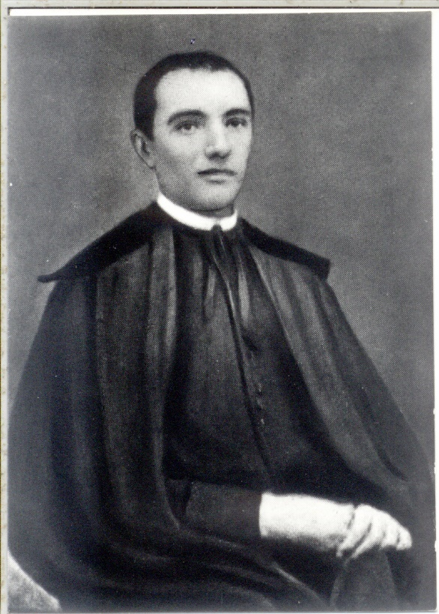
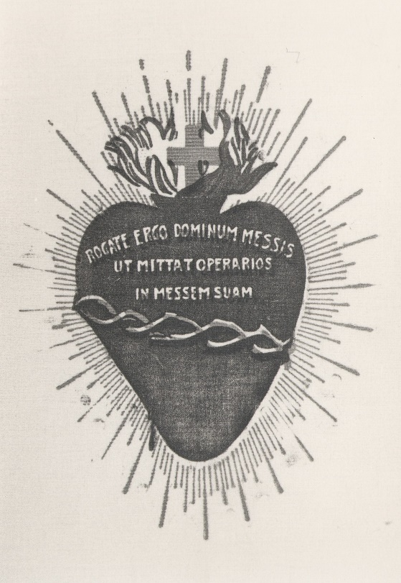

A rare photo of St. Hannibal Mary Di Francia in 1879
and the emblem of the Rogate in the Most Sacred Heart of Jesus.
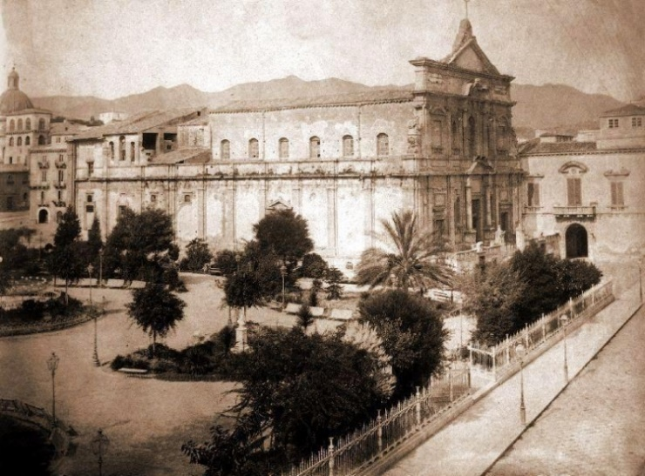
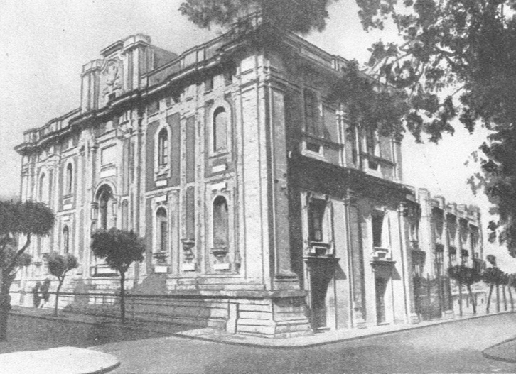

The Church of San Giovanni di Malta in Messina before the 1908 earthquake
and after its reconstruction.

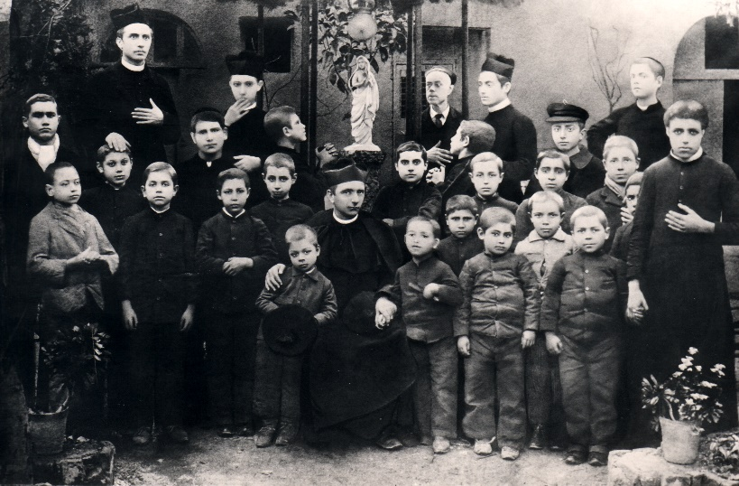
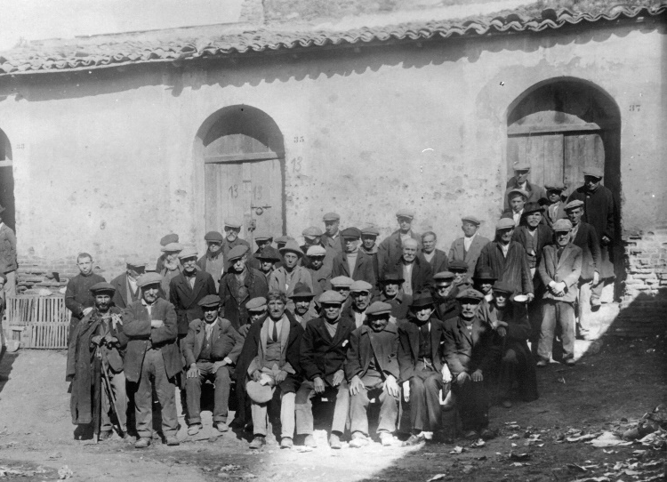

The poor of the Avignone Quarter; St. Hannibal in the midst the orphans.

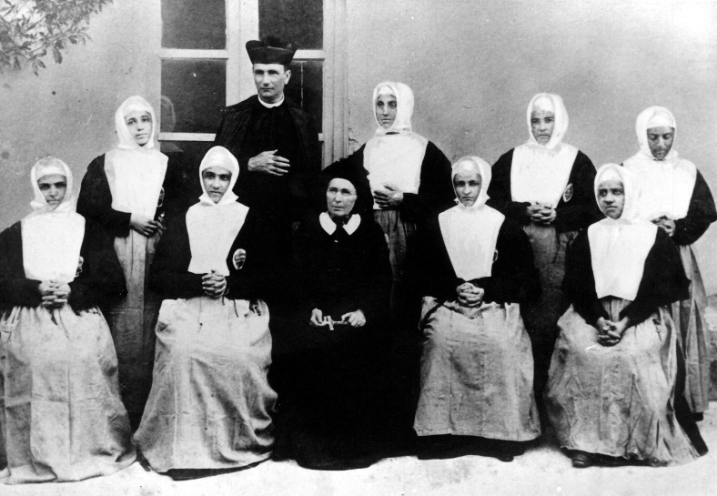

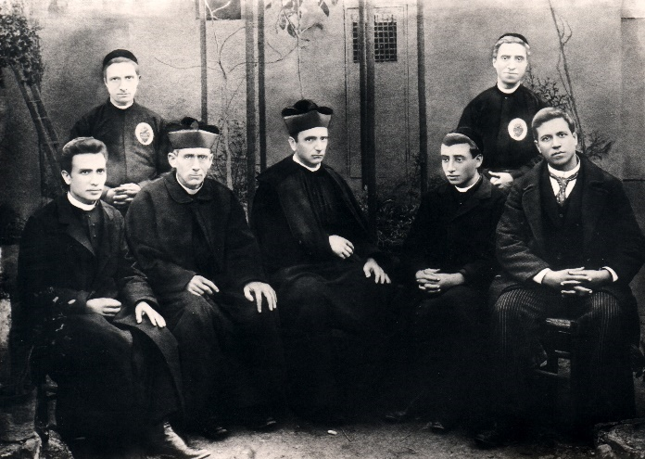

St. Hannibal with the novices of the Daughters of Divine Zeal and Melanie Calvat; St. Hannibal together with the first Rogationist religious.
2. Photographs of some events celebrated on the 150th anniversary of the Inspiration of the Rogate.

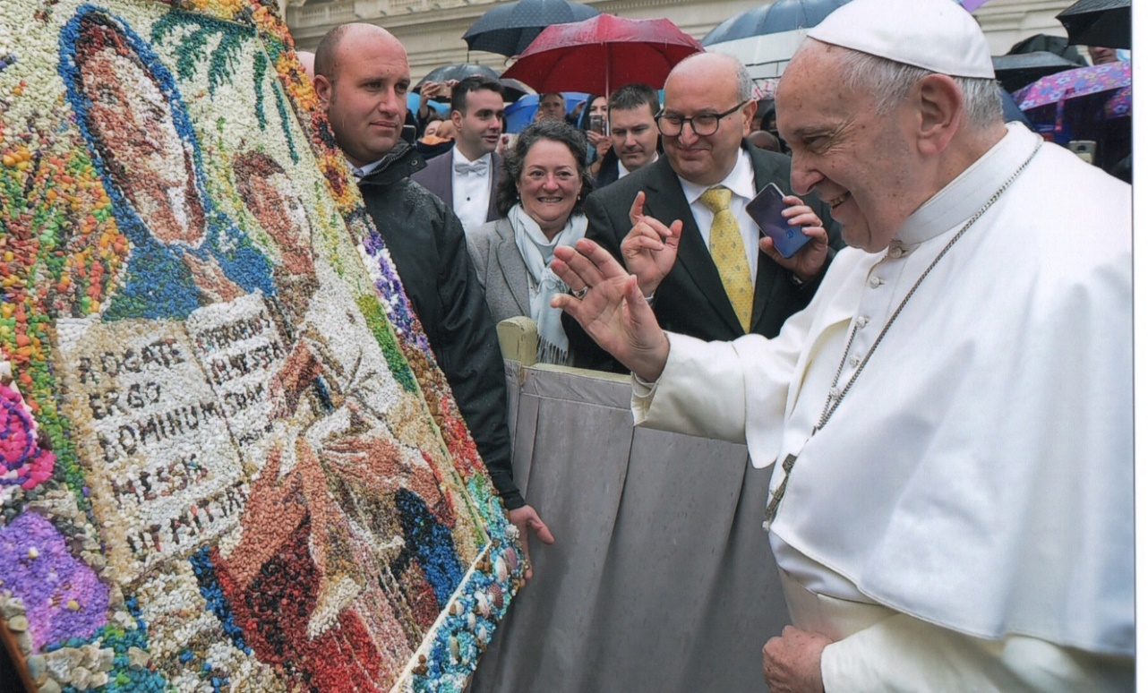

Vatican City, Rome. Celebration for the 150th anniversary of the Inspiration of the Rogate. Pope Francis blesses the mosaic of the Our Lady of the Rogate made
by the inmates of the Prison of Taranto (May 15, 2019).

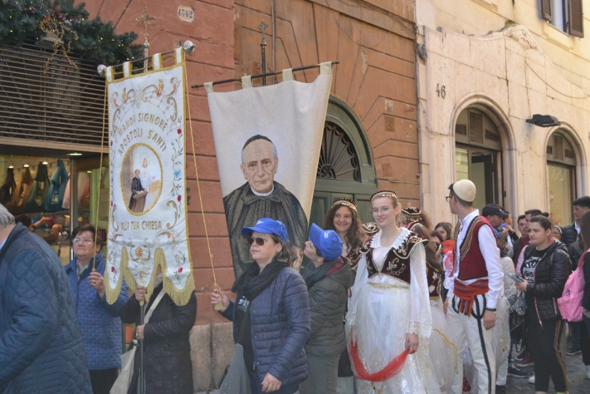
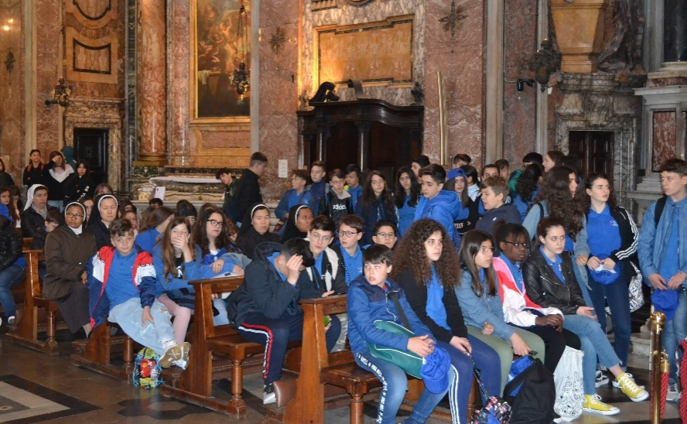

Rome, Celebration for the 150th anniversary of the Inspiration of the Rogate. Procession from the Church of the St. Magdalene of the Camillian Fathers to the Pantheon, with the children of the schools of Oria, Francavilla Fontana and Messina (May 16, 2019).

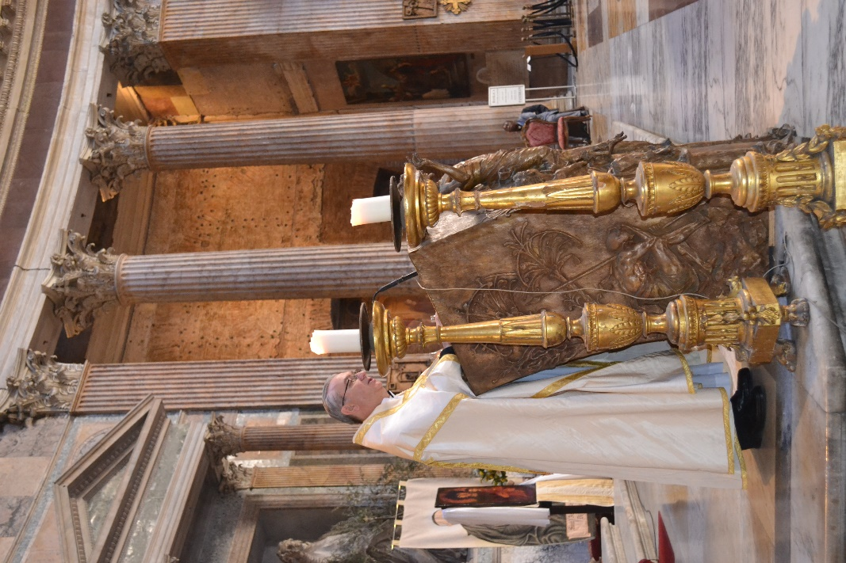
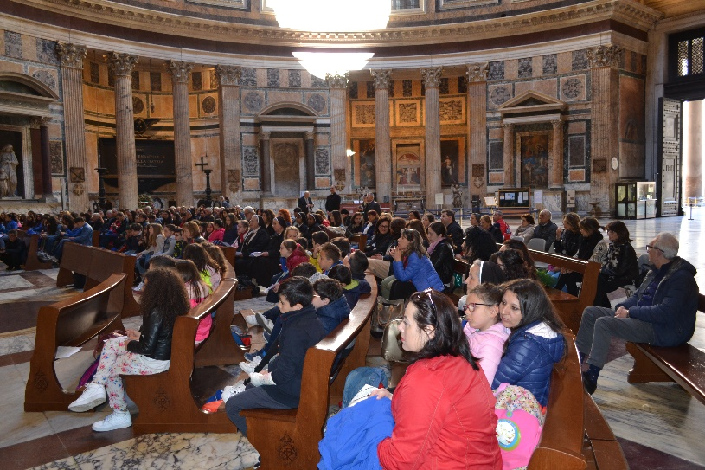

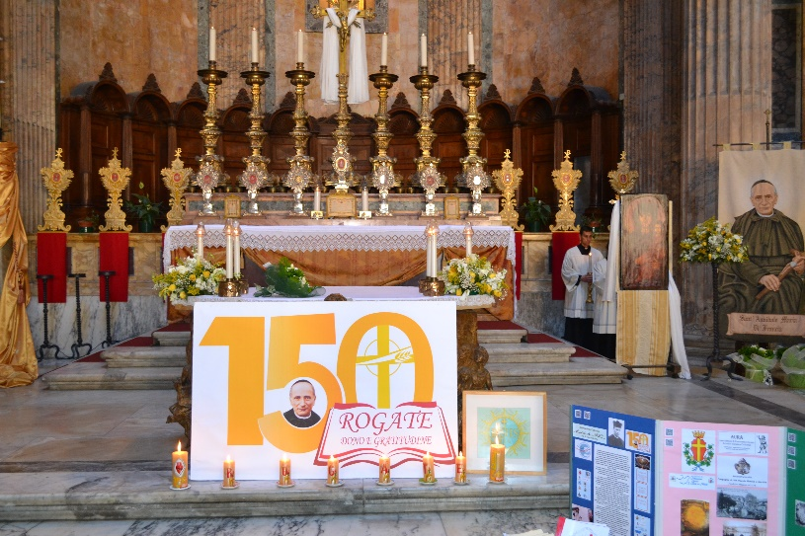

Rome, Celebration for the 150th anniversary of Inspiration of the Rogate in the Pantheon with the children of the schools of Oria, Francavilla Fontana and Messina (May 16, 2019).

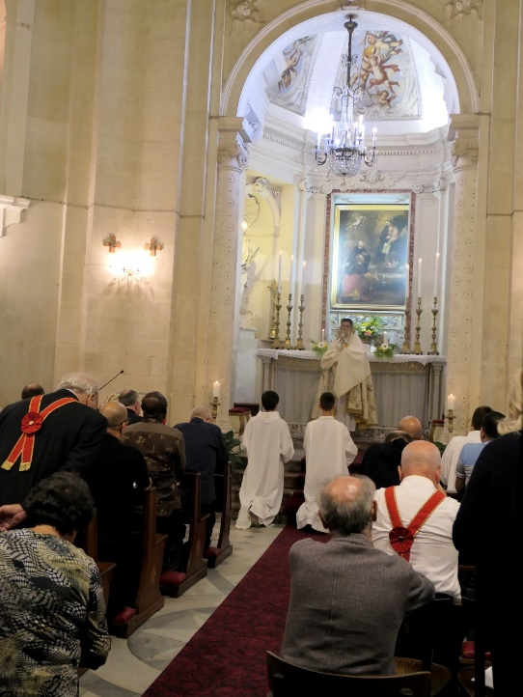
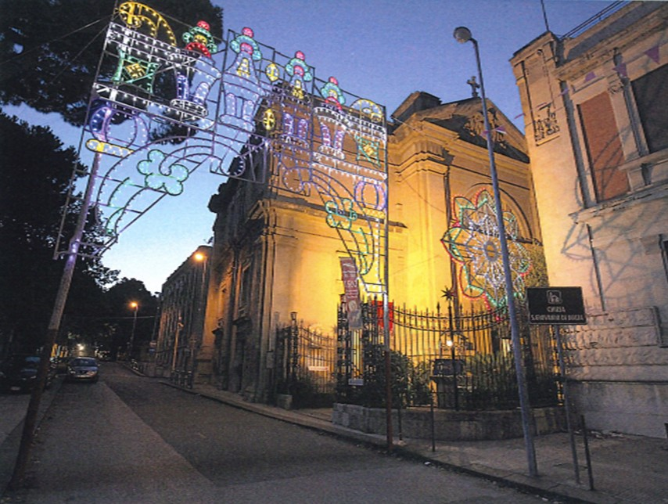

Celebration for the 150th anniversary of Inspiration of the Rogate on the occasion of the Conference of Superiors and Council of Circumscriptions. Eucharistic adoration in the Church of San Giovanni di Malta (October 17, 2019).

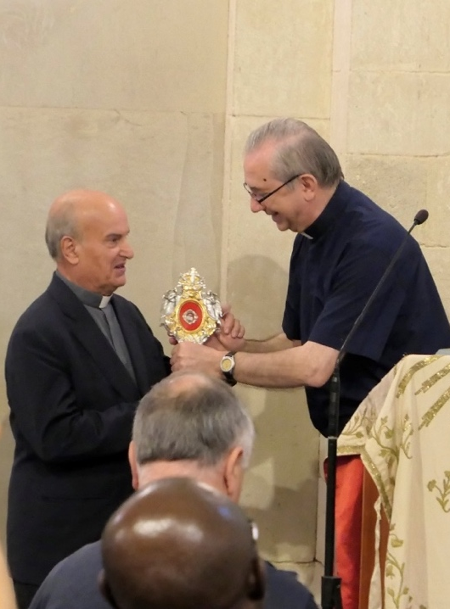
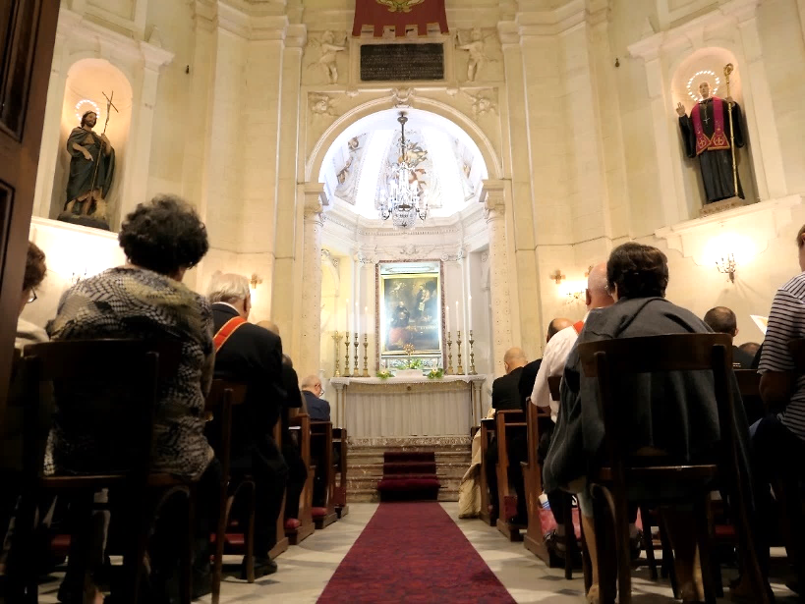

At the end of the Eucharistic Adoration, the Superior General, Fr Bruno Rampazzo, donates a relic of St. Hannibal to Mons. Angelo Oteri, Rector of the Church of San Giovanni di Malta (October 17, 2019).

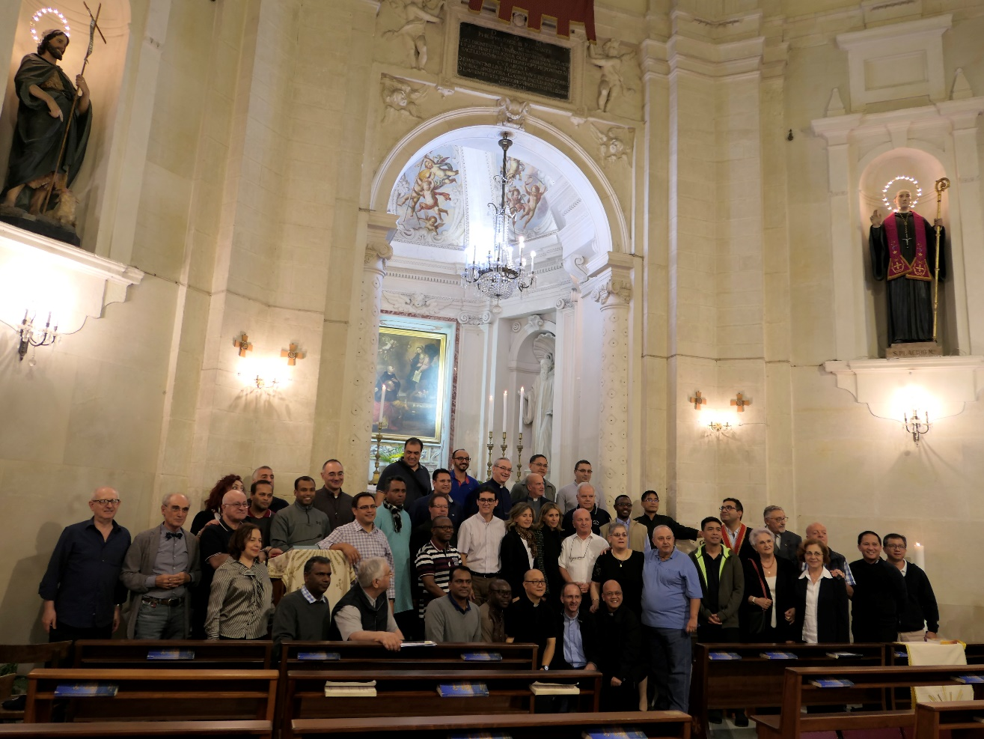

Group photo in the Church of San Giovanni di Malta
(October 17, 2019).

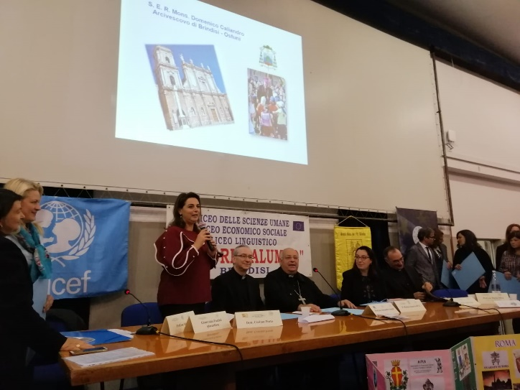
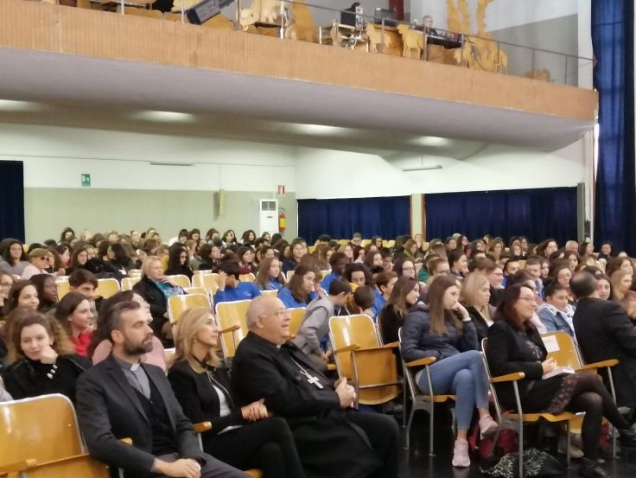

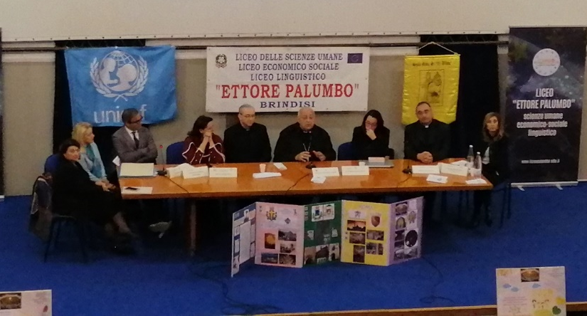

Brindisi, “Ettore Palumbo” Senior High School of Human Sciences and Linguistics.
Mons. Domenico Caliandro, Archbishop of Brindisi, Bruno Rampazzo and Fr. Matteo Sanavio at the conference on the pedagogy of St. Hannibal (November 20, 2019).

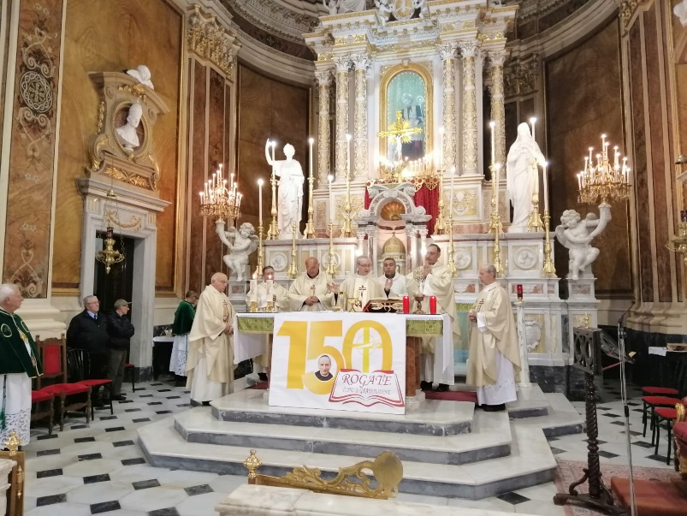
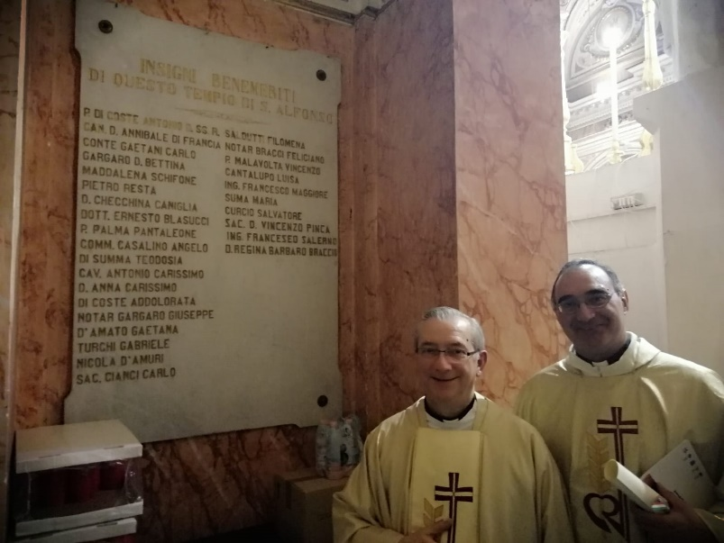

Francavilla Fontana (BR), Mass of the Superior General
in the Church of St. Alphonsus and the stone marker in which St. Hannibal is remembered as distinguished benefactor (November 20, 2019).

Contents

Introduction
1. THE INSPIRATION
1.1. Becoming an Apostle and Propagator of the Rogate
2. WITH THE POOR
2.1. The Rogate and the Poor
2.2. The Rogate in the midst of the Poor
2.3. The Poor of the Rogate
3. THE EUCHARISTIC HEART OF JESUS
3.1. Generating the Rogate
3.2. The Charity and Zeal of the Rogate
3.3. The Integrity of the Charism of the Rogate
4. THE ROGATE GIVEN TO THE CHURCH
4.1. The Sacred Alliance
4.2. The Pious Union of Evangelical Rogation
5. THE HERITAGE OF THE ROGATE
5.1. For the Glory of God and the Salvation of Souls
6. TOWARDS A DEFINITION OF THE CHARISM AND SPIRITUALITY
6.1. The Charism and Spirituality of Rogate from the Forty Declarations and Promises
6.2. The Threefold Dimension of the Rogate
6.3. The Rogate in the Constitutions
7. THE GREAT SECRET OF SALVATION IN THE GOOD WORKERS
8. THE JOURNEY TRACED BY THE ROGATE
8.1. Rogate Ergo Magazine
8.2. The Rogate in Father Francesco B. Vitale and in Father Serafino Santoro
8.3. The Rogate in Father Teodoro Tusino
8.4. The General Chapter of 1956
8.5 The Recognition of the Church and the Universal Prayer of Rogate
8.6. The Sacred Alliance during the Vatican Council II
8.7. The Fourth Special Ordinary General Chapter of 1968
8.8. The Fifth General Chapter of 1974
8.9. The Evolution of Rogate Ergo Magazine
8.10. The Sixth General Chapter of 1980
8.11. The Seventh General Chapter of 1986
8.12. The Essay on Rogate, Research Conferences, and Circular Letters
8.13. The Eighth General Chapter of 1992
8.14. The Ninth General Chapter of 1998
8.15. The Tenth General Chapter of 2004
8.16. The Website www.rcj.org
8.17. The Eleventh General Chapter of 2010
8.18. The Twelfth General Chapter of 2016
9. THE ROGATE NEW WAY OF SANCTIFICATION TODAY

APPENDICES
1. Photos from the Photographic Archives of the Rogationist Postulation
2. Photos of some events celebrated on the 150th anniversary of the Inspiration of the Rogate

Vitale F., Il Canonico Annibale M. Di Francia nella vita e nelle opere, Ed. Rogate, Roma, 1994, p. 759.
See Ibidem, p. 34, 534; Tusino T., L’anima del Padre. Testimonianze, Roma, 1973, p. 273.
*Notes/highlights in the translation in English are put inside square brackets [= notes in italics] or marked by the asterisk *.
Positio, Vol. II, Chronology, p. 1268; Vitale, Il Canonico, pp. 14-15, 42-44, 155; see Di Francia A., Preziose Adesioni, Tipografia Antoniana Maschili, Messina, 1940, pp. 8-9; Tusino T., L’anima del Padre, pp. 110-111; Tusino T., Non Disse Mai No, Edizioni Paoline, Roma, 1966, pp. 53-54; Archive of the Rogationist Postulation, nos. 14-595, 24-1229, 61-4345.
Vitale F., Il Canonico, pp. 42-43.
Di Francia A., Prefazione alle Preziose Adesioni, 1901, in Preziose Adesioni, Tipografia Antoniana Maschili, Messina, 1940, p. 9.
Ibidem, p. 10.
See Tusino T., L’anima del Padre, p. 111; Tusino T., Memorie Biografiche, Part I, Ed. Rogate, Roma, 1995, pp. 119-121.
Vitale F., Il Canonico, p. 722.
Positio, Vol. I, p. 211-212; Positio, Vol. II, Testimonianze, no. 115.
Positio, Vol. I, p. 215-216217; Relatio et Vote, p. 94.
Positio, Vol. I, p. 216-217; Relatio et Vote, p. 26 - 27.
Vitale F., Il Canonico, p. 129.
Positio, Vol. I, p. 211; Positio, Vol. II, Testimonianze, no. 216.
Positio, Vol. I, p. 220; Positio, Vol. II, Testimonianze, no. 302.
*Father Hannibal used the Bible in the Latin Vulgate whose Chapter and verse references might not be exactly the same with our current Biblical references.
Tusino T., Memorie Biografiche, Part I, Ed. Rogate, Roma, 1995, p. 546-547.
Santoro S., Inizio carismatico e laborioso dell’Istituto delle Figlie del divino Zelo, Pro manuscripto, Trani, 1974, p. 124.
Ibidem, p. 124.
Vitale F., Il Canonico, p. 663-664.
Di Francia A., Lettera agli Amici (APR 37), 1925, in Scritti, Vol. 50, p. 549.
Di Francia A., La festa del 1° Luglio, Messina, 1903, in Padre Annibale Oggi, New series 38, 2011, pp. 22-24.
Di Francia A., Scritti, Regolamenti, Vol. VI, Ed. Rogate, Roma, 2010, p. 396.
Di Francia A., Scritti, Regolamenti, Vol. VI, Ed. Rogate, Roma, 2010, pp. 397-398.
Di Francia A., Gli inni del 1° Luglio, Messina, 1940, pp. 37, 54, 61, 64, 71, 81, 85, 89, 92, 95, 96, 103 ff.
Di Francia A., Autoelogio…, in Scritti, Vol. 58, APR 5220; Vitale F., Il Canonico, pp. 757-761.
Di Francia, A., La Festa del 1° Luglio, Messina, 1903, in Padre Annibale Oggi, New series 38, 2011, pp. 33-34.
Ibidem, p. 34.
Di Francia A., Scritti, Regolamenti, Vol. VI, Ed. Rogate, Roma, 2010, p. 398.
Di Francia A., Scritti, Preghiere al Signore, Vol. I, Ed. Rogate, Roma 200,7, p. 386.
See Sardone A., Rogate Dominum Messis. Saggio sul Rogate, Ed. Rogate, Roma, 1996, p. 358.
“Flood waters flowed over my head; I said: I am lost” (Lam. 3:54).
Di Francia A., Prefazione alle Preziose Adesioni, in Preziose Adesioni, Tipografia del Sacro Cuore, Messina, 1901, pp. 8-9.
Ibidem, pp. 10-11.
*Virtual intention is an intention that was once made and continues to influence the act now being done. But it is not present to the person's consciousness at the moment of performing the act. This kind of intention is sufficient for a human act to be voluntary and therefore morally responsible. See catholicculture.org.
Ibidem, pp. 12-13.
Ibidem, p. 16.
See Sardone A., Rogate Dominum Messis. Saggio sul Rogate, Ed. Rogate, Roma, 1996, p. 306.
Di Francia A., Epistolario, Vol. V (1922-1927), edited by C. Quaranta, p. 196.
Bollettino, May-August 1933, p. 219.
Di Francia A., Scritti, Regolamenti, Vol. V, Ed. Rogate, Roma, 2009, p. 592.
Tusino T., Memorie Biografiche, Part III, Ed. Rogate, Roma, 1998, pp. 83-84.
Register for the Pious Union of the Evangelical Rogation, Messina, 1900, p. 1.
Congregation for the Causes of Saints, Annibale Maria Di Francia. Biografia, Ed. Rogate, Roma, 1994, p. 132.
Di Francia A., Scritti, Memoriale dei Divini Benefici, Vol. 61, APR 380.
See Cipriani S., Rogate Dominum Messis. Saggio sul Rogate, Ed. Rogate, Roma, 1996, p. 19 ff.
Di Francia A., Scritti, Regolamenti, Vol. V, Ed. Rogate, Roma, 2009, p. 82.
*Educande is derived from Educandario, which means boarding school.
Ibidem, p. 83.
Ibidem, pp. 116, 117-118; see also p. 128.
Ibidem, p. 126.
Ibidem, p. 515.
Ibidem, p. 134.
Ibidem, p. 176.
Ibidem, p. 177.
Ibidem, p. 192.
Ibidem, pp. 196-197.
Ibidem, p. 197.
Ibidem, pp. 227, 228, 229, 233.
Ibidem, p. 244.
*Rogandina is in the gerundial form. Literally, it means “Should-be-praying” Congregation.
Ibidem, p. 247.
Ibidem, pp. 276, 277, 278.
Ibidem, pp. 353, 356.
Ibidem, p. 370.
Ibidem, pp. 420-421.
Ibidem, p. 517.
Ibidem, p. 519.
See Ibidem, p. 533-534.
Ibidem, p. 540.
Ibidem, p. 553.
See Santoro D. S., Breve Profilo Storico della Congregazione dei Rogazionisti, Roma, 1985, p. 64.
Di Francia A., Scritti, Regolamenti, Vol. V, Ed. Rogate, Roma, 2009, p. 619; See also the text of the Dichiarazioni e Promesse (of Rogationist religious) in the same volume on pp. 578-619.
*The numbering and text of Declarations and Promises used in this Circular Letter are based on the first version of the document, published in Di Francia A., Scritti, Regolamenti, Vol. V, Ed. Rogate, Roma 2009, pp. 578-619.
Ibidem, pp. 703-704.
Ibidem, pp. 790-791.
Ibidem, p. 814.
Ibidem, p. 834.
Ibidem, p. 832.
Ibidem, p. 835.
Di Francia A., Scritti, Regolamenti, Vol. VI, Ed. Rogate, Roma 2010, pp. 60-61.
Ibidem, pp. 73-74.
Ibidem, p. 234.
Ibidem, pp. 397-398.
Constitutions of the Religious Congregation of the Rogationists of the Heart of Jesus, Messina, 1927, p. 9.
Di Francia A., Scritti, Vol. 58, p. 182.
Di Francia A., Scritti, Regolamenti, Vol. V, Ed. Rogate, Roma, 2009, pp. 413-414.
Di Francia A., Scritti, Epistolario, Vol. VIII, Ed. Rogate, Roma, 2019, p. 70.
Di Francia A., Scritti, Regolamenti, Vol. VI, Ed. Rogate, Roma, 2010, pp. 60-61.
Bollettino, Supplement, Messina, 1945, p. 14.
Lettere Circolari, Scuola Tipografica Antoniana, Oria, 1950, pp. 225, 229-230.
Ibidem, pp. 229-230.
Tusino T., Il Rogazionista, figlio del Padre e della Congregazione, Roma, 1948, pp. 30-31.
Bollettino, Special Issue, July 1956, p. 23.
Bollettino, March-April 1957, Particular office of each General Consultor, p. 99.
Consiglio Generalizio dei PP. Rogazionisti, 2º Libro dei verbali s 19/8/1956 - 1/3/1962, p. 89.
Ibidem, p. 186.
Bollettino, January-February 1963, p. 2.
Rogate Ergo, April, 1964, p. 96.
See Curia Generalizia dei Padri Rogazionisti, Mitte Domine Operarios, Roma, 1964.
IV Capitolo Generale, Dichiarazioni e Decreti, Roma 1969, p. 202 ff.
Congregation of the Rogationists, Constitutions and Norms, Roma 1970: Constitutions, art. 126-127; Norms, art. 101-111.
See Bollettino, July-October 1974, pp. 161-162.
See Bollettino, January-February 1976, p. 2.
See Ibidem, p. 32.
See Documenti Capitolari, Roma 1980, pp. 287-288.
Ibidem, pp. 154-156.
See Bollettino, January-February 1982, p. 11.
See Bollettino, January-February 1987, p. 32.
See Norms 1986, art. 103-107.
VII Capitolo Generale, Documenti, Litografia Cristo Re, Morlupo 1994, pp. 32-33.
See Comunione e Comunità Rogazionista, Litografia Cristo Re, Morlupo, 1986, pp. 37-44.
Consulta Generale 1989, Documenti, Litografia Cristo Re, Morlupo, 1994, pp. 78-79.
VII General Chapter, Documents (English ed.), Rome, 1994, no. 1 in the part Apostolate of the Congregation.
IX General Chapter, Called to Stay with Him. Primacy of Spiritual Life (English ed.), Rome, 1998, no. 57, p. 67.
Ibidem, no. 68, p. 76.
Ibidem, no. 79, p. 81.
Ibidem, no. 84, p. 85.
Bollettino, July-September 1998, p. 761.
Ibidem, p. 760.
See Bollettino, Annuario 2000, p. 15.
See Bollettino, Annuario 2015, p. 91.
Bollettino, July-September 2004, pp. 691-692; also http://www.vatican.va/content/john-paul-ii/en/speeches/2004/july/documents/hf_jp-ii_spe_20040710_rogazionisti.html
X General Chapter, Apostles of the Rogate (English ed.), Rome, 2004, no. 33, p. 35.
Bollettino, July-September 2004, p. 752.
XI General Chapter, The Rogationist Rule of Life (English ed.), Rome, 2010, p. 34. Also http://www.vatican.va/content/benedict-xvi/en/messages/pont-messages/2010/documents/hf_ben-xvi_mes_20100705_rogazionisti.html
Ibidem, no. 40, p. 18.
XII General Chapter, “Seeing the Crowds, He Felt Compassion for Them and Said, ‘Rogate’” Our Charismatic Identity in Today’s Challenges (English ed.), Rome, 2016, no. 45, p. 11.
Ibidem, no. 84, pp. 20-21.
Ibidem, no. 95, p. 24.
Ibidem, no. 99, pp. 24-25.
Ibidem, no. 123, p. 30.
Di Francia A., Scritti, Regolamenti, Vol. V, Ed. Rogate, Roma, 2009, pp. 418-419.

