August 21, 2020

To: Superiors / Responsible of the Houses and all Confreres of St. Matthew Province Re: Request for Prayers and Support for the Diaconal Ordination

Dear,

Greetings of peace and joy!

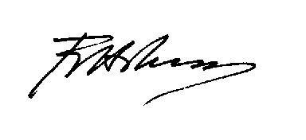
I would like to request you and your community to include the following religious brothers: Bro. Marcelinus Koka, RCJ, Bro. John Paul Mapacpac, RCJ, Bro. Frederikus Yorius Ndawi, RCJ, Bro. Arthur James Paciente, RCJ, Bro. Yoseph Emanuel Rua, RCJ, Bro. Paulo Sambile, RCJ, and Bro. Jeffren Tugbo, RCJ, in your community prayers and to support them as they prepare themselves for their diaconal ordination.

They are scheduled to be ordained on September 14, 2020, 3:30 pm, at the Holy Spirit Chapel of the Fr. Di Francia Center of Studies, in Don Jose Green Court, San Dionisio, Parañaque City, by Most Rev. Jesse E. Mercado, DD, Bishop of Parañaque.

Your prayers will help them prepare and be disposed in receiving the great gift of Ordination to the Diaconate.

We are grateful to the Lord of the Harvest for the generosity of these young men and for the gift of Vocations He bestowed upon our Congregation and the Church. May they serve God and mankind in joyful fidelity and holy perseverance.

Fr. Herman Abcede, RCJ
Superior / Prefect

