AIDS TO
COMMUNITY PRAYER ENCOUNTERS
in preparation for the

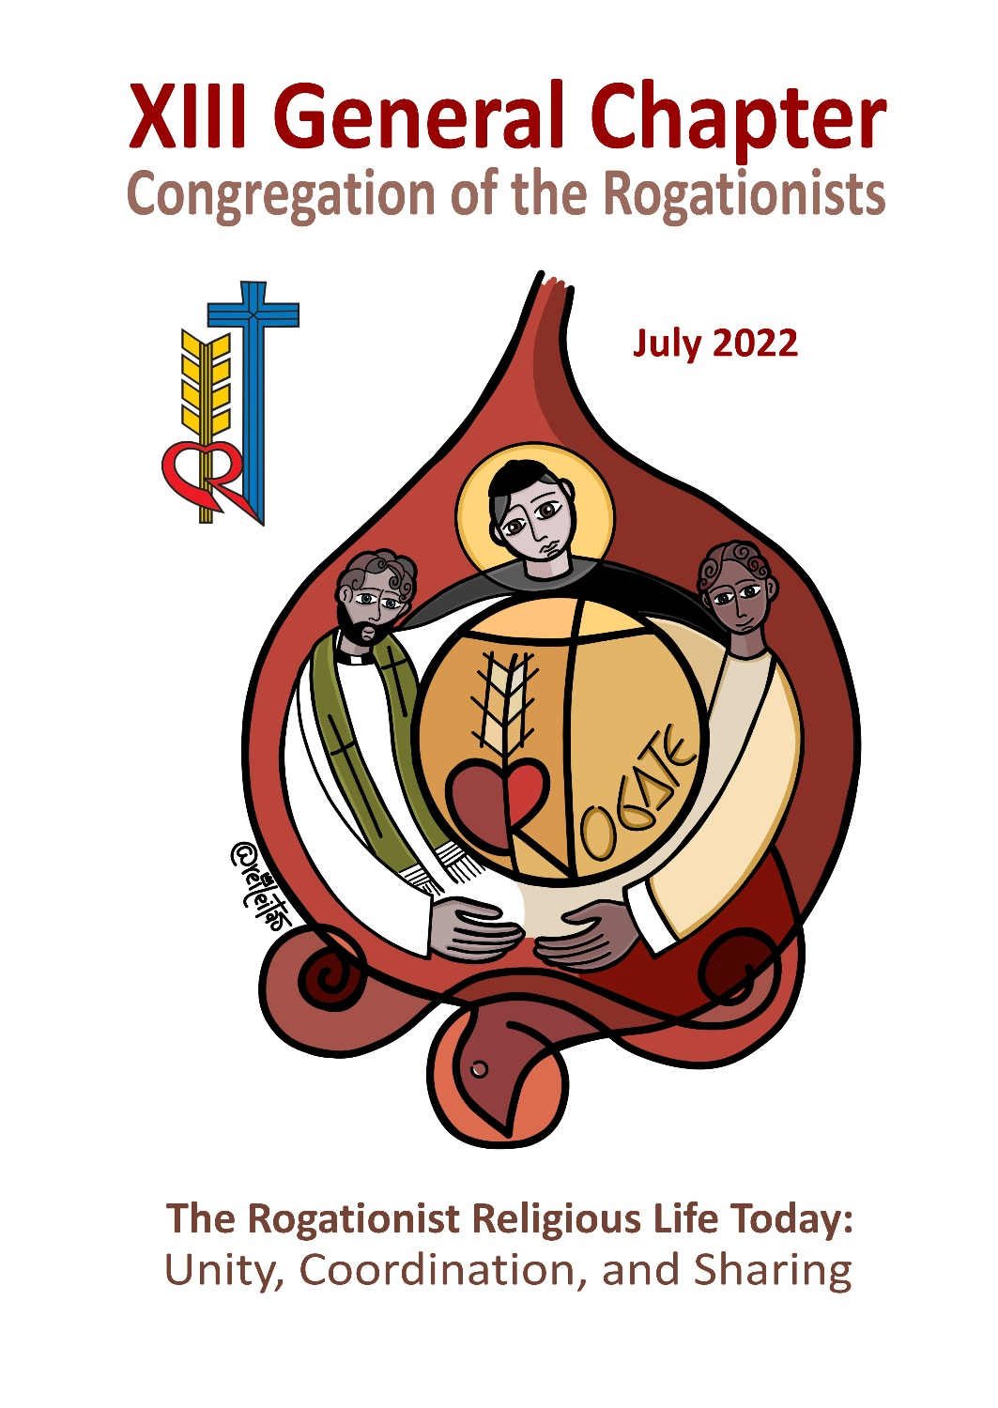

NOTES
ON THE AIDS TO COMMUNITY PRAYER ENCOUNTERS
in preparation for the XIII General Chapter

As our Congregation approaches the XIII General Chapter, let us all partake in its immediate preparation even as individuals and communities, particularly by means of prayer.
Prayer is the highest expression of our unity and communion, first of all in union with the Holy Trinity. Gathered in the Name of Jesus, he is in our midst to pray for us and with us, making our prayer acceptable to the Father. In communion with him, under the inspiration of the Holy Spirit, we rediscover our vocation as baptized and as Rogationist religious who form a charismatic family called and sent by the Christ of the Rogate. In prayer, we are reinforced in our identity and mission as we journey on the path of synodality.
The following prayer aids, intended for community use in the last three months prior to the start of the General Chapter (April, May, June), include the following:

1. Community Prayer Encounters
- There are two variations of the guide to prayer, a. with the exposition of the Blessed Sacrament, b. without the exposition of the Blessed Sacrament.
- There are three schemas, corresponding to the three themes of the General Chapter: unity, collaboration, sharing
- The community chooses the appropriate songs related to the theme.

2. Community celebration of the Holy Mass

- Suggested Mass formulary and Readings: Masses for various needs. For Spiritual or Pastoral Gathering (no. 20)
- Suggested Preface and Eucharistic Prayer: For use of Masses for various needs. The Church on the Path of Unity.
- Prayers of the Faithful: three sets corresponding to the three themes of the XIII General Chapter: unity, collaboration, sharing

XIII Rogationist General Chapter
ROGATIONIST RELIGIOUS LIFE TODAY: UNITY, COORDINATION, SHARING

COMMUNITY PRAYER GUIDE
IN PREPARATION FOR THE GENERAL CHAPTER

THE PATH OF UNITY AND COMMUNION

Introduction: Unity and communion. These words can be fully understood only in the light of the mystery of the Holy Trinity – the central mystery of our Christian faith. This we know and believe, thanks to the Word-made-flesh, Jesus who revealed it to us. In this community prayer, we are invited to meditate on the priestly prayer of Jesus, which reveals not only His unity with the Father but also the unity of those who believe in Him. Indeed, there is no true unity and communion unless we go to the very foundation of our faith – that we are all brothers in God who is our Father; to go to the very foundation of our mission – that we are all sent in the world as Christ’s disciples; and to go to the very foundation of our charismatic identity – that we are all inflamed by the Holy Spirit to dedicate ourselves to the Divine Command: Rogate.

As we prepare for the XIII General Chapter, let us recall how we are united by the calling and following of Christ of the Rogate who forms us as one Religious Family for the building up of the Kingdom of God. May unity and communion become the flesh of our prayers, as we all strive for holiness.

Opening Song

Variation #1 (if there is the exposition of the Blessed Sacrament)
Greetings to the Blessed Sacrament

Lord Jesus Christ, on the night before you were handed on to suffer and die on the Cross, you prayed for the unity of your brethren by asking the Father to consecrate them in truth.

Praise and Thanks every moment, to the most Holy and most Divine Sacrament…
Glory to the Father…
Send, O Lord…

Lord Jesus Christ, on the night when Nicodemus reached out to you as His new teacher, you assured him that when you are lifted up from the earth, you will draw everyone to yourself.

Praise and Thanks every moment, to the most Holy and most Divine Sacrament…
Glory to the Father…
Send, O Lord…

Lord Jesus Christ, on the night of betrayal and denial by your friends, you instituted the Holy Eucharist and the Priesthood as the memorial of your love and as the sacrament of unity that confirms and strengthens the bond between brothers.

Praise and Thanks every moment, to the most Holy and most Divine Sacrament…
Glory to the Father…
Send, O Lord…

Variation #2 (if there is no exposition of the Blessed Sacrament)
Invocation to the Holy Spirit

Come, Holy Spirit, from heaven shine forth with your glorious light.
Veni Sancte Spiritus.

Come, Father of the poor, come, generous Spirit, come, light of our hearts.
Veni Sancte Spiritus.

Come from the four winds, O Spirit, come breath of God; disperse the shadows over us, renew and strengthen your people.
Veni Sancte Spiritus.

Most kindly warming light! Enter the inmost depths of our hearts, for we are faithful to you. Without your presence, we have nothing worthy, nothing pure.
Veni Sancte Spiritus.

You are the only comforter, Peace of the soul. In the heat you shade us; in our labor you refresh us, in trouble you are strength.
Veni Sancte Spiritus.

On all who put their trust in you and receive you in faith, shower all your gifts. Grant that they may grow in you and persevere to the end. Give them lasting joy!
Veni Sancte Spiritus.

Silent Prayer

Biblical Readings: from the Gospel according to John (John 17:1, 6-10, 20-26)

When Jesus had said this, he raised his eyes to heaven and said, “Father, the hour has come. Give glory to your Son, so that your Son may glorify you. […] I revealed your name to those whom you gave me out of the world. They belonged to you, and you gave them to me, and they have kept your word. Now they know that everything you gave me is from you, because the words you gave to me I have given to them, and they accepted them and truly understood that I came from you, and they have believed that you sent me. I pray for them [...] because they are yours, and everything of mine is yours and everything of yours is mine, and I have been glorified in them.
“I pray not only for them but also for those who will believe in me through their word, so that they may all be one, as you, Father, are in me and I in you, that they also may be in us, that the world may believe that you sent me. And I have given them the glory you gave me, so that they may be one, as we are one, I in them and you in me, that they may be brought to perfection as one, that the world may know that you sent me and that you loved them even as you loved me. Father, they are your gift to me. I wish that where I am they also may be with me, that they may see my glory that you gave me because you loved me before the foundation of the world. Righteous Father, the world does not know you, but I know you, and they know that you sent me. I made known to them your name and I will make it known, that the love with which you loved me may be in them and I in them.”

Silence / Reflection

Psalm 133

How good and how pleasant it is,
when brothers dwell together as one!
Like fine oil on the head,
running down upon the beard,
Upon the beard of Aaron,
upon the collar of his robe.
Like the dew of Hermon coming down
upon the mountains of Zion.
There the Lord has decreed a blessing,
life forevermore!

From the Writings of St. Hannibal Mary Di Francia (Declarations and Promises n. 9)

I declare that I have learned, to my great delight, that in this Institute, great value is placed on mutual love and respect; and that the precept given by Our Lord Jesus Christ, Love one another as I have loved you (Jn. 15:12), which form the distinctive mark of all Christians, is the primary rule of this Institute, as that of loving God above all things with all your heart, with all your soul and with all your strength (cf. Mt. 22:37; Mk. 12:29-30).
Having said this, I will devote myself, with the help of the divine grace and my own goodwill, and I promise to be most attentive to this holy love. I will seek to form in myself a heart which is tender, affectionate, and loving with all persons of the Institute; I will ask of the most Holy Heart of Jesus for this spirit of charity towards all my brethren. I will love them, show them compassion; as much as I can, I will pray for them, desire and obtain their good as it were my own personal good.

Silence

Community Prayer:

Lord God, your Church is gathered because it is convoked by your word. We Rogationists are formed as one family because of the Divine Word of the Rogate that your Son Jesus addresses to our hearts. You have called us to have his same compassion in seeing the crowds as sheep without a shepherd, his same interest of imploring the Lord of the harvest to send laborers in the harvest, and his same zeal as collaborators in his mission. May the prayer of unity of your Christ may come true; that we may be one as you are one in him. Dispel from us every temptation of egoism, discord, distrust, disunity. Make us persevere in every effort to walk together in following your call. As we prepare for the XIII General Chapter, grant that we may recognize each other as brothers in the Lord Jesus, so that our hearts, hands, and lips, may raise up the unceasing prayer for men and women who bring the tired and scattered flock into the one fold, gather the rich harvest in the one barn, and become living testimonies of unity. Amen.

(if the Blessed Sacrament is exposed)
Tantum Ergo / Benediction

Divine Praises
Blessed be God
Blessed be the Name of the Lord
Blessed be Jesus Christ, true God and true Man
Blessed be his Most Sacred Heart
Blessed be His Most Precious Blood
Blessed be Jesus in the Most Holy Sacrament of the Altar
Blessed be the Holy Spirit, the Paraclete
Blessed be the Great Mother of God, Mary Most Holy
Blessed be her Holy and Immaculate Conception
Blessed be her glorious Assumption,
Blessed be the Name of Mary, Virgin and Mother
Blessed be St. Joseph, her Most Chaste spouse
Blessed be God, in His Angels and His Saints.

Concluding Song

XIII Rogationist General Chapter
ROGATIONIST RELIGIOUS LIFE TODAY: UNITY, COORDINATION, SHARING

COMMUNITY PRAYER GUIDE
IN PREPARATION FOR THE GENERAL CHAPTER

THE PATH OF COLLABORATION

Introduction: Collaboration is a concrete means of expressing unity. By collaborating, we become living and active members of our religious family, especially in witnessing our religious vocation and consecration in a world characterized by globalization. While our contemporary world enjoys advancements in technology and communication, on the other, it suffers different kinds of fragmentation and dehumanization. In this community prayer, we are invited not only to draw inspiration from the seventy-two whom Jesus sent to collaborate with him in the proclamation of the Kingdom of God but to remind us of our very own charismatic expression of collaborating with God’s plan – as “pray-ers” for more and holy laborers and as laborers in the vineyard of the Lord. Like the seventy-two, we are sent by the Lord as his collaborators in the work of salvation. Aware and convinced that “No one is saved alone”, let us therefore proclaim to the world the command of the Rogate is an effective means that all may be saved. This is what our Saintly Founder taught and what we, his spiritual children, ought to do.

As we prepare for the XIII General Chapter, let us beg the Lord to inspire in us the spirit of brotherhood, founded and sustained by our obedience to the Divine Command of Jesus, so that we may walk together on the path of collaboration for the good of the Church and the salvation of souls, especially for the are “sheep without a shepherd” of our time.

Opening Song

Variation #1 (if there is the exposition of the Blessed Sacrament)
Greetings to the Blessed Sacrament

Lord Jesus Christ, you sent seventy-two disciples to proclaim the Kingdom of God; here we are, send us too as collaborators in your work of Salvation.

Praise and Thanks every moment, to the most Holy and most Divine Sacrament…
Glory to the Father…
Send, O Lord…

Lord Jesus Christ, moved with compassion, you saw how rich the harvest is and the scarcity of laborers; help us have that same compassion as we share in your mission.

Praise and Thanks every moment, to the most Holy and most Divine Sacrament…
Glory to the Father…
Send, O Lord…
Lord Jesus Christ, we have received the Rogate from your sacred lips; grant that by obeying your Divine Command, we may dedicate ourselves to the building of your Mystical Body.

Praise and Thanks every moment, to the most Holy and most Divine Sacrament…
Glory to the Father…
Send, O Lord…

Variation #2 (if there is no exposition of the Blessed Sacrament)
Invocation to the Holy Spirit

We stand before You, Holy Spirit, as we gather together in Your name.
With You alone to guide us, make Yourself at home in our hearts;
Teach us the way we must go and how we are to pursue it.

We are weak and sinful; do not let us promote disorder.
Do not let ignorance lead us down the wrong path
nor partiality influence our actions.

Let us find in You our unity, so that we may journey together to eternal life
and not stray from the way of truth, and what is right.
All this we ask of You, who are at work in every place and time,
in the communion of the Father and the Son,
forever and ever. Amen.

Silent Prayer

Biblical Readings: From the Gospel according to Luke (Luke 10:1-9)

After this, the Lord appointed seventy-two others whom he sent ahead of him in pairs to every town and place he intended to visit. He said to them, "The harvest is abundant, but the laborers are few; so, pray the Lord of the harvest to send out laborers for his harvest. Go on your way; behold, I am sending you like lambs among wolves. Carry no money bag, no sack, no sandals; and greet no one along the way. Into whatever house you enter, first say, 'Peace to this household.' If a peaceful person lives there, your peace will rest on him; but if not, it will return to you. Stay in the same house and eat and drink what is offered to you, for the laborer deserves his payment. Do not move about from one house to another. Whatever town you enter, and they welcome you, eat what is set before you, cure the sick in it and say to them, 'The kingdom of God is at hand for you.'

Silence / Reflection

Psalm 127

If the Lord does not build the house, *
in vain do its builders labor;
if the Lord does not watch over the city, *
in vain does the watchman keep vigil.
In vain is your earlier rising, *
your going later to rest,
you who toil for the bread you eat, *
when he pours gifts on his beloved while they slumber.
Truly sons are a gift from the Lord, *
a blessing, the fruit of the womb.
Indeed the sons of youth *
are like arrows in the hand of a warrior.
O the happiness of the man *
who has filled his quiver with these arrows!
He will have no cause for shame *
when he disputes with his foes in the gateways.

From the Writings of St. Hannibal Mary Di Francia (Cf. Scritti, vol. 56, p. 317. Excerpt of the letter sent to Cardinal Joseph Guarino, Archbishop of Messina, dated December 22, 1895).

To the Most Eminent Cardinal Archbishop Giuseppe Guarino
As you know Your Eminence, I have started a male Orphanage and a small community of clerics, with the goal of educating the orphans and evangelizing the poor. In this way, the daily needs of this new institute are provided for. I would like to start to form a small community of lay brothers who would be giving service to the community. These brothers would be wearing a simple habit of this Religious Congregation. All this I submit to your judgment, your Eminence, as I wait for your decision.

Silence

Community Prayer

O Lord Jesus,
deign to send the omnipotent breath of holy vocation
into the heart of so many youths,
whose spirit is open to the influx of your grace.
You who called Matthew from the tax collector’s booth,
Peter, Andrew, James, and John from their nets.
O Lord Jesus,
you are infinitely provident and loving,
deign to grant the necessary means of success
to all whom you please to call,
that they may respond to the holy vocation,
and become true salt of the earth and light of the world.
We ask you for priests for the whole Church,
for all cities, for all towns and villages, for all lands,
and we ask that they be according to your Heart. (St. Hannibal Mary)

(if the Blessed Sacrament is exposed)
Tantum Ergo / Benediction

Divine Praises
Blessed be God
Blessed be the Name of the Lord
Blessed be Jesus Christ, true God and true Man
Blessed be his Most Sacred Heart
Blessed be His Most Precious Blood
Blessed be Jesus in the Most Holy Sacrament of the Altar
Blessed be the Holy Spirit, the Paraclete
Blessed be the Great Mother of God, Mary Most Holy
Blessed be her Holy and Immaculate Conception
Blessed be her glorious Assumption,
Blessed be the Name of Mary, Virgin and Mother
Blessed be St. Joseph, her Most Chaste spouse
Blessed be God, in His Angels and His Saints.

Concluding Song

XIII Rogationist General Chapter
ROGATIONIST RELIGIOUS LIFE TODAY: UNITY, COORDINATION, SHARING

COMMUNITY PRAYER GUIDE
IN PREPARATION FOR THE GENERAL CHAPTER

THE PATH OF SHARING

Introduction: The mystery of the Incarnation reveals to us God’s desire to share in our humanity. In like manner, the Paschal Mystery reveals to us God’s willingness to give himself up to save humanity. God himself taught us that sharing is not an idea but a reality, not just a word but an experience. During his public ministry, Jesus did not just share things about God. Instead, he shared God himself. At the Last Supper, he took the bread, broke it, and gave it to his disciples. At the foot of the cross, he gave his Mother to the Church. On the day of Pentecost, he gave the apostles the gift of the Holy Spirit. In the footsteps of the Master, Church lives the gospel logic freely giving what one has freely received.
In this prayer gathering, let us ask the Blessed Virgin Mary to make us men of sharing just like her Son. May she accompany us with her maternal care as she did to the apostles as they await the coming of the Paraclete. Upon receiving the gifts of the Holy Spirit, they were transformed from being frightened men and women to being zealous witnesses of what they experienced. We, too, have received a gift from the Holy Spirit –that was revealed to our founder St. Hannibal Mary in a privileged manner. It is a gift given by the Lord, destined to be shared for the building up of God’s Kingdom.
As we prepare for the XIII General Chapter, let us put ourselves in the hands of Mary, the one who listened and obeyed every word of his Son. Let us ask her to accompany and sustain us in our contemplation of the Great Word Rogate and its zealous fulfillment. Let us ask her intercession that, like the apostles, we may be docile to the Holy Spirit, zealous to share in the mission of Christ, and ready to be sent out to all the world to share the Gospel of the Rogate.

Opening Song

Variation #1 (if there is the exposition of the Blessed Sacrament)
Greetings to the Blessed Sacrament

Lord Jesus Christ, by your Incarnation and Passion, you became like us in all things to express the infinite mercy of God towards humanity.

Praise and Thanks every moment, to the most Holy and most Divine Sacrament…
Glory to the Father… Send, O Lord…

Lord Jesus Christ, you gave Mary as Mother to your beloved disciple. She accompanied and sustained your Apostles as they waited for the Paraclete.

Praise and Thanks every moment, to the most Holy and most Divine Sacrament…
Glory to the Father… Send, O Lord…

Lord Jesus Christ, you commissioned your disciples to preach, baptize, and be instruments of the Father’s mercy to all.

Praise and Thanks every moment, to the most Holy and most Divine Sacrament…
Glory to the Father… Send, O Lord…

Variation #2 (if there is no exposition of the Blessed Sacrament)
Invocation to the Holy Spirit (if the Blessed Sacrament is not exposed.)

VENI, Creator Spiritus,  mentes tuorum visita,  imple superna gratia  quae tu creasti pectora. | COME, Holy Spirit, Creator blest,  and in our souls take up Thy rest;  come with Thy grace and heavenly aid  to fill the hearts which Thou hast made.
Qui diceris Paraclitus,  altissimi donum Dei,  fons vivus, ignis, caritas,  et spiritalis unctio. | O comforter, to Thee we cry,  O heavenly gift of God Most High,  O fount of life and fire of love,  and sweet anointing from above.
Tu, septiformis munere,  digitus paternae dexterae,  Tu rite promissum Patris,  sermone ditans guttura. | Thou in Thy sevenfold gifts are known;  Thou, finger of God's hand we own;  Thou, promise of the Father, Thou  Who dost the tongue with power imbue.
Accende lumen sensibus:  infunde amorem cordibus:  infirma nostri corporis  virtute firmans perpeti. | Kindle our sense from above,  and make our hearts o'erflow with love;  with patience firm and virtue high  the weakness of our flesh supply.
Hostem repellas longius,  pacemque dones protinus:  ductore sic te praevio  vitemus omne noxium. | Far from us drive the foe we dread,  and grant us Thy peace instead;  so shall we not, with Thee for guide,  turn from the path of life aside.
Per te sciamus da Patrem,  noscamus atque Filium;  Teque utriusque Spiritum  credamus omni tempore. | Oh, may Thy grace on us bestow  the Father and the Son to know;  and Thee, through endless times confessed,  of both the eternal Spirit blest.
Deo Patri sit gloria,  et Filio, qui a mortuis  surrexit, ac Paraclito,  in saeculorum saecula.  Amen. | Now to the Father and the Son,  Who rose from death, be glory given,  with Thou, O Holy Comforter,  henceforth by all in earth and heaven.  Amen.
Silent Prayer

Biblical Readings: From the Acts of the Apostles (Acts 1,6-14)

When they had gathered together they asked him, "Lord, are you at this time going to restore the kingdom to Israel?" He answered them, "It is not for you to know the times or seasons that the Father has established by his own authority. But you will receive power when the Holy Spirit comes upon you, and you will be my witnesses in Jerusalem, throughout Judea and Samaria, and to the ends of the earth." When he had said this, as they were looking on, he was lifted up, and a cloud took him from their sight. While they were looking intently at the sky as he was going, suddenly two men dressed in white garments stood beside them. They said, "Men of Galilee, why are you standing there looking at the sky? This Jesus who has been taken up from you into heaven will return in the same way as you have seen him going into heaven." Then they returned to Jerusalem from the mount called Olivet, which is near Jerusalem, a sabbath day's journey away. When they entered the city, they went to the upper room where they were staying, Peter and John and James and Andrew, Philip and Thomas, Bartholomew and Matthew, James son of Alphaeus, Simon the Zealot, and Judas son of James. All these devoted themselves with one accord to prayer, together with some women, and Mary, the mother of Jesus, and his brothers.

Silence / Reflection

Psalm 25

To you, O Lord, I lift up my soul. †
I trust you, let me not be disappointed; *
do not let my enemies triumph.
Those who hope in you shall not be disappointed, *
but only those who wantonly break faith.
Lord, make me know your ways. *
Lord, teach me your paths.
Make me walk in your truth, and teach me: *
for you are God my savior.
In you I hope all day long *
because of your goodness, O Lord.
Remember your mercy, Lord, *
and the love you have shown from of old.
Do not remember the sins of my youth. *
In your love remember me.
The Lord is good and upright. *
He shows the path to those who stray,
he guides the humble in the right path; *
he teaches his way to the poor.
His ways are faithfulness and love *
for those who keep his covenant and law.
Lord, for the sake of your name *
forgive my guilt; for it is great.

From the Writings of St. Hannibal Mary Di Francia (Vol. LIV, pp. 165-168)

Our Lord Jesus Christ conferred the sacred character to the Apostles and instructed them in all his mysteries, but they understood nothing […]. Instead, [Mary] the Seat of Wisdom, filled with the Holy Spirit since the moment of the Incarnation, understood everything, and after the Ascension of Our Lord Jesus Christ, she gathered the Apostles and disciples in the Cenacle and urged them to pray for the Holy Spirit to descend upon them.
And the Apostles and the disciples prayed, and having with them the Mother of God, they persevered in prayer. More than the melodious sound of the angelic harp, the fervent prayers coming from the Immaculate Heart of Mary penetrated the Divine Presence! […] If I look at that Immaculate heart, I see all the words uttered by our Lord Jesus Christ imprinted with golden characters. How true the saying of St. Luke is: ‘Mary kept all the words of the Son, reflecting on them in her heart’ (Lk 2:19.51). That being said, it is impossible not to find imprinted with heavenly characters in her Immaculate Heart those words coming from the divine zeal of the Heart of Jesus: ‘Rogate ergo Dominum messis ut mittat operarios in messem suam…” Yes, Mary kept this command in her heart and observed it” (cf. Lk 11:28).
Extending her sight on all the afflicted humankind, Mary could see all the peoples of the world as an abundant abandoned harvest. She felt the great necessity of the mystical laborers in this vast field and could not but remember the words of our Lord Jesus Christ: “Rogate ergo dominum mesiss ut mittat operarios in messem suam” (Lk 9:38). Yes, Mary was praying! And she was praying to the great Master of the harvest, who is God, to send out the evangelical laborers. Who can tell how she was inflamed with this prayer! [...]
That “Rogate” so often repeated by her divine Son, was resounding in her ears and in her heart, and she was praying, praying, praying. [...] Mary most Holy has not ceased and will not cease to pray to obtain for the Holy Church the priceless treasure of good Gospel laborers. [...]

Silence

Community Prayer:

Lord our God, as the Blessed Virgin was at prayer with the Apostles in the Cenacle, you poured out on her in abundance the gifts of the Holy Spirit; grant that united with Mary, our mother, we too, being filled with the same Spirit, may persevere with one mind in the unceasing prayer for the gift of new laborers of the harvest, to bring to the world around us the Good News of salvation. Through our Lord Jesus Christ, your Son, who is God, and lives and reigns with you in the unity of the Holy Spirit, forever and ever.

(if the Blessed Sacrament is exposed)
Tantum Ergo / Benediction

Divine Praises
Blessed be God
Blessed be the Name of the Lord
Blessed be Jesus Christ, true God and true Man
Blessed be his Most Sacred Heart
Blessed be His Most Precious Blood
Blessed be Jesus in the Most Holy Sacrament of the Altar
Blessed be the Holy Spirit, the Paraclete
Blessed be the Great Mother of God, Mary Most Holy
Blessed be her Holy and Immaculate Conception
Blessed be her glorious Assumption,
Blessed be the Name of Mary, Virgin and Mother
Blessed be St. Joseph, her Most Chaste spouse
Blessed be God, in His Angels and His Saints.

Concluding Song

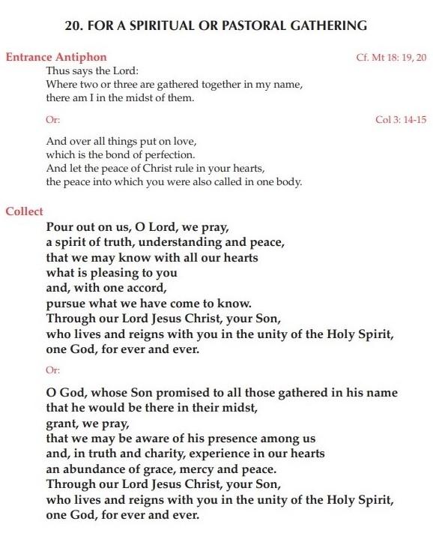
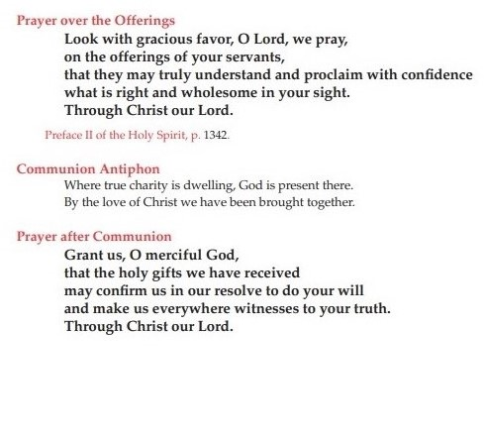

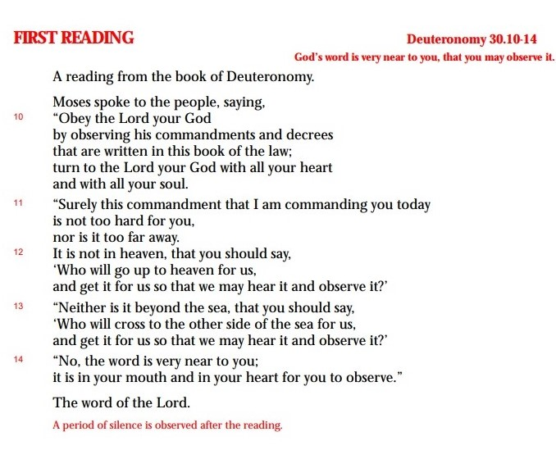
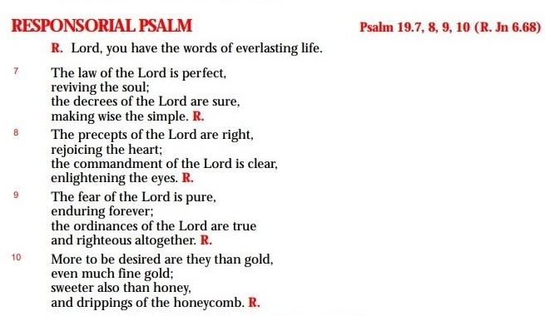

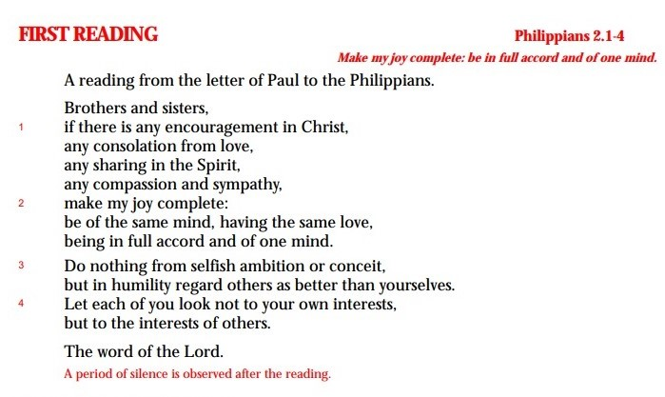

Gospel Acclamations
Lent
Glory and praise to you, O Christ!
A pure heart create for me, O God
and give me again the joy of your help
Glory and praise to you, O Christ!

Outside Lent
Alleluia! Alleluia!
Behold, how good and pleasant it is
when brothers dwell in unity!
Alleluia! Alleluia!

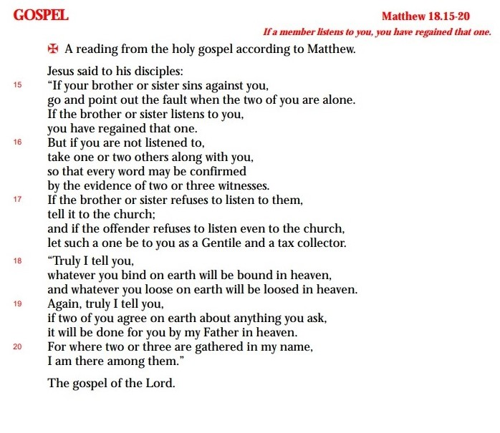
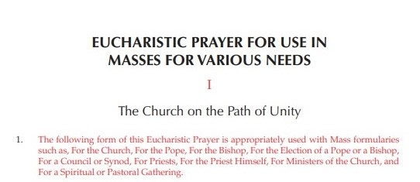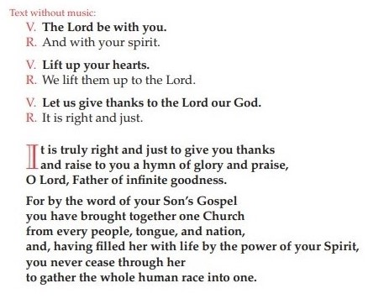
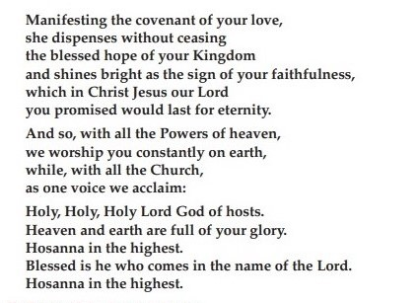
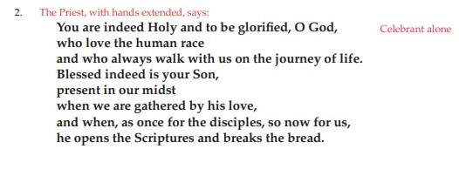
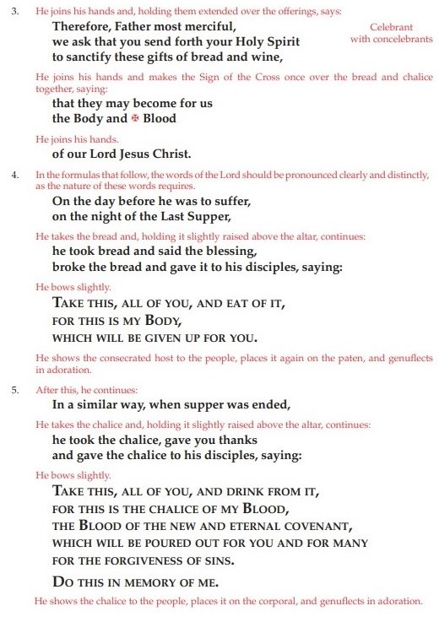
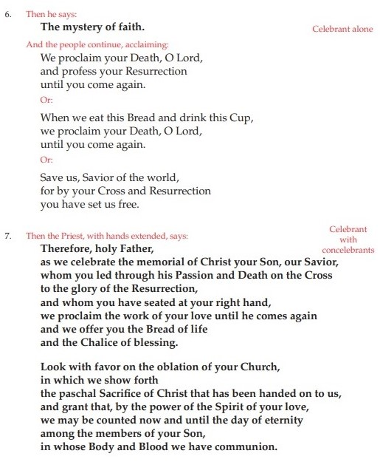

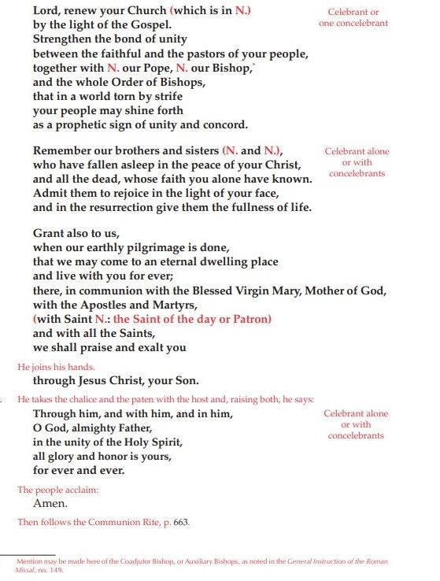
PRAYERS OF THE FAITHFUL 1
For the Community Mass in preparation for the XIII General Chapter
Theme: Unity

Priest: Called by God the Father to gather as one family, in the name of Jesus, his Son, let us ask for the grace of the Holy Spirit to journey in communion in the building up the Kingdom. Let us pray…

LORD, UNITE US IN YOUR LOVE

1. That the Church may journey on the synodal path in the spirit of conversion and contemplation that enables her to listen to and obey the promptings of the Holy Spirit and form a community of faith in one mind and one heart, as brothers and sisters of the one Father. We pray…

2. That political leaders, especially in places where war and discord exist, may seek the path of encounter, dialogue, and peace so as to build a world where love and unity reign. We pray…

3. That the Lord may inflame the hearts of the Rogationists and the whole Family of the Rogate to be apostles of unity and communion in a divided world by way of their fraternal love and the zealous fulfillment of the Divine Command of the Rogate. Grant enlightenment to the delegates of our XIII General Chapter. We pray…

4. That the Lord may open the eyes and touch their hearts of the young people of today to venture to dream and work for what you earnestly desire: the unity and fraternity of your disciples, and dedicate themselves in the service of communion, especially following the vocation to the priestly and religious life. We pray…

5. For our departed loved ones, that after a life dedicated to the service of God and their brethren, may they have communion with the Lord in his Heavenly Banquet. We pray…

Priest: Father, hear our prayers and help us to be true to our mission. As we prepare for the XIII General Chapter, show us the way that leads to unity and grant us the strength to build communion. Through Christ, our Lord. Amen.

PRAYERS OF THE FAITHFUL 2
For the Community Mass in preparation for the XIII General Chapter
Theme: Collaboration

Priest: Christ the Lord is the Good Shepherd who leads the flock to green pastures and seeks those who are lost. Let us lift our prayers to him as we pray…

LORD, MAKE US SHARERS OF YOUR MISSION

1. That the Church may joyfully proclaim to the world, with words and deeds, the message of the Gospel and the hope in the resurrection. We pray…

2. That the men and women of today may strive together to build a world of peace, justice, and love and never lose courage and hope in humanity which the Lord Jesus has redeemed and reconciled through the Paschal mystery. We pray…

3. That the victims of war and violence, the poor, the sick, the jobless, those who feel abandoned, and those who do not find a reason to live, may find among the followers of Christ companions in the journey who witness to faith, hope, and love in concrete ways. We pray…

4. That Family of the Rogate may be zealous collaborators of the Lord of the Harvest in the mission of announcing the Gospel of the Rogate for the fulfillment of the Kingdom of God through our prayer and apostolate. Grant enlightenment to the delegates of our XIII General Chapter We pray…

5. That the Lord may continue to call the youth to stay with him, follow him, be conformed to him, and share his mission of salvation. We pray…

Priest: Hear, O Lord, the prayers we present to you, and grant that as we prepare for the XIII General Chapter, we may never tire of fulfilling our mission as your co-laborers in your mystical harvest, always seeing “the other” as a brother or a sister in you You, who live and reign, forever and ever. Amen.

PRAYERS OF THE FAITHFUL 3
For the Community Mass in preparation for the XIII General Chapter
Theme: Sharing

Priest: Before we partake in the table of the Lord, let us ask the Father that the new life born from the cross and resurrection of Christ may reach the whole world. We pray

LORD, CONFIRM US IN YOUR LOVE

1. For the Church and all Christians. May they be living witnesses to the love and service of Christ who gave up everything so that we might have life. We pray…

2. For the pastors of the Church. May they be prophetic announcers and sharers of the Mercy of God, by their words and deeds, in our world in dire need to hear and experience the good news of salvation. We pray…

3. For those experiencing the tragedy of war, for the hungry and the thirsty, for the poor and the needy, for the refugees and immigrants, for broken families, for the persecuted Christians, and for all those who suffer unjustly. May they experience in Christians God’s mercy and companionship, through their spiritual support and charity. We pray…

4. For us Rogationists and all consecrated people. May we deepen our understanding and zeal of the charism we have received from the Holy Spirit and joyfully share it for the building up of the Church. Grant enlightenment to the delegates of our XIII General Chapter. We pray…

5. For all of us gathered around the table of the Eucharist. May we make “memory” of the Lord’s Supper by becoming bread broken and shared in life-giving communion and recognize the Lord in the brokenness of our brothers and sisters. We pray…

Priest: Father, hear the prayers we present to you as followers of Jesus, your Son. As we prepare for the XIII General Chapter, accompany us so that we may become your joyful apostles and prophets in the world. Through Christ our Lord. Amen.

