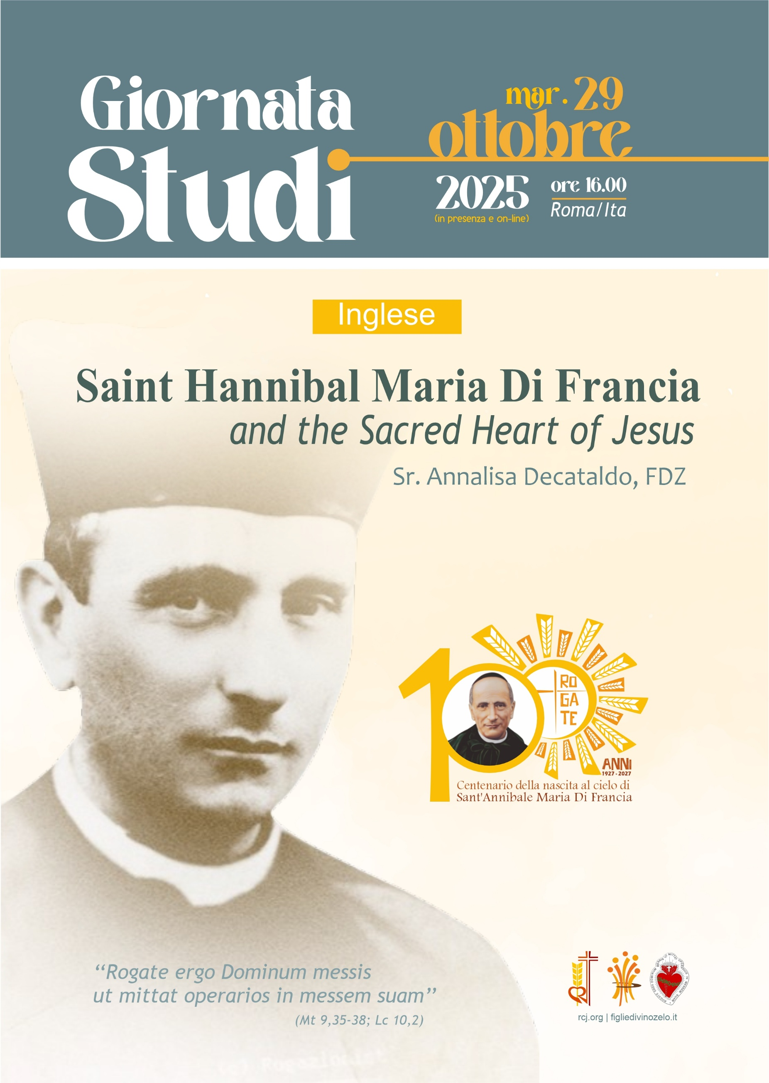

Saint Hannibal Maria Di Francia and the Sacred Heart of Jesus
Study Day - October 29, 2025
Sr. Annalisa Dacataldo FDZ
(Note: unedited translation using DeepL translator)

Introduction
In the life of the Church, the great saints have found and continue to find in the love of the Sacred Heart of Jesus not only a point of devotion, but a generative source of holiness, mission, and communion. St. Hannibal Maria Di Francia is one of these: his human, spiritual, and charismatic life was deeply rooted in and constantly nourished by the experience of the divine Heart.
The content of this report does not claim to be exhaustive or comprehensive. The purpose of this sharing is to show how Saint Hannibal did not “add” devotion to the Sacred Heart of Jesus to his life but lived it as the very heart of his active holiness. Guided by his experience of worship of the Sacred Heart of Jesus and some of his writings, we want to gather formative and spiritual insights for all of us.

1. Brief biographical profile of Saint Hannibal
Saint Hannibal Maria Di Francia was born in Messina on July 5, 1851, into a noble and Christian family. Orphaned by his father at a very young age (when he was not yet two years old), he experienced from an early age the absence, fragility, and solidarity with the poor of his native land.
His religious education as a child took place at the College of Gentlemen, where even at a young age he showed a sensitive heart towards the poor: it is said that, when faced with a beggar who was being mocked by others, he stood up and gave him his food ration, a gesture that remained engraved as a prophetic sign of his future life. Ordained a priest on March 16, 1878, in the Church of Santa Maria dello Spirito Santo, he immediately devoted himself to preaching, assisting the poor and orphans, and Christian education, starting in the Avignone district of Messina.
“We say nothing about the Rogate: he devoted himself tirelessly to it throughout his life, whether out of zeal or fixation, or both.” The Rogate emerges as the central core and essential element of St. Hannibal's personality, spirituality, and activity. He interpreted the Gospel phrase “Pray therefore to the Lord of the harvest to send out laborers into his harvest” (Mt 9:38) not as a metaphor but as a concrete orientation for apostolic life. It was in this context that the two institutes were founded: the Daughters of Divine Zeal of the Heart of Jesus in 1887 and the Rogationists of the Heart of Jesus in 1897. The canonical approval of these Congregations came in 1926, shortly before Hannibal's death. He died in Fiumara Guardia (Messina) on June 1, 1927. His beatification took place on October 7, 1990, and his canonization on May 16, 2004.

2. Saint Margaret Mary Alacoque: the historical and spiritual roots of devotion to the Sacred Heart
Between 1673 and 1675, Saint Margaret Mary Alacoque, a nun in the monastery of the Visitation in Paray-le-Monial (France), received a series of private revelations from Jesus.
During these mystical experiences, Jesus showed her his Heart “surrounded by flames of love,” a symbol of his infinite charity towards humanity, but also pierced and crowned with thorns, a sign of the indifference and ingratitude of men.
Jesus communicated to her his desire that the Church honor his Heart with a special devotion, consisting of:
· reparation for the offenses received,
· love and Eucharistic adoration,
· spreading the cult of the Sacred Heart,
· practicing the first Fridays of the month,
· and a liturgical feast dedicated to the Heart of Jesus (now celebrated on the Friday after the Solemnity of Corpus Christi).
The revelations were received with caution but later recognized as authentic; the feast of the Sacred Heart was officially instituted by Pope Pius IX in 1856.
During the apparitions, Jesus made a series of promises to St. Margaret Mary addressed to those who would practice devotion to his Heart with faith and constancy.
The best-known “twelve promises” derive from subsequent summaries, in particular from a 19th-century text that collected the main passages from her writings.
Here they are, in their traditional formulation:
1 I will give them all the graces necessary for their state.
2️ I will bring peace to their families.
3️ I will console them in all their afflictions.
4️ I will be their safe refuge in life and especially at the hour of death.
5️ I will pour abundant blessings upon all their undertakings.
6️ Sinners will find in my Heart the source and infinite ocean of mercy.
7️ Lukewarm souls will become fervent.
8️ Fervent souls will quickly rise to great perfection.
9️ I will bless the homes where the image of my Sacred Heart is displayed and honored.
10️ I will give priests the gift of touching the most hardened hearts.
11 Those who promote this devotion will have their names written in my Heart and will never be erased.
12️ To all those who, for nine consecutive months, receive Communion on the first Friday of the month, I will grant the grace of final perseverance, and they will die in my love.
The latter, the so-called “great promise”, is the best known and gave rise to the practice of the first nine Fridays of the month, as a sign of love and reparation to the Heart of Jesus.
The promises are not a “magical contract,” but an expression of Christ's merciful love for those who respond with faith and constancy. Theologically, they are based on three pillars:
· The Heart as a symbol of divine love incarnate: in biblical language, the heart indicates the center of being; in the Heart of Jesus, the charity of God made flesh is concentrated (cf. Jn 19:34: “one of the soldiers pierced his side, and immediately blood and water came out”).
· Reparation: devotion includes personal and communal offerings to repair the offenses committed against Christ's love. It is not autonomous expiation, but participation in redeeming love.
· Imitation of Christ: those who honor the Heart of Jesus are called to conform themselves to his love, practicing meekness, forgiveness, compassion, and charity toward the poor.
In this sense, the spirituality of the Sacred Heart has inspired many saints and founders, such as St. John Eudes, St. Claude de la Colombière (the confessor of St. Margaret Mary Alacoque), and, later, St. Hannibal Maria Di Francia.

3. The Church's Magisterium on the Sacred Heart
To understand the spiritual richness of the Heart that nourished Hannibal, it is helpful to recall the magisterial teaching on the Sacred Heart.
· Pope Pius IX (1856) extended the feast of the Sacred Heart to the whole Church.
· Pope Leo XIII (1899) consecrated the entire human race to the Sacred Heart with the encyclical Annum Sacrum, inviting the faithful to place all their hope in the divine Heart. The encyclical affirms that the cult of the Heart is not a devotional appendage, but the beating heart of the Christian faith.
· Pope Pius XII (1956) dedicated the encyclical Haurietis Aquas (“You will draw water with joy”) to the theology of the Sacred Heart, clarifying the meaning of the promises in a Christocentric and biblical key. The encyclical addresses the dangers of a “sentimental” or “naturalistic” devotion to the Heart and calls for Christian balance. It affirms that the Divine Heart is a natural symbol of Christ's infinite love. This encyclical provides a theological basis for distinguishing healthy and living devotion from a superficial attitude.

4. The experience of the Heart of Christ in the works and writings of St. Hannibal
The twelve promises to St. Margaret Mary are not quoted “verbatim” by Hannibal in his writings, but he embodies their spirit and reinterprets them in his life and in his institutes in the light of the Rogate Charism. One of the most obvious examples is to name everything, from the first Chapel in the Avignone Quarter to the names of the Work of Evangelical Rogation, the poor, and the Female and Male Institutes, after the Heart of Jesus. Not only that, he names the Heart of Jesus as the absolute, effective, and immediate Superior of the Institutes.
Father Hannibal had undertaken his mission in the Avignon Quarter, moved by compassion for the little ones and the poor, with the intention of helping them from a human, social, and, above all, spiritual point of view. After several years of this apostolate, feeling the need to celebrate Holy Mass there, he set up a small chapel as best he could, as Fr. Vitale tells us: "It was an unusual competition among those poor people to adorn the Chapel as best they could, which the Father dedicated to the Sacred Heart of Jesus, the center of his love and hopes. The painting of the Sacred Heart, beautifully adorned with candles and vases of flowers, stood out on the altar, while on the walls the image of the Blessed Virgin and a statue of St. Joseph attracted the eyes and hearts of the poor." The image is placed on the altar but, at the same time, it also stands out on the small façade of the Chapel, in this case surrounded by the Gospel pericope that recalls the prayer for good workers.[1]
There was a thought that Father had constantly nurtured for years: to proclaim Our Lord and the Blessed Virgin as Divine Superiors of the Daughters of Divine Zeal and the Rogationists.
Fr. Vitale explains the reasons: "In short, he wanted to strip himself of any direct immediate leadership, renounce the name of Founder (which he never accepted) or Director, but everyone had to recognize the Most Sacred Heart of Jesus as the immediate, effective, and absolute Superior of the two Congregations, and as a concomitant and crowning glory of this sovereign grace, in order to facilitate the attainment of all particular graces, the Blessed Virgin herself would also have to be the effective Superior of all the Works, as the One who presented them to her Divine Son, and therefore made them worthy of help." He chose the greatest feast of the Work, July 1 and 2, 1913, in the House of Oria, for the Rogationists, for the proclamation.
On March 19, 1914, Father Hannibal, in the Mother House of Messina, after adequate preparation, proclaimed the Eucharistic Heart of Jesus “absolute, effective, and immediate Superior” of the Congregation of the Daughters of Divine Zeal.
The names given to the Institutes: "The Evangelical Rogation, with a sacred periphrasis, we have also called: The Mandate of the Divine Zeal of the Heart of Jesus. Consequently, the House of the Sisters is called: Institute of Divine Zeal. And the Sisters have taken a name. The Daughters of the Divine Zeal of the Heart of Jesus, or simply: The Daughters of Divine Zeal. But what name was given to the poor, both great and small, who are the object of the exercise of spiritual and temporal charity on the part of the Rogationists and the Daughters of Divine Zeal? We have called them by their ancient and honorable name of the Poor of the Heart of Jesus. What a great reason this name is for the Rogationists and the Daughters of Divine Zeal to attend to the spiritual and temporal good of the poor, adults and children, with great care and reverent devotion![2]
Another aspect is that of Reparation. Jesus, showing his Heart to St. Margaret Mary Alcoque and lamenting the ingratitude of men, asked her to receive Holy Communion in reparation, especially on the First Friday of each month. This appeal of the Sacred Heart was particularly well received by the faithful, and this is natural because the more we penetrate the mystery of love of the Sacred Heart, the more we feel the need for reparation. Father T. Tusino reminds us of this: "The consequence of God's love and hatred of sin is the spirit of reparation, which was very much alive in the Father. When he founded the Work, he wanted all his followers to join the Pious Union of Prayer and Penance, whose specific purpose was the reparation of sins. He made sure that the pious practices of reparation for the first Friday and first Saturday of the month were carried out with fervor in their homes. He prescribed litany prayers to the Holy Face for the month of April, in reparation for blasphemies; for the last days of Carnival, he wanted a triduum of reparation, during which the moving verses he had composed on the intimate sufferings of the Most Sacred Heart of Jesus were sung.[3] And then we remember the annual novena to the Most Holy Name of Jesus with the Blessed Sacrament exposed: in nine prayers, reparation was offered for nine categories of sins: blasphemies, heretical blasphemies, scandals, persecutions of the Holy Church, insults to the papacy and the priesthood, bad press, sins of consecrated souls, ruin of youth, profanation of the Most Holy Eucharist. And these were the themes of the Father's sermons for 34 years. [4]
Only by entering into the depths of St. Hannibal's spiritual intimacy can we understand how the Heart shaped his holiness. The volumes of Father's Writings contain many of his personal prayers, supplications, and invocations to the Heart of Christ. And the volumes of his Correspondence give us the living words of Saint Hannibal in his relationships with confreres, religious, and lay people, and show how the theme of the Heart is constantly present in his letters of spiritual direction.
In 1880, he composed the first prayer for vocations, not having found any in the books of devotion. It was printed in the Avignone Quarters printing house and distributed among the faithful in September 1885. It is the first prayer to the Heart of Jesus to obtain good workers for the Holy Church. He explains in the preface that the greatest punishment with which God wants to punish a people is to deprive them of good priests, whereas the greatest of divine mercies is when the good Lord sends good workers. The prayer begins as follows: "Compassionate Heart of Jesus, may the groans and sighs we raise to you reach your presence. We have come to ask you for great and immense mercy for the benefit of your Church and for the salvation of souls. Deign to send holy priests among the peoples..."[5] Therefore, praying for vocations is not an abstract idea for him, but a living integration of the desire of the divine Heart.
Another pearl of immense value is the passage "The Daughters of Divine Zeal ... have a very special purpose, namely to penetrate the Most Holy Side of Jesus, to live within that Divine Heart, to feel its love, to espouse all its interests, to sympathize with all its pains, to share in its sacrifice, to console that Divine Heart with their own sanctification and by winning souls for it, especially by obeying that Divine Command that came from the divine zeal of the Heart of Jesus when he said: “The harvest is plentiful, but the laborers are few; therefore pray the Lord of the harvest to send out laborers into his harvest.” They will do all this through the exercises of Martha and Mary, that is, the interior life and the active life."[6] Father Hannibal explains each of these words in his various regulations to help his daughters and sons understand what it means to live in the Heart of Christ in order to live the Rogate more deeply.

5. The Rogate flowed from the Compassionate Heart of Jesus
The Rogate springs directly from the compassionate Heart of Jesus: “Seeing the crowds, he felt compassion for them, because they were weary and exhausted like sheep without a shepherd. Then he said to his disciples, ‘The harvest is plentiful, but the laborers are few. Pray (Rogate) therefore to the Lord of the harvest to send laborers into his harvest.’” (Mt 9:36-38)
Here the verb “felt compassion” (ἐσπλαγχνίσθη) is the key. It expresses a visceral movement of the Heart of Jesus: a love that “is moved in the depths,” that does not remain contemplative, but becomes invocation and action. The Rogate, therefore, is the prayer of the Heart of Jesus himself, not just a command to his disciples. Jesus does not say to pray in the abstract: He reveals His Heart and invites us to share in His own compassion.
The Father writes: “The harvest is truly plentiful, but the workers are few. Rogate ergo Dominum messis, ut mittat operarios in messem suam” (Lk 10:1-2). With these words that came from the Most Holy Heart of Jesus, moved with pity for souls abandoned like sheep without a Shepherd, the Divine Redeemer made an explicit and clear recommendation to all faithful souls, inviting them to share with Him this supreme concern of His Divine Heart, and exhorting them to pray to the great Master of the harvest to provide for this by sending good cultivators of the Mystical Field, that is, priests.
St. Hannibal Maria Di Francia understands this Gospel passage in a prophetic way.
For him, the Rogate is not a simple precept of prayer, but the very voice of the Heart of Jesus. The Rogate is not a piece of advice, it is a cry from the Heart of Jesus. It is the heartfelt plea of the Divine Heart that sees the abandoned multitudes. It is a command. It is not an optional task, but the privileged form in which the intimate desire of the Heart of Christ is realized.
For St. Hannibal, the Heart of Jesus is:
· Source of the Rogate, because from Him comes the desire for vocations;
· Model of the Rogate, because Jesus himself is the first to pray to the Father;
· End of the Rogate, because the end of every vocation is to be configured to the Heart of Christ the Good Shepherd.
The Church will have holy workers only when the hearts of the faithful are inflamed with the zeal of the Heart of Jesus. The Rogate is not only a verbal prayer, but a permanent attitude of the human heart united to the Heart of Christ.
To be Daughters of Divine Zeal, to be Rogationists, to be lay members of the Rogate Family, means to allow oneself to be shaped interiorly by this movement of compassion that becomes intercession and mission.

Conclusion
In the Heart of Jesus, the Rogate is the fruit of compassion for the harvest; it is the voice of Christ interceding for humanity.
In St. Hannibal, the Rogate becomes man's response to that Heart: praying for vocations, loving the poor, spreading charity means continuing the very beating of the Heart of Jesus in history.
The Heart of Jesus is a Heart that loves and suffers, but also a Heart that invokes and calls. Those who unite themselves to this Heart become themselves a living Rogate. From the Heart that loves and suffers springs the prayer that invokes new apostles; from prayer springs charity; from charity, reparation and the salvation of the poor. Mission becomes an expression of the Heart, not an isolated end.
The Heart of Jesus unites love, offering, and mission:
· Love: it is the eternal source of divine giving.
· Offering: the redemptive sacrifice is the offering of the Heart.
· Mission: graces flow from the Heart and go out into the world.
I conclude by repeating a question that I want to leave you with: What does the Heart of Christ want from me today?
May each of us return to our own environments with the desire to read the words of St. Hannibal every day, like a diary of the heart, and to conform our lives to the Heart that loves, gives, and calls.
Thank you for your attention.

END NOTES
[1] TUSINO T., Anima del Padre – Testimonianza (1973), p.140
[2] Cf. HANNIBAL MARY DI FRANCIA, Typewritten Writings, Vol. 61 pp.106-110
[3] HANNIBAL M.DI FRANCIA (ed.), Prayers and Practices of Piety of the Daughters of Divine Zeal, Trani, 1934, p.455.
[4] TUSINO T., The Father’s Soul – Testimonies, Rome (1973), p. 219ff
[5] HANNIBAL MARIA DI FRANCIA, Writings Vol 1, Prayers to the Lord, p.64ff
[6] Cf. HANNIBAL MARY DI FRANCIA, Writings Vol 2 p.151



